MT455 Sales Plan
Territory Design and Sales Forecasting
Name: ________________________ Date: ___________

Sales Plan

Provide an introduction to the project. Give the reader an overview of what this phase of the project is about. Be sure to double space your work and give credit where credit is due by citing your sources according to APA guidelines. Your company's strategy should be 2–3 pages (a minimum of 500 words) in length and must include an additional references list.
Size of the Sales Force
Discuss the size of the sales force.

Territory Design
Analyze the sales territories, and the most appropriate sales forecasting method. Evaluate the organization’s territory design. Is the company using the most optimal territory design?
Sales Forecasting
Discuss what forecasting method would be most appropriate for the organization and explain why. Consider the advantages and disadvantages of the primary sales forecasting methods. Be sure to review concepts covered in Chapter 2, pages 59–86 of Cron and DeCarlo (2009) for guidance.
Sales Forecast for 2 years:
Sample Sales Forecast Chart for 2 years: (Do not use this chart in your submission.)

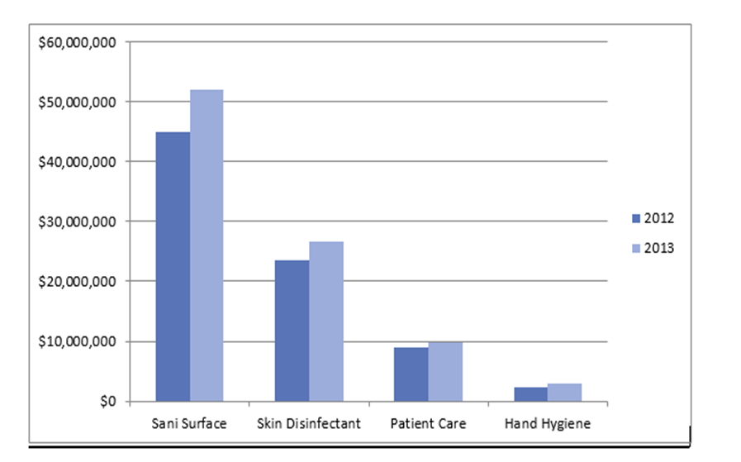
2.2 Measuring Results

Explain what might be a reason for the forecast to be inaccurate?
What might be the consequences for the sales group if the forecasts are not met?

References
Cron, W. L. & DeCarlo, T. E. (2009). Dalrymple's sales management: Concepts and cases (10th ed.). New York, NY: The McGraw-Hill Companies, Inc.
Note: Include a reference list on a separate page. Be sure you cite your sources in the body of your work and use your reference list to include all sources you used. Refer to Academic Writer located in the Academic Tools area of the course for assistance with APA.

