Eclipse Installation Instructions
https://www.eclipse.org/downloads/
NOTE: Please be sure to download and install the Java JDF first before installing Eclipse.
You should see the download for the operating system you are on and click Download. If a second web page shows, click Download again:
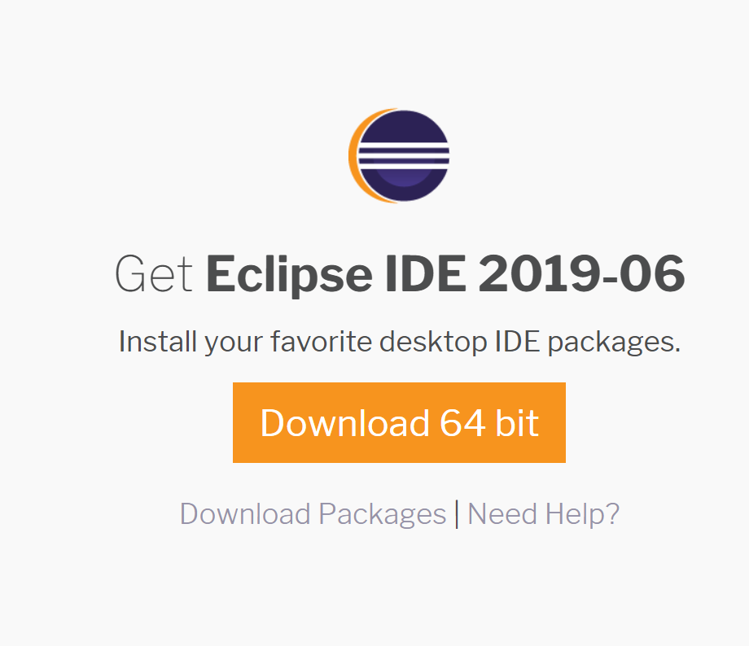

Double-click the downloaded file to install. Select Eclipse IDE for Java Developers:
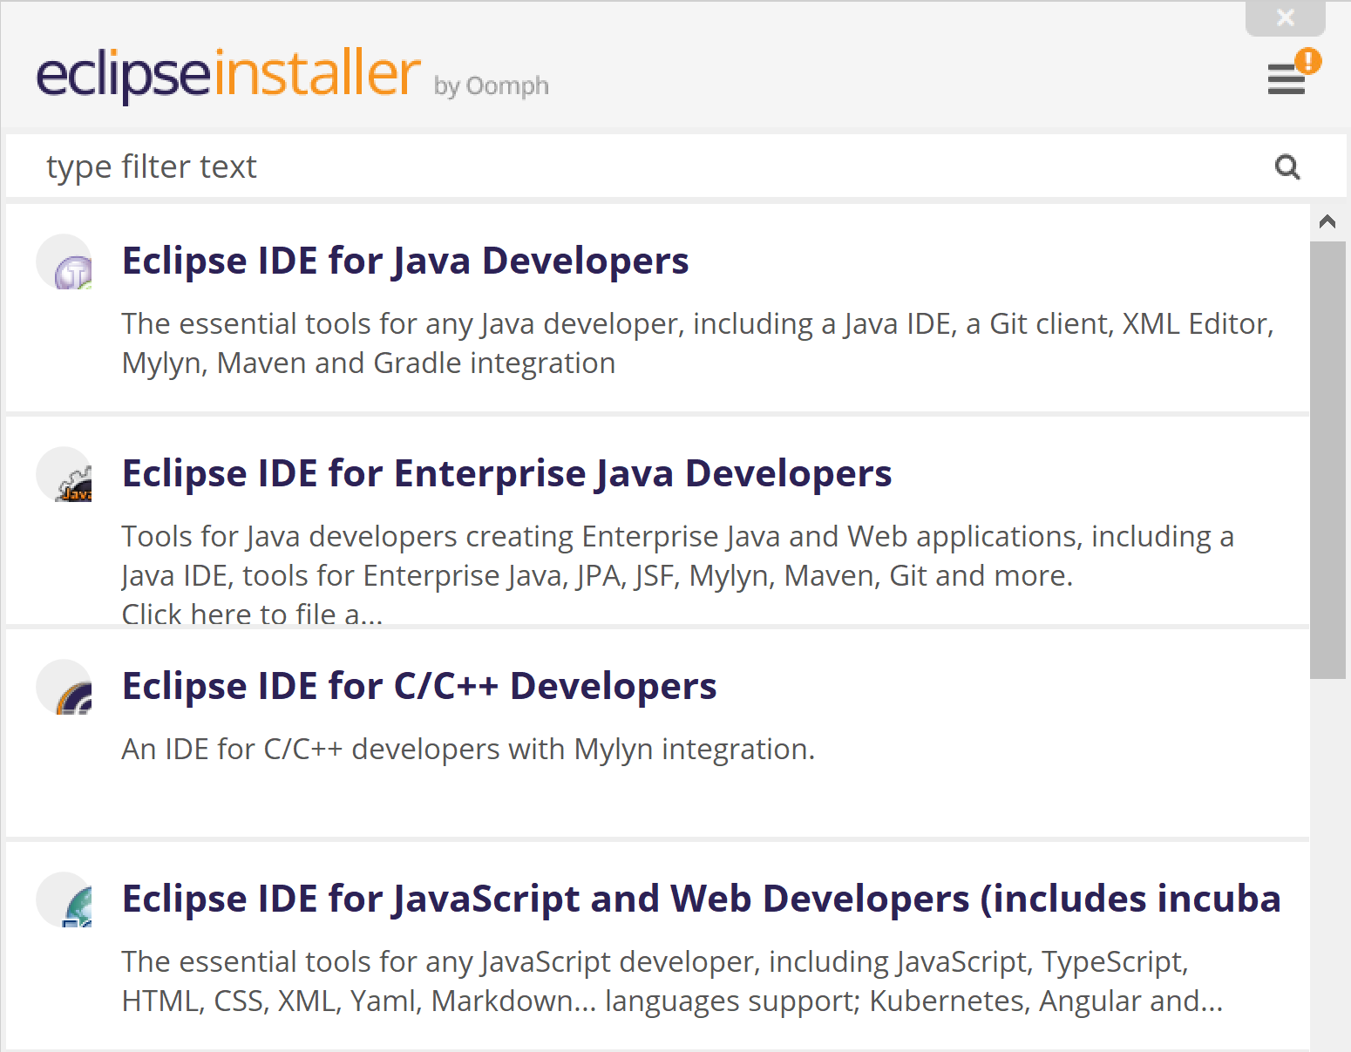

Select the JDK you installed for Java and click Install:
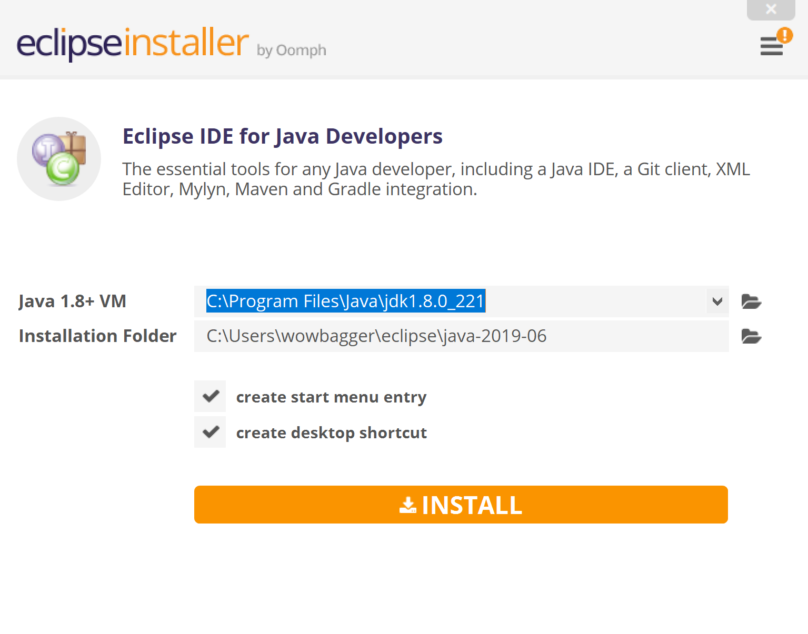
There may be pop-ups; click Accept if there are.

You can see the install directory above or click Launch when finished installing:
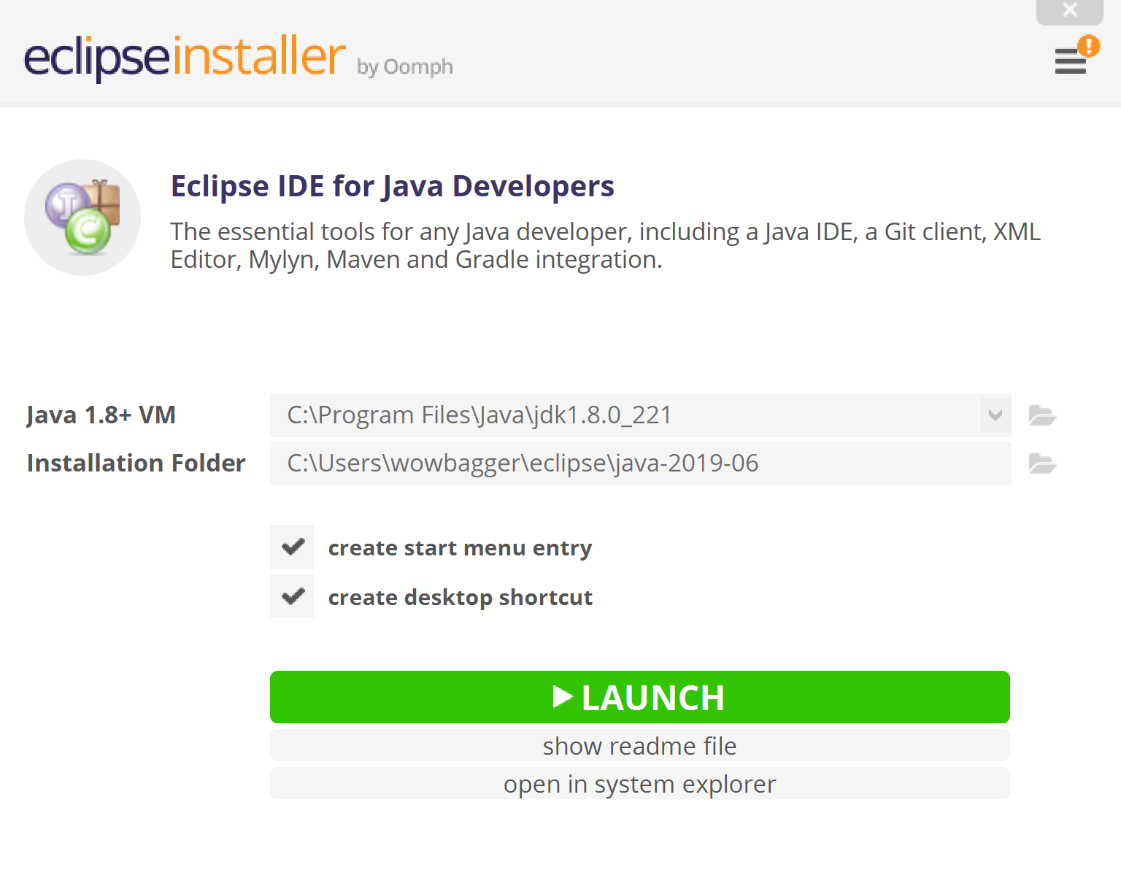

Once Launch is clicked, or the application started, you should select Launch, or change the default location where you Java files will be stored:
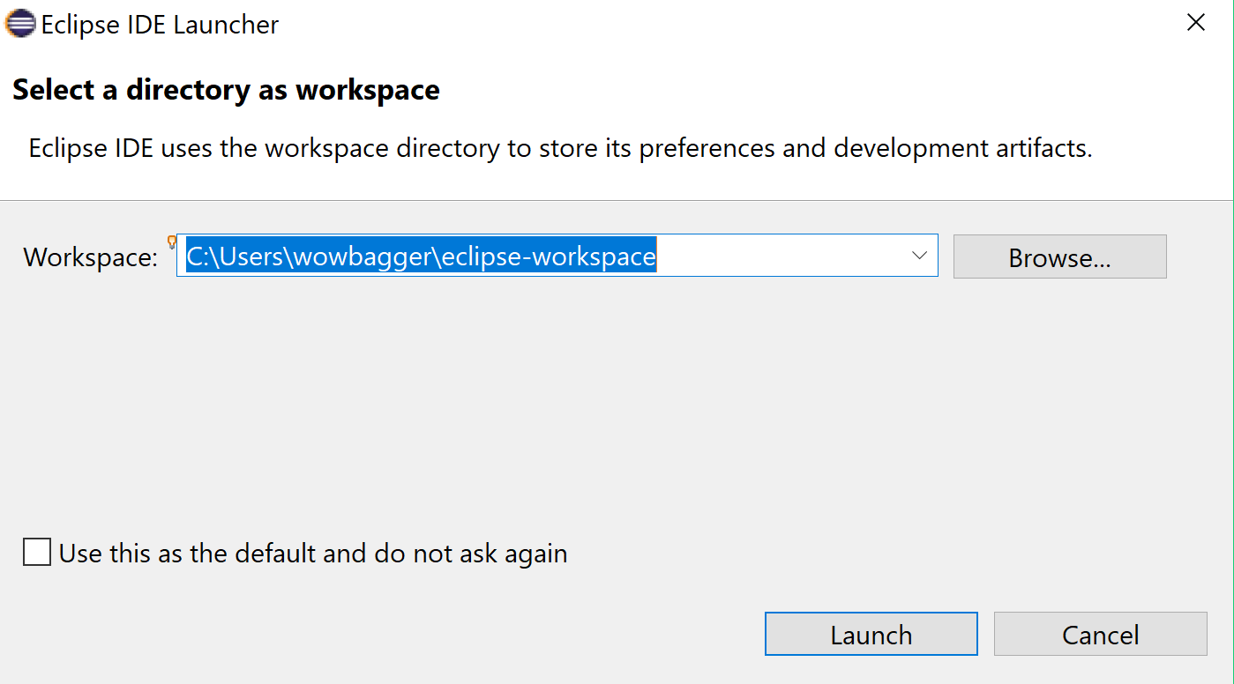

Eclipse should launch as shown below. Select Create a new Java project:
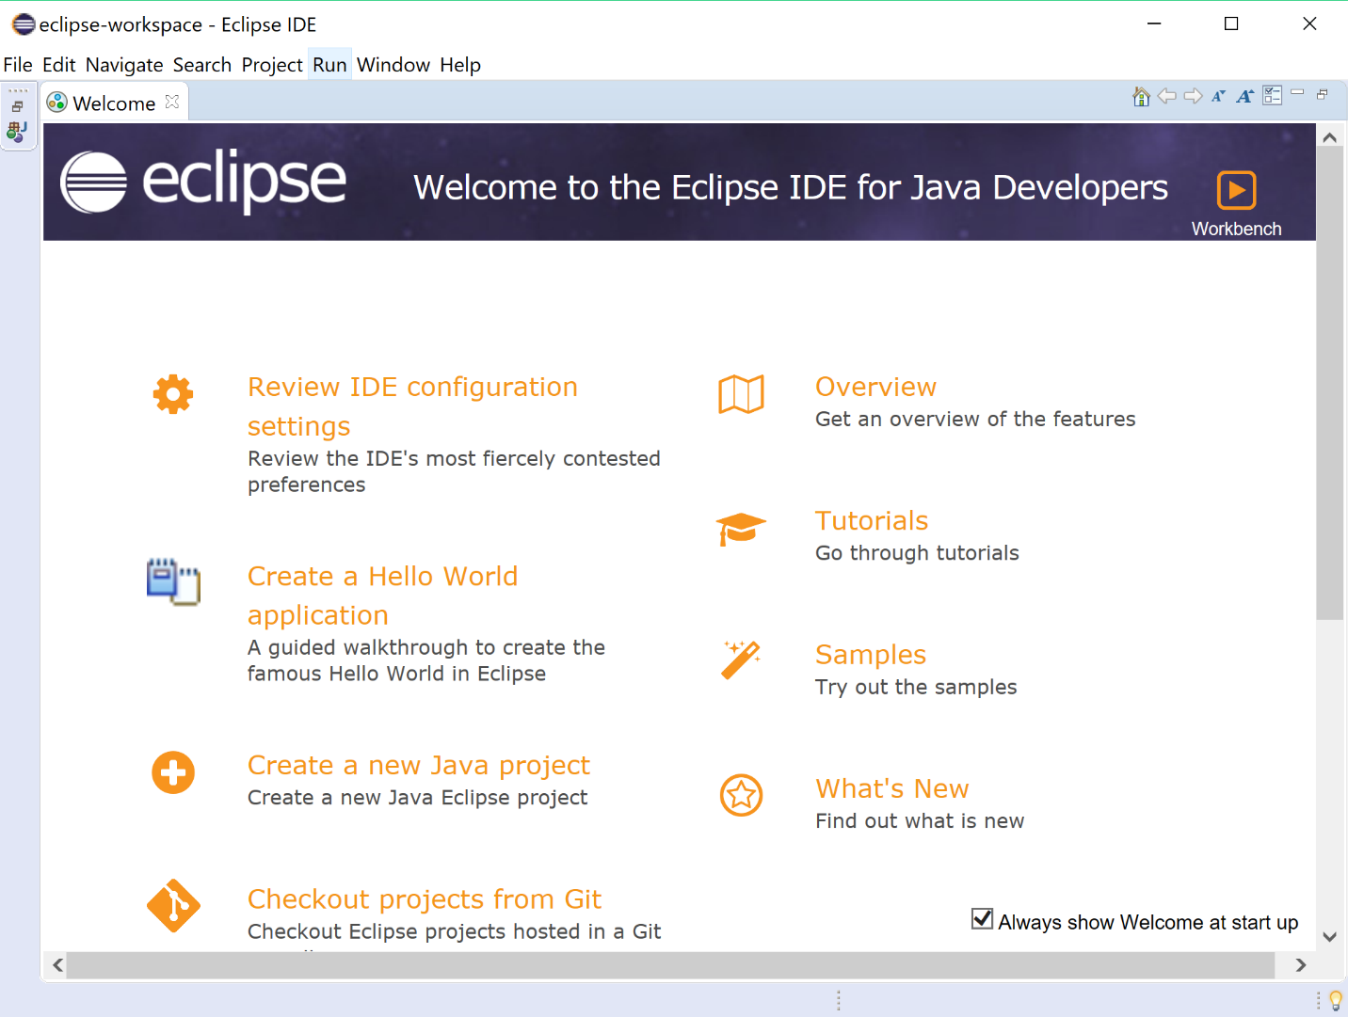

Create the project name and select the Use project specific JRE. Then click Finish:
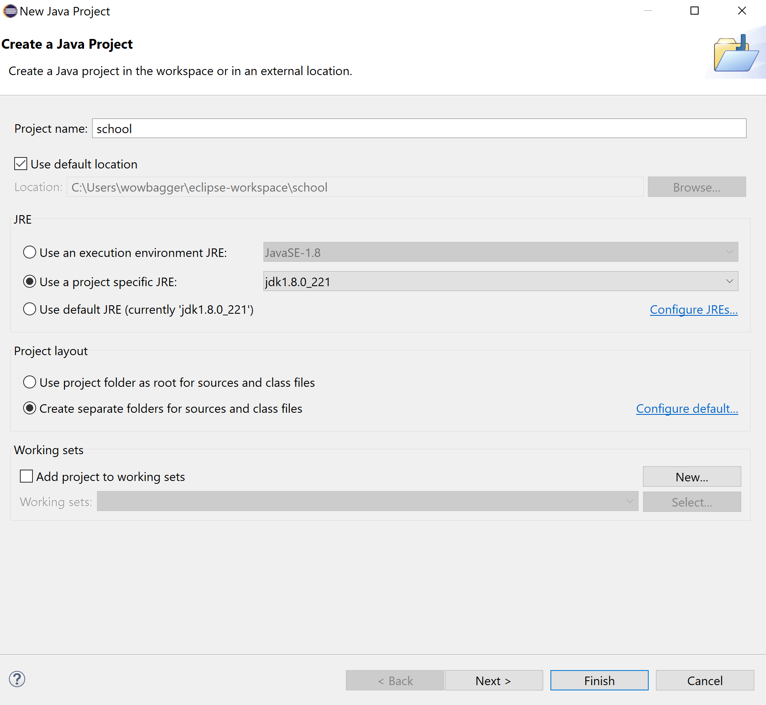

You should see this screen:
