Java JDK Installation Instructions

https://www.oracle.com/technetwork/java/javase/downloads/index.html

Click the JDK download button as shown below:
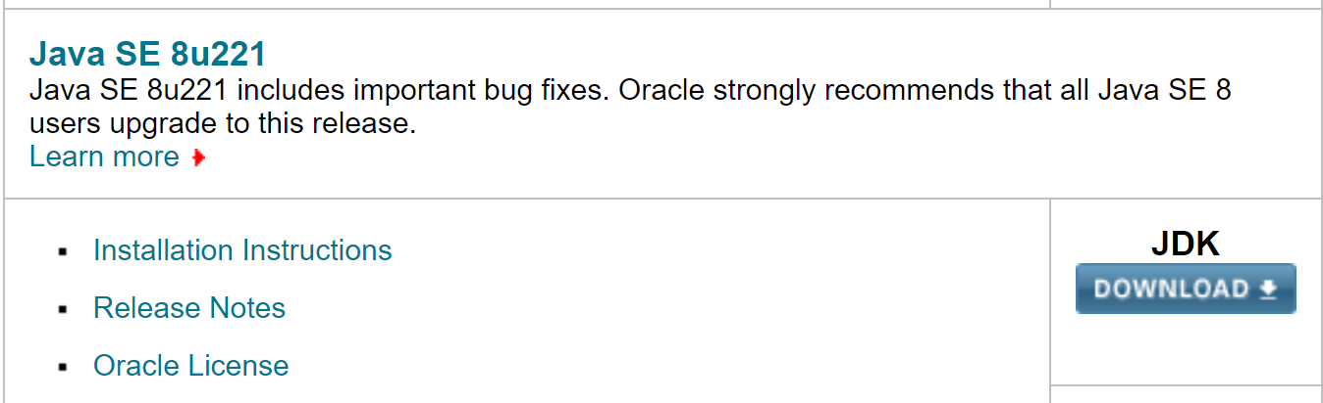

Select the appropriate operating system. For Windows 10, you should try the 64-bit version:
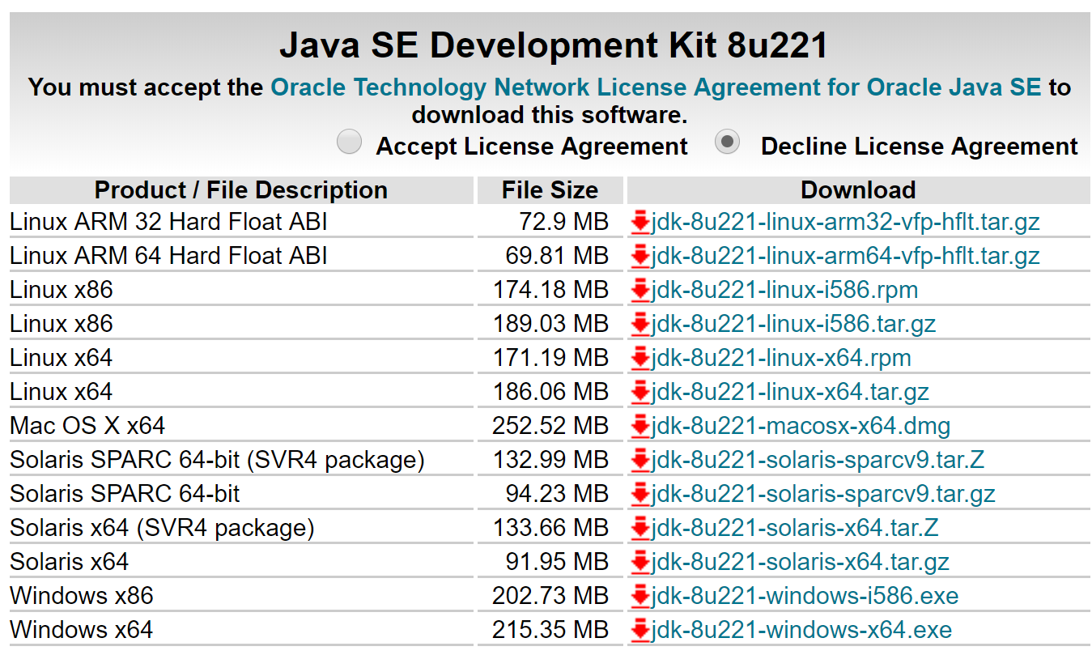

Create an account to download:
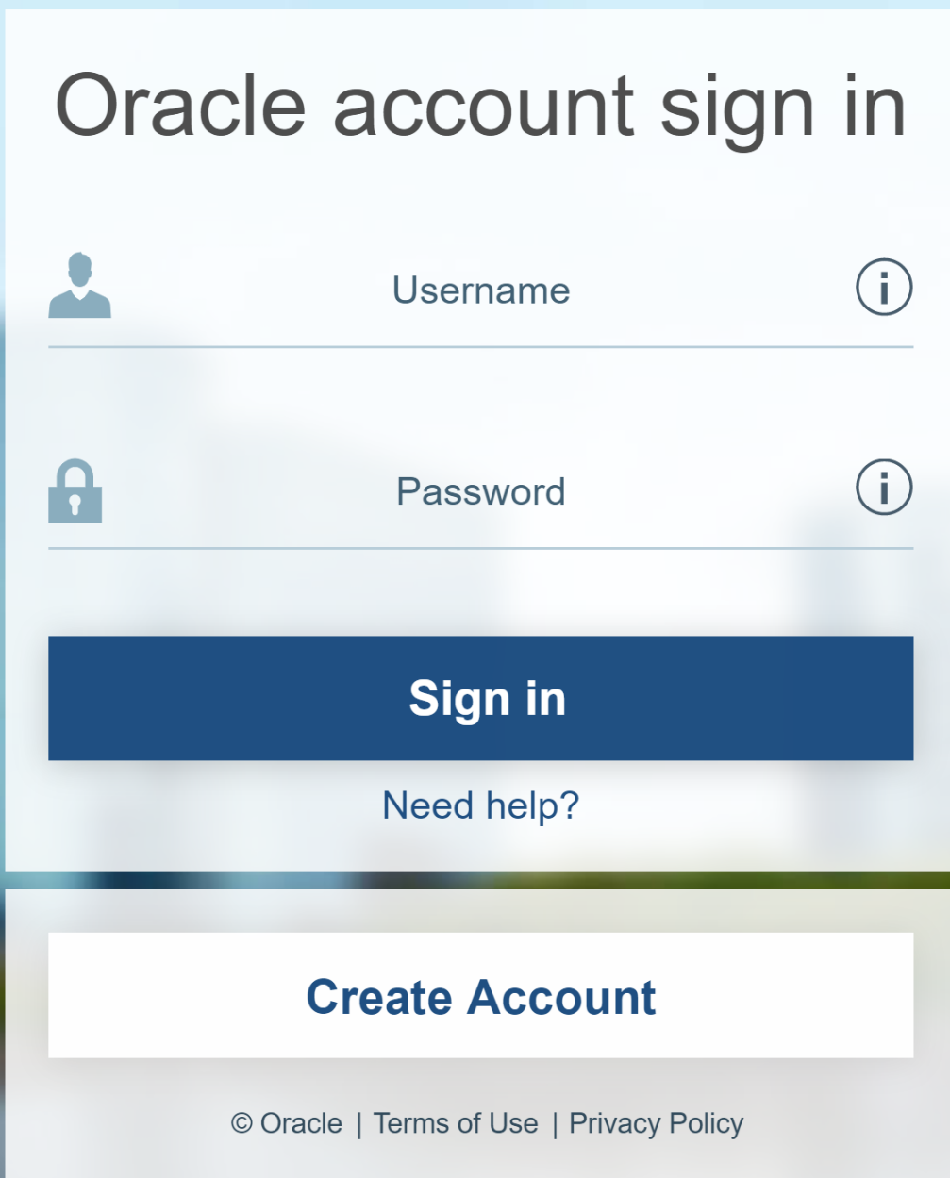

Sign in and the download will begin.
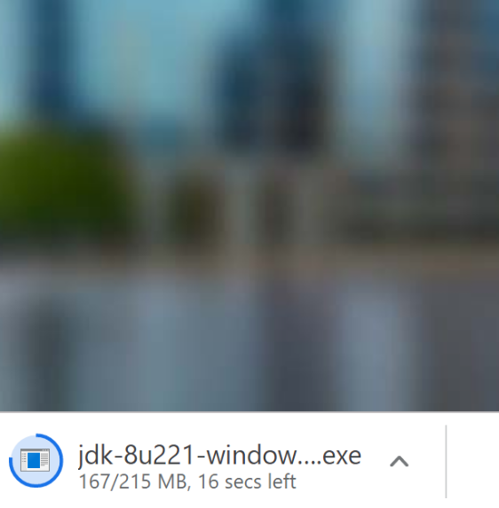

Once the download has finished, double-click it to install. The wizard will walk you through the installation. Select Next:
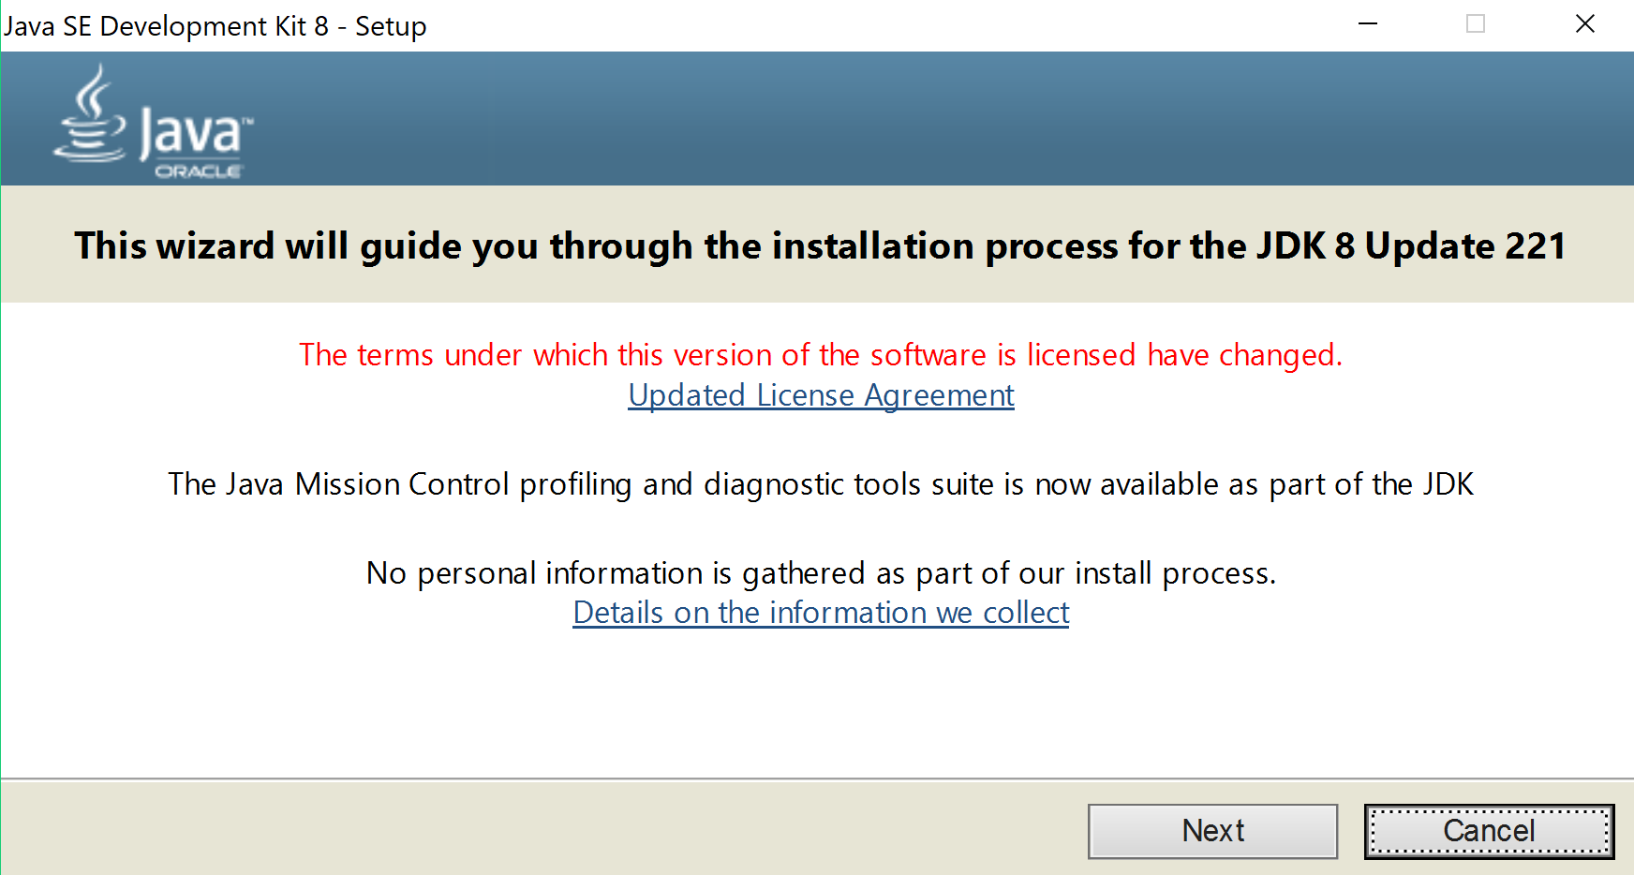

Select Next:
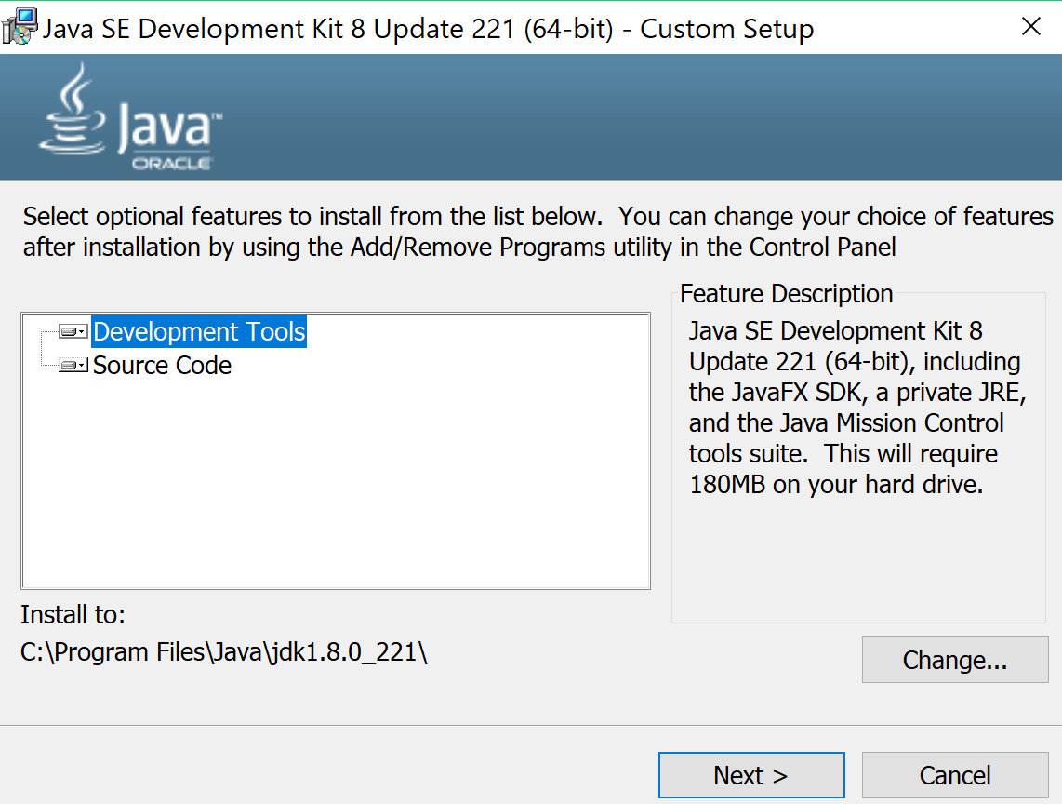

Select Close:
