Python Installation Instructions
Download the latest version at:
https://www.python.org/downloads/
Python Windows download page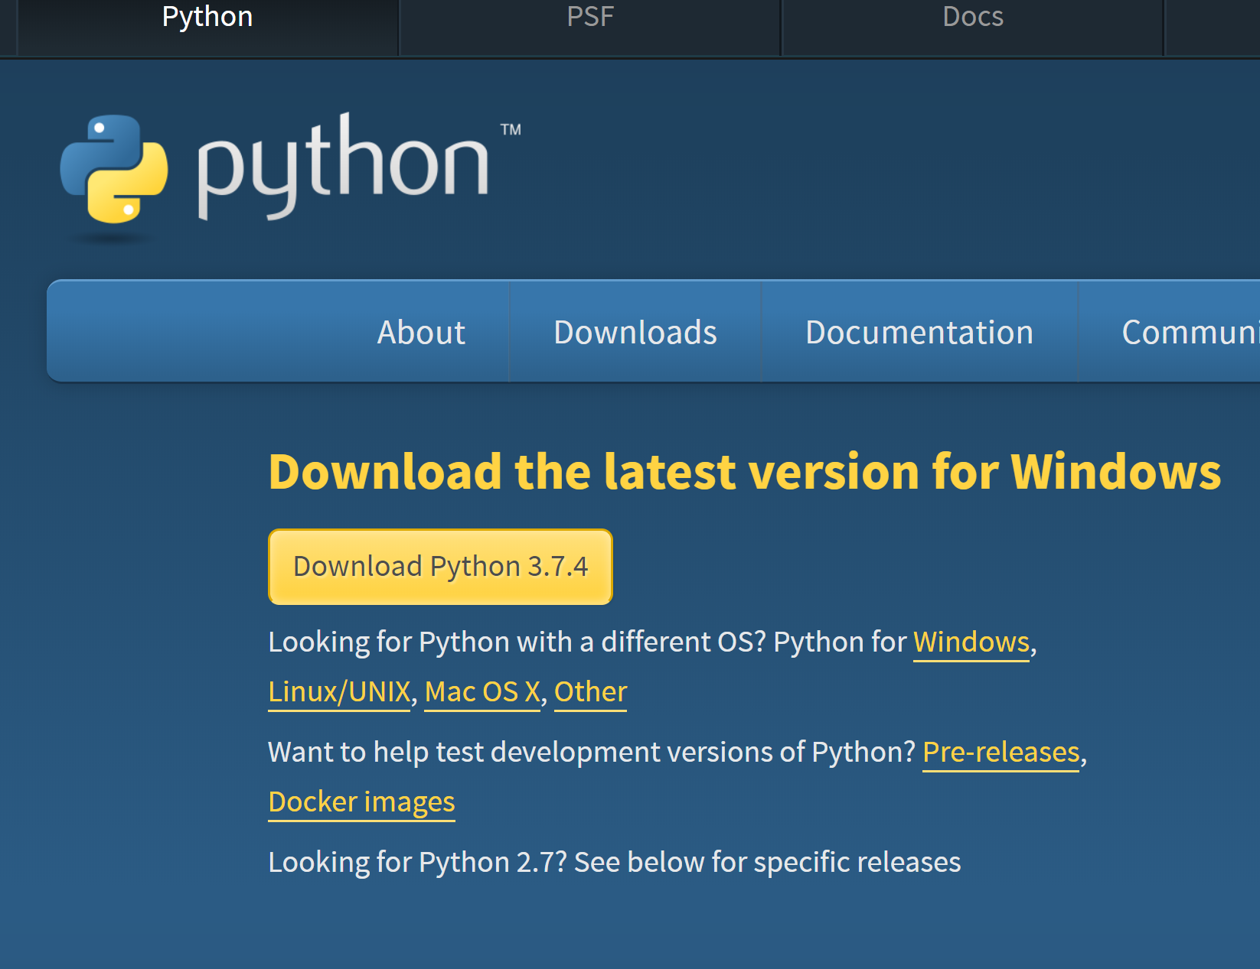

Double-click the download and select Install Now:
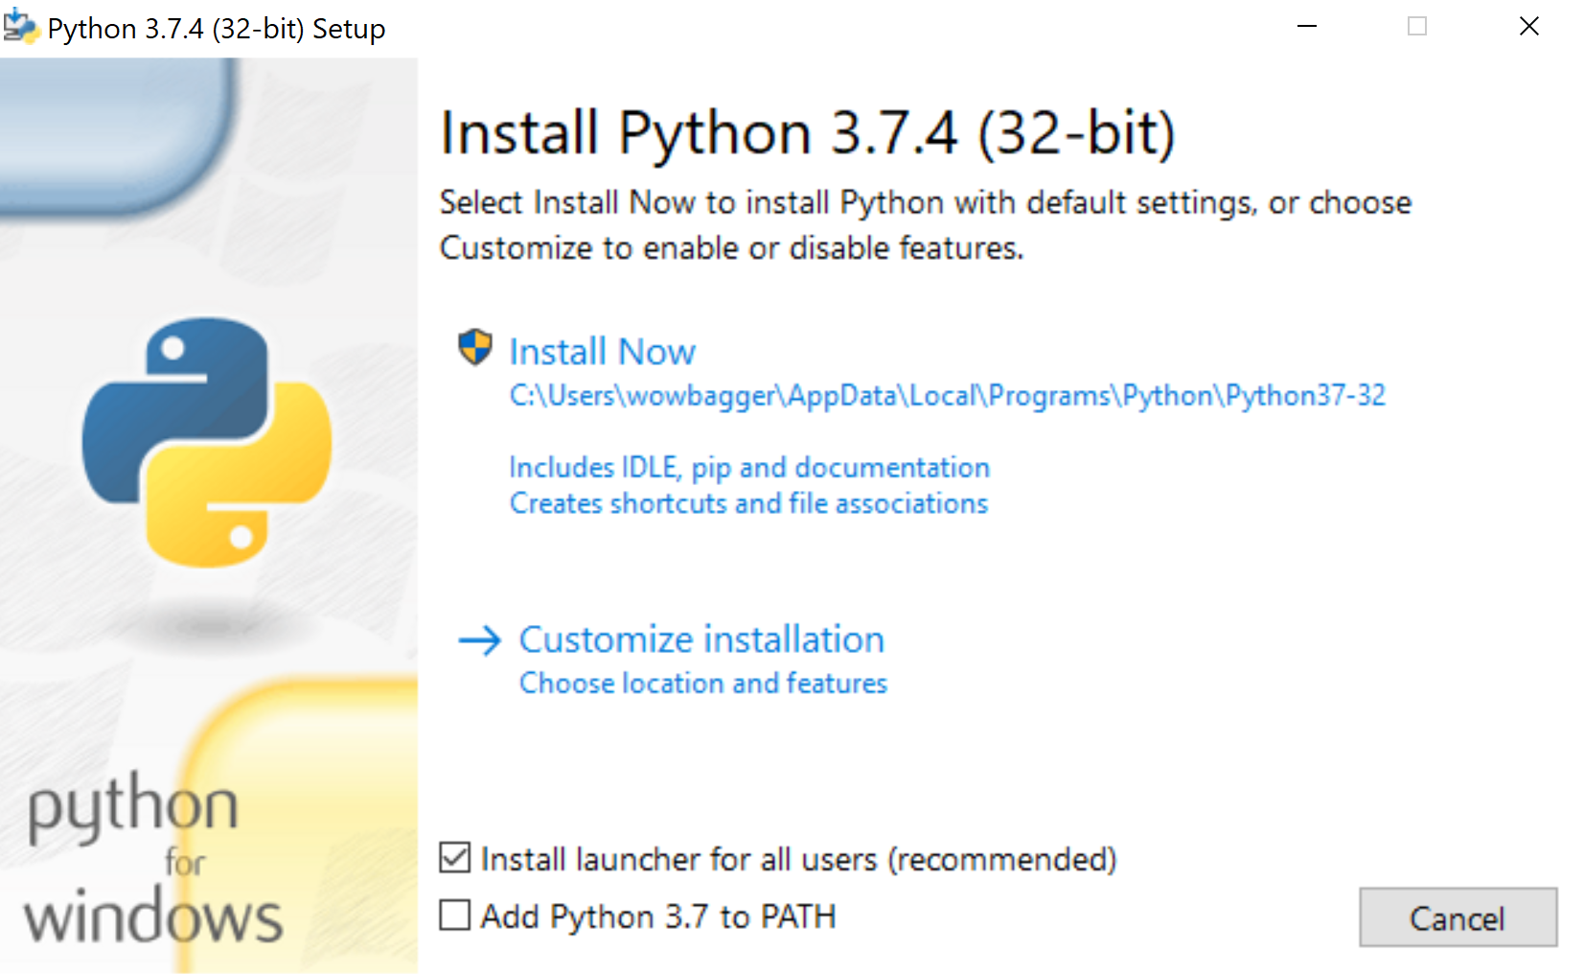

You should see the below when the install finishes. Click Close:
