R Installation Instructions
https://www.r-project.org/

Click the download R link:
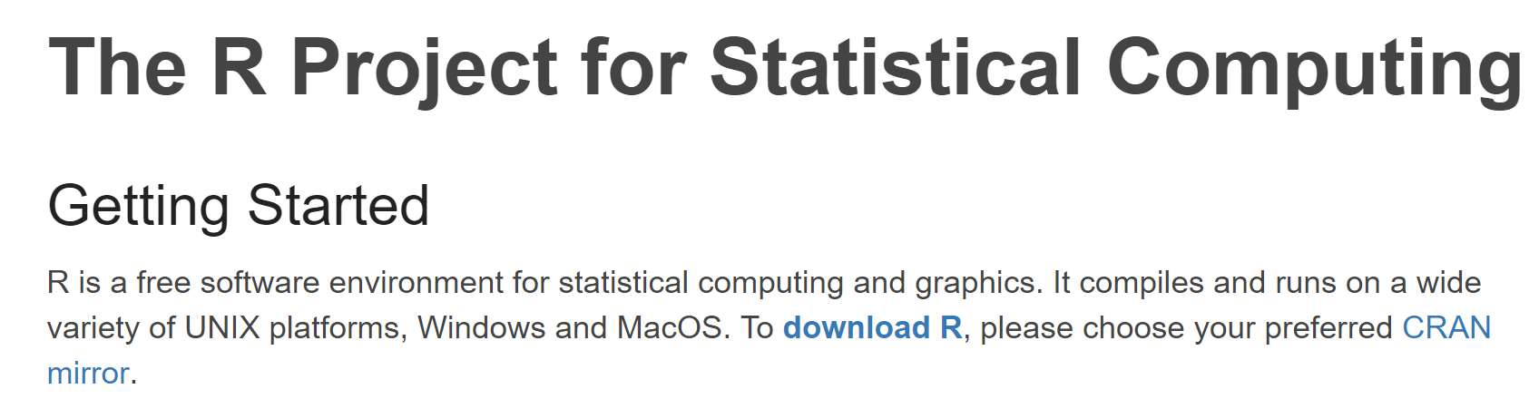

Select a mirror site in the USA:
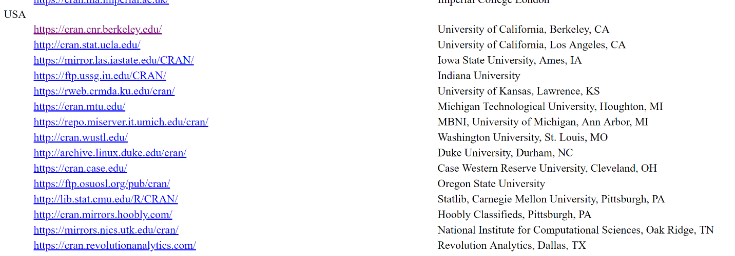

Download R for your operating system:
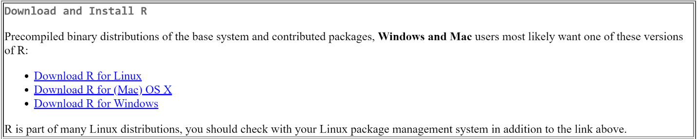

Select the base version:
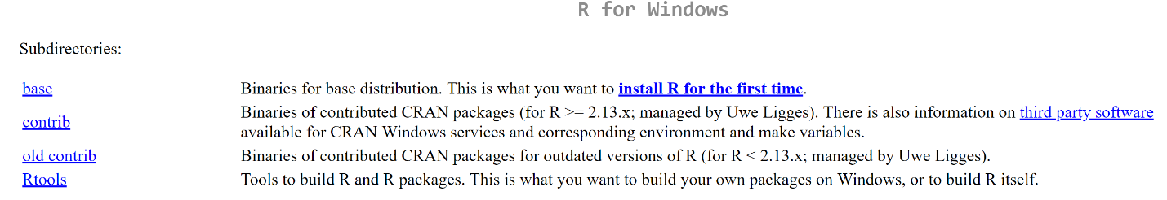

Click the Download option:
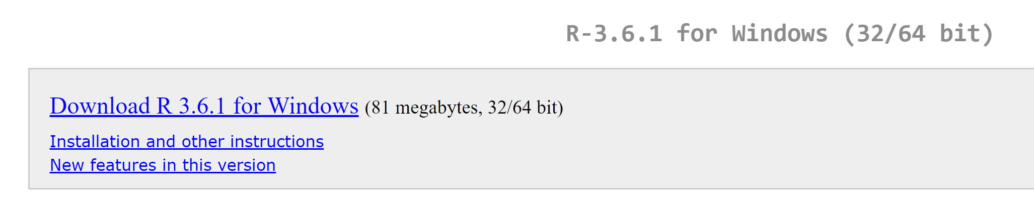
Once the download completes, double-click the file downloaded to install.
Select OK for English:
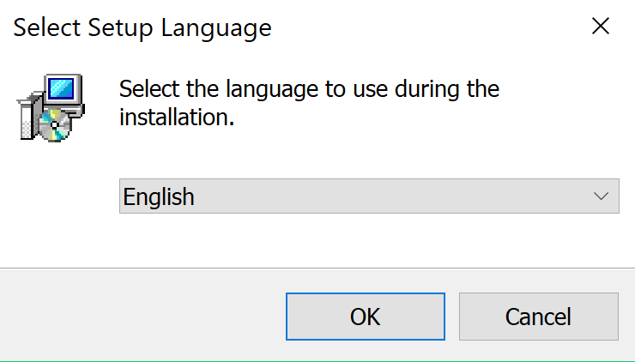

Select Next:
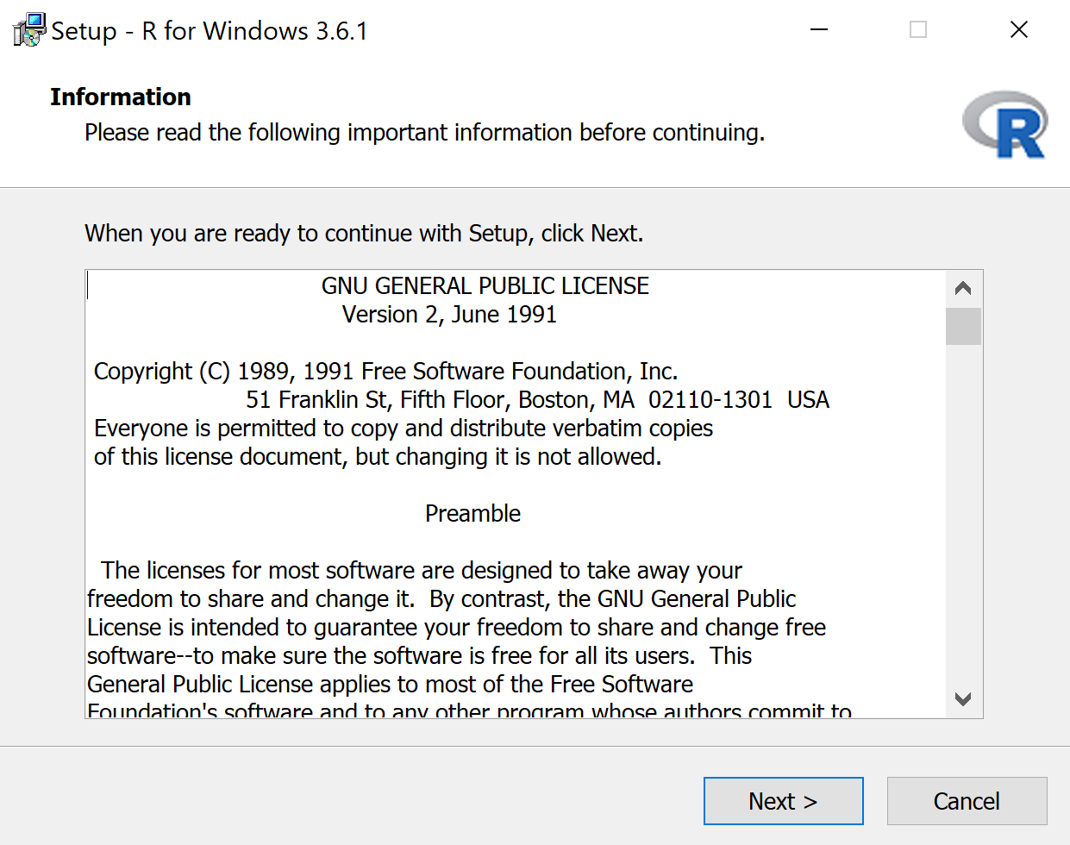

Select Next:
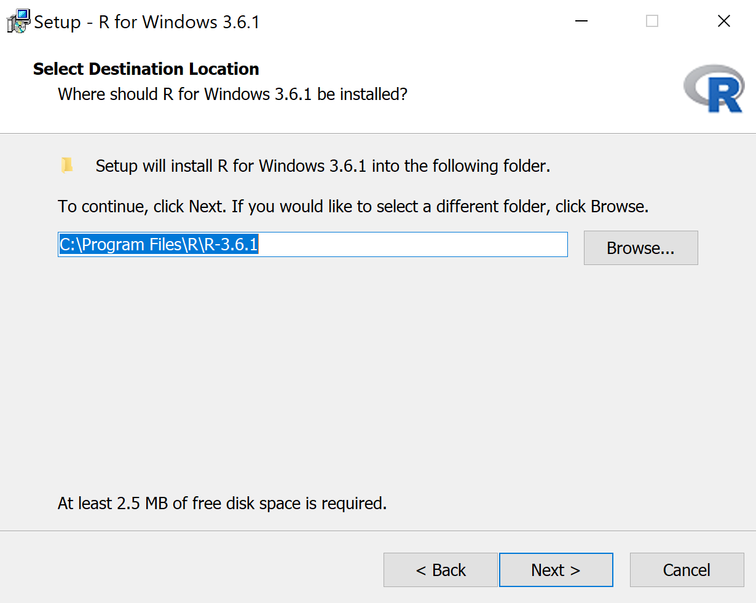
Select Next:
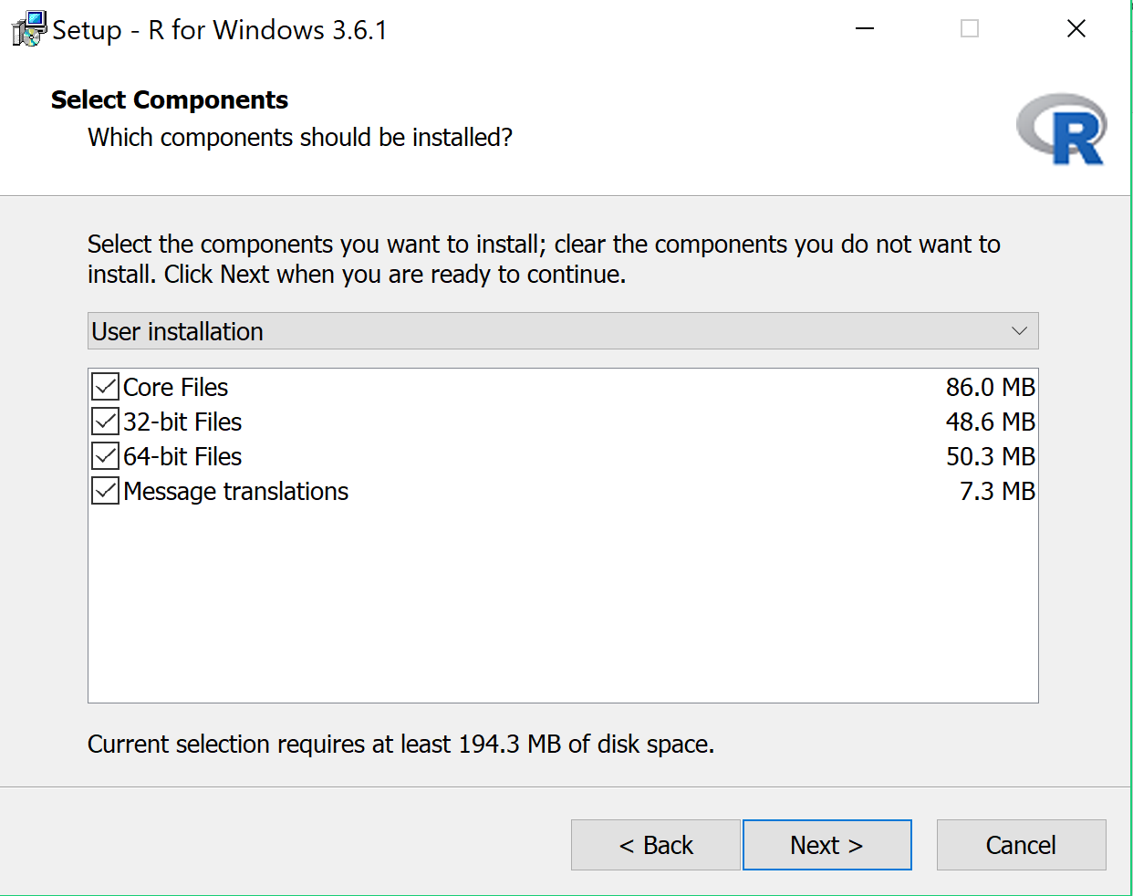
Select Next:
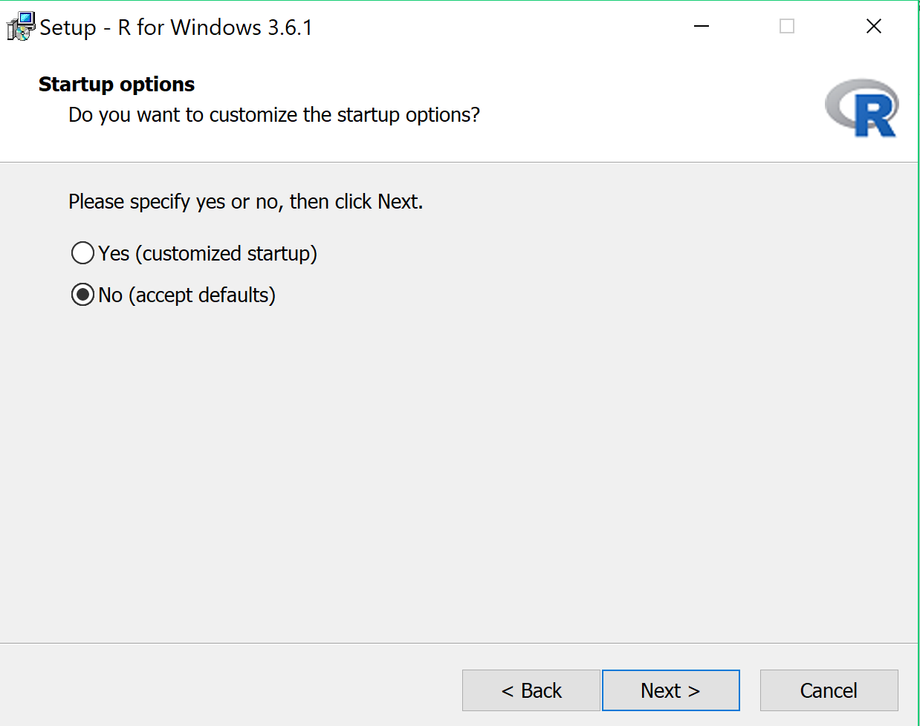

Select Next:
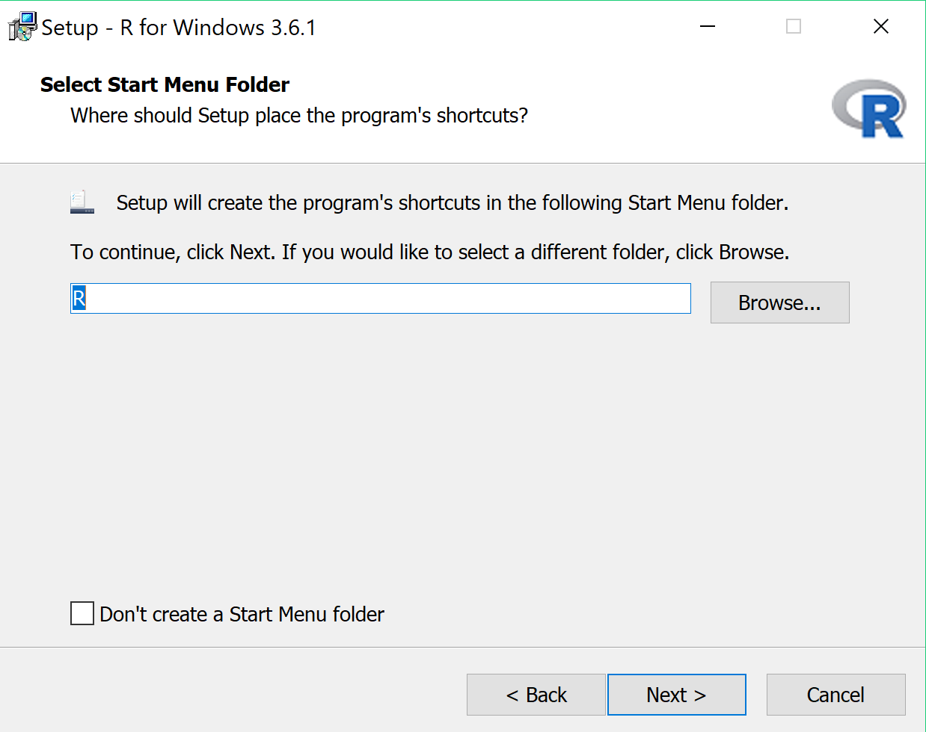
Select Create a desktop shortcut and then Next:
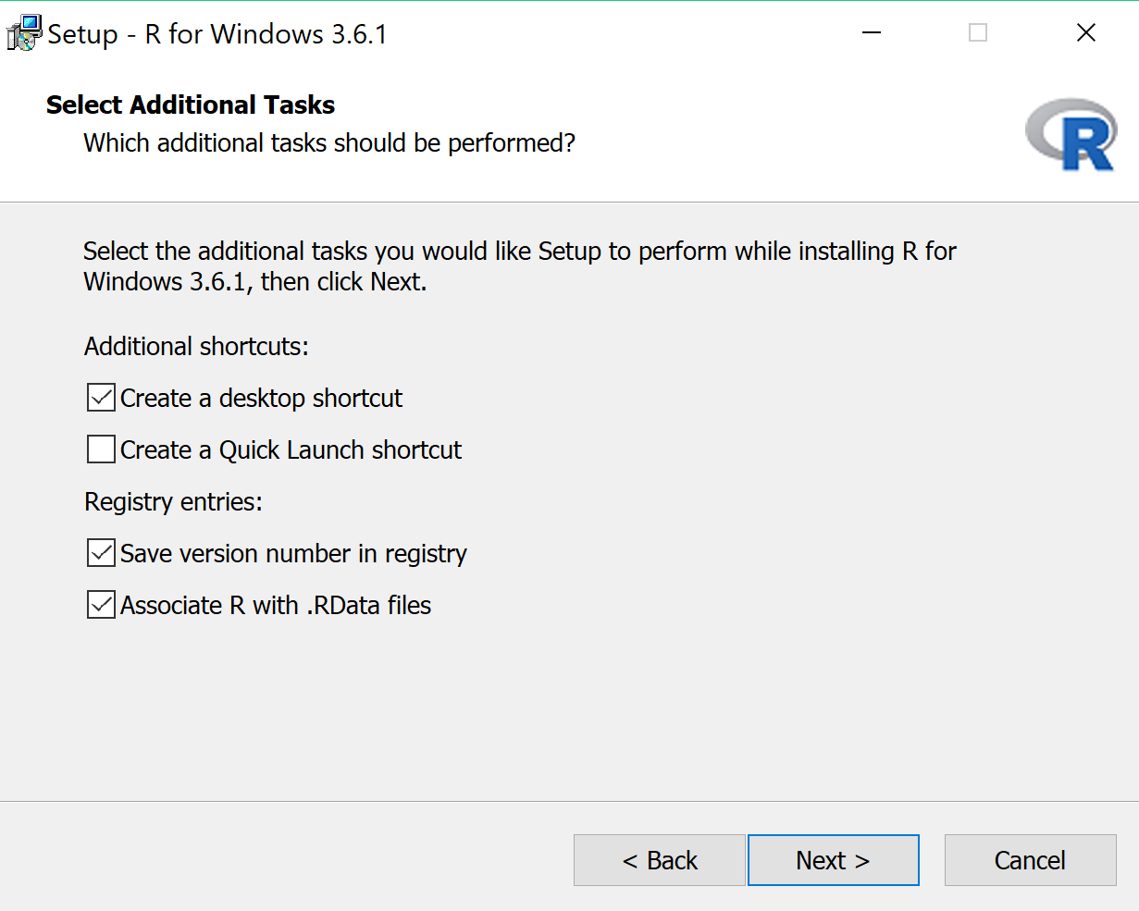
Click Finish:
