R Studio Installation Instructions
https://www.rstudio.com/products/rstudio/download/#download
NOTE: Be sure to get the free version and have R installed first.
Download the correct version for your operating system.
R S 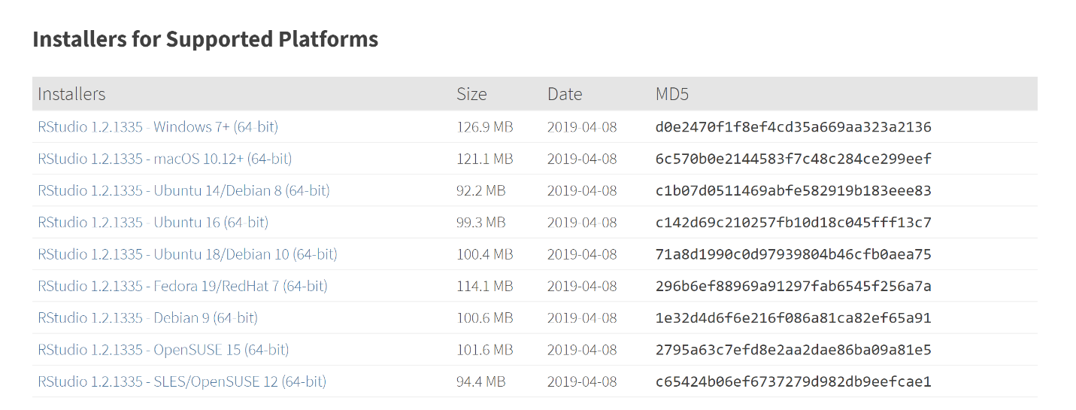
Once the download completes, double-click to install.
Click Next:
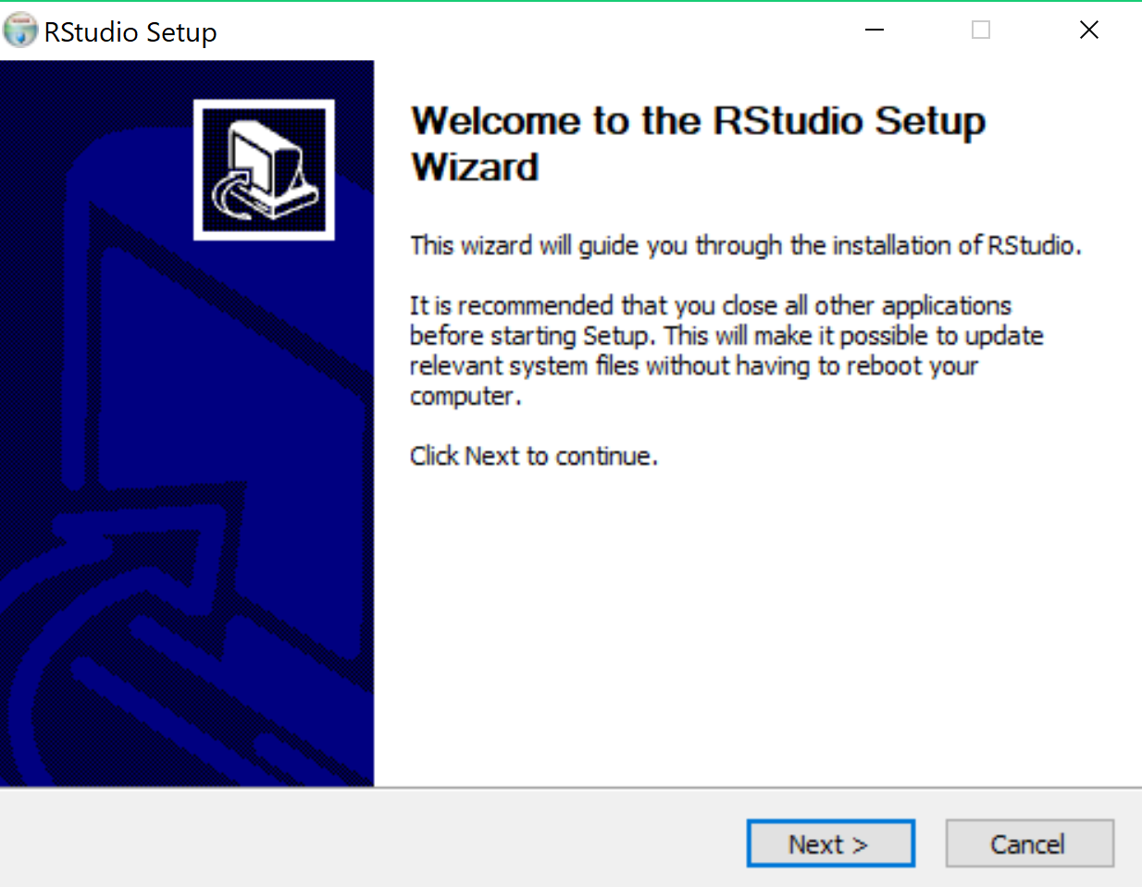

You can change where to install and/or click Next:
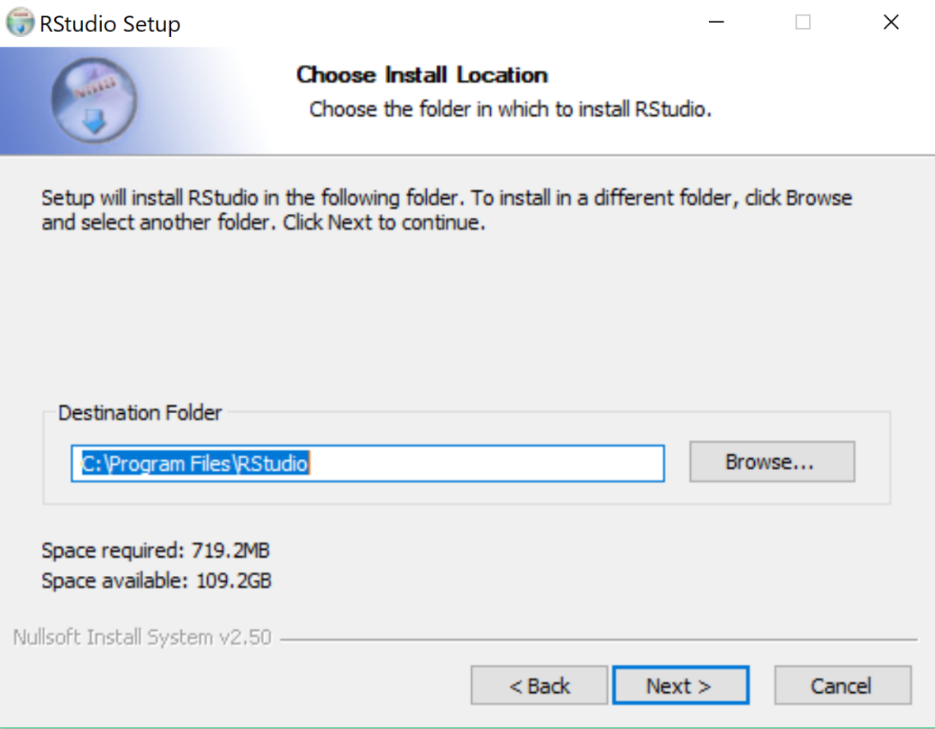

Click Install:
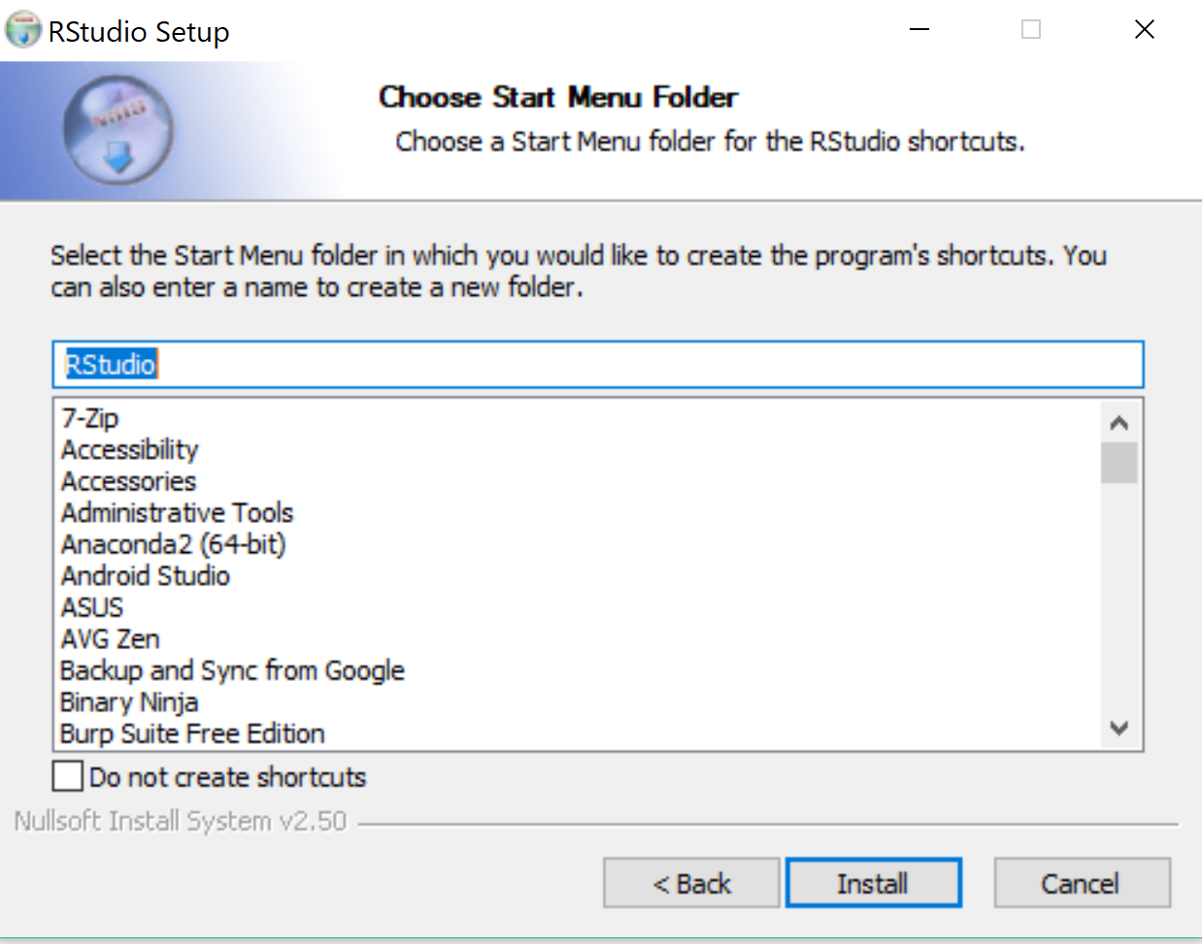

Click Finish:
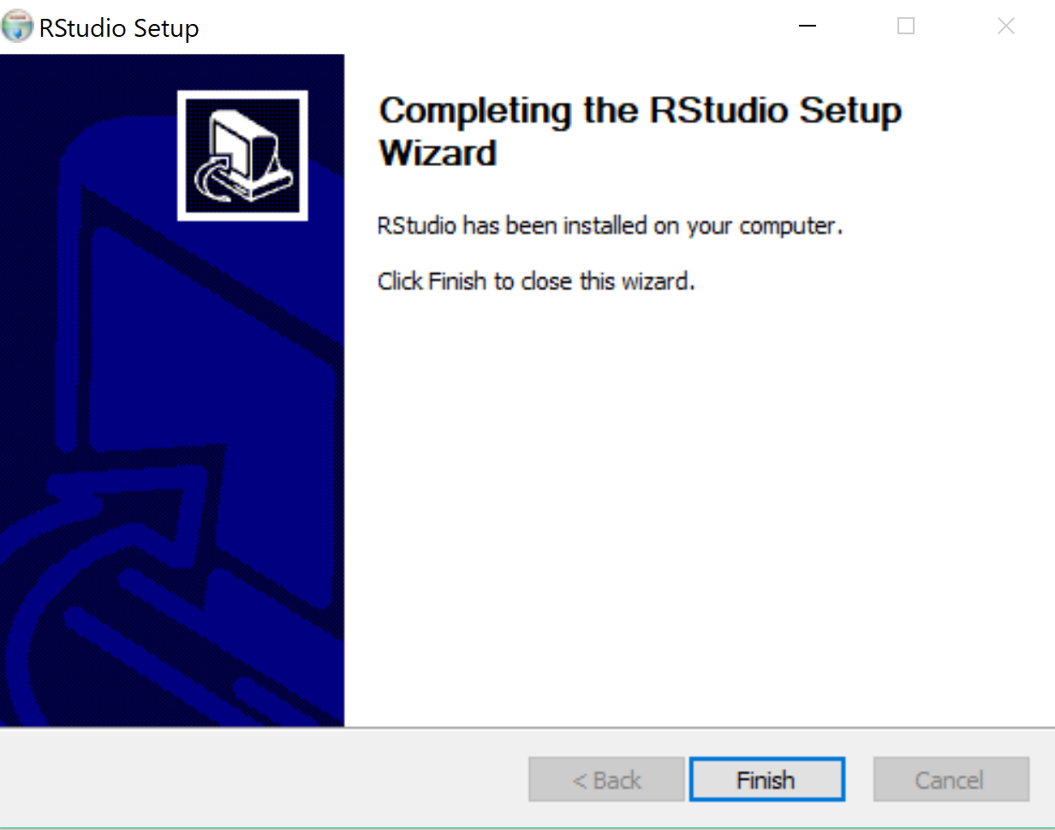
Start R Studio and you should see:
