Installing Hortonworks Hadoop HDP

To be able to run the Hadoop environment, you must download VirtualBox first. Select the proper platform package to match your operating system. This demonstration uses a Mac.

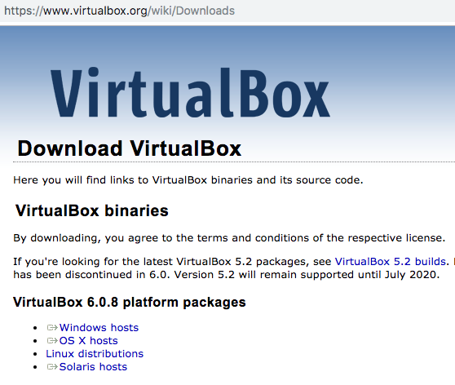

After clicking the OS X hosts for MAC, you will see the DMG file download:

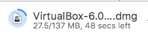

Once completed downloading, double-click on the DMG file to install:

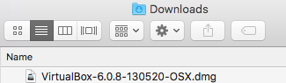

You then double-click the VirtualBox.pkg and open VirtualBox from the Applications folder:

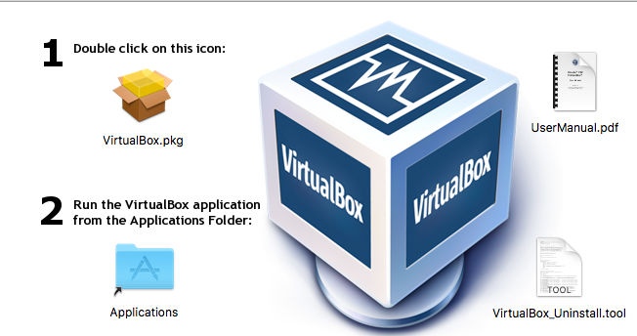

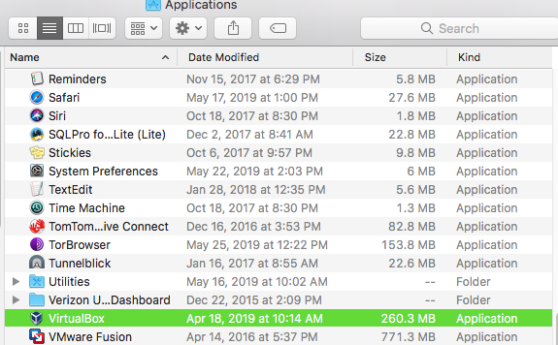

Then download the Hortonworks Hadoop HDP Sandbox:

Then select the VirtualBox installation type and click LET’S GO! ->:

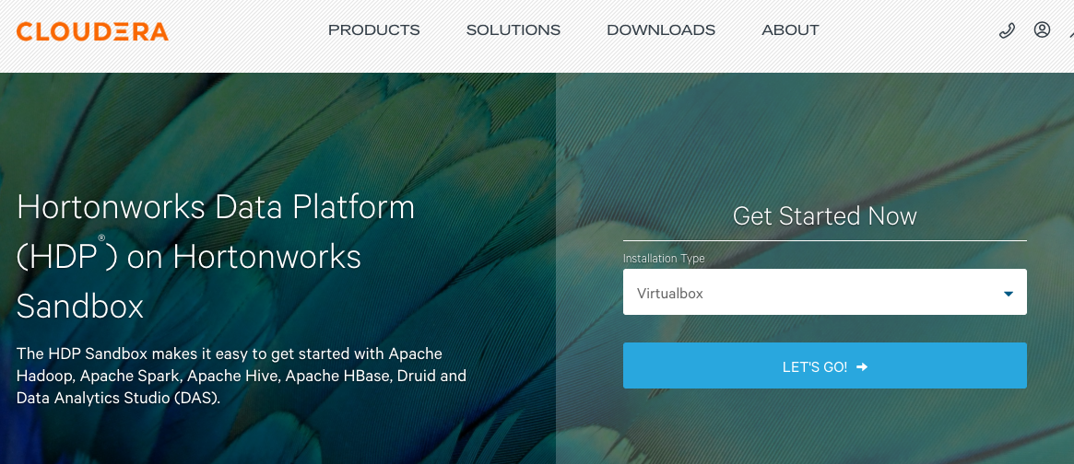

Fill out the form and select CONTINUE:

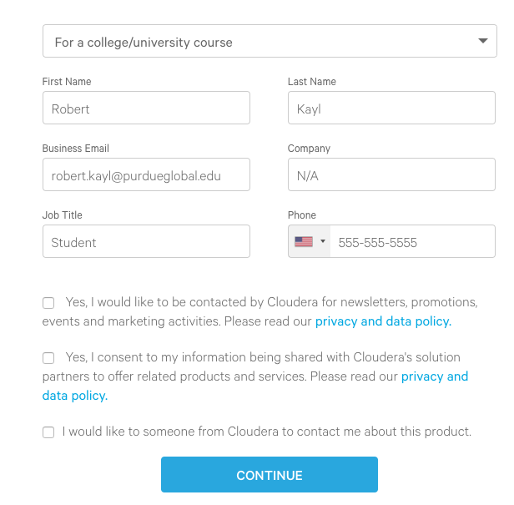

Accept the terms and click SUBMIT:

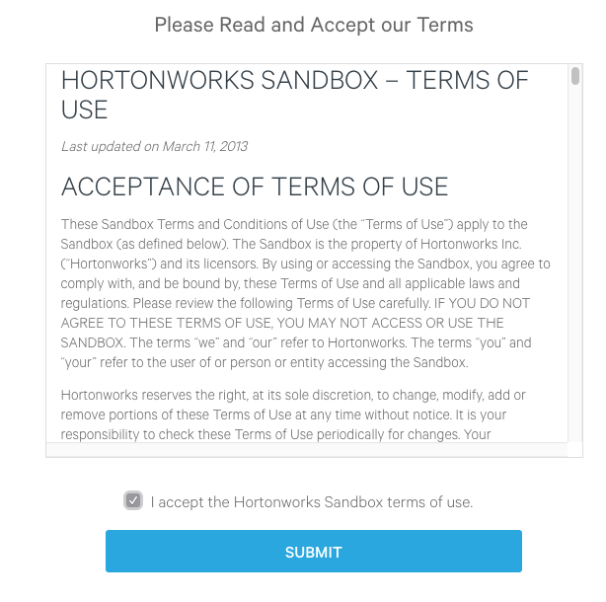

Select the latest version button. In this case, the HDP SANDBOX 3.0.1 (LATEST) button:

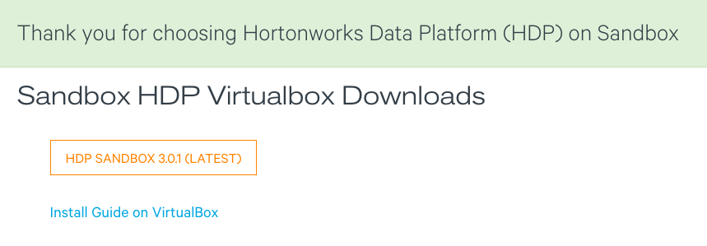

Once downloaded, follow the link called “Install Guide on VirtualBox” as shown above:

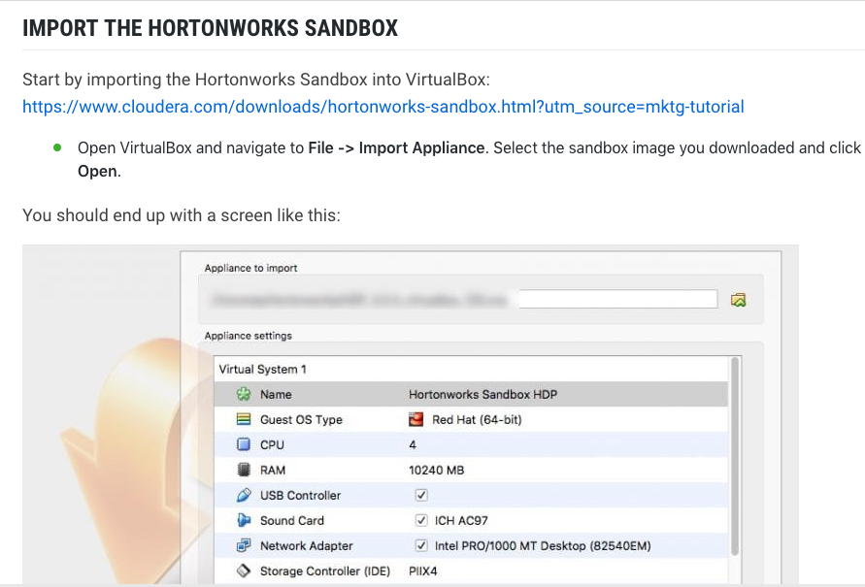

Reminder that the file downloaded is called HDP_3.0.1_virtualbox_181205.ova and in the Download folder. The version may change as you download the latest:

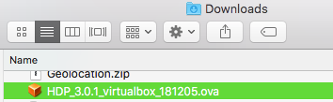

Once you imported the OVA file, you start Hadoop in VirtualBox:

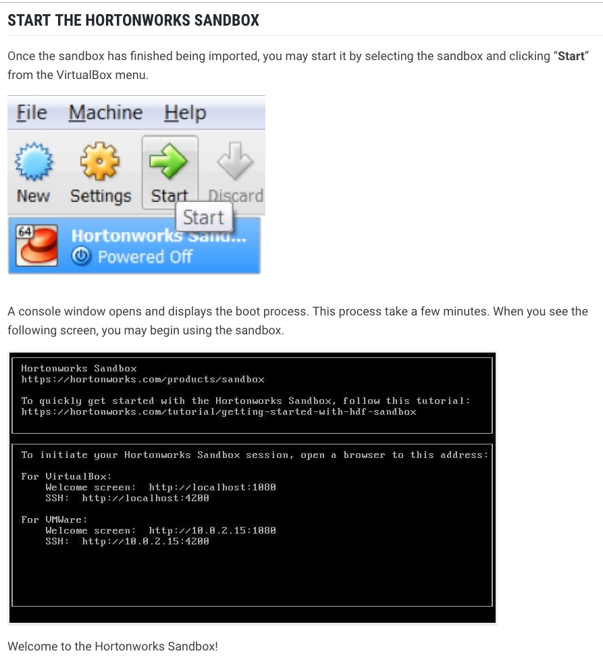

Then you can use your web browser and go to localhost:1080. Click LAUNCH DASHBOARD to see the Hadoop components of the ecosystem:

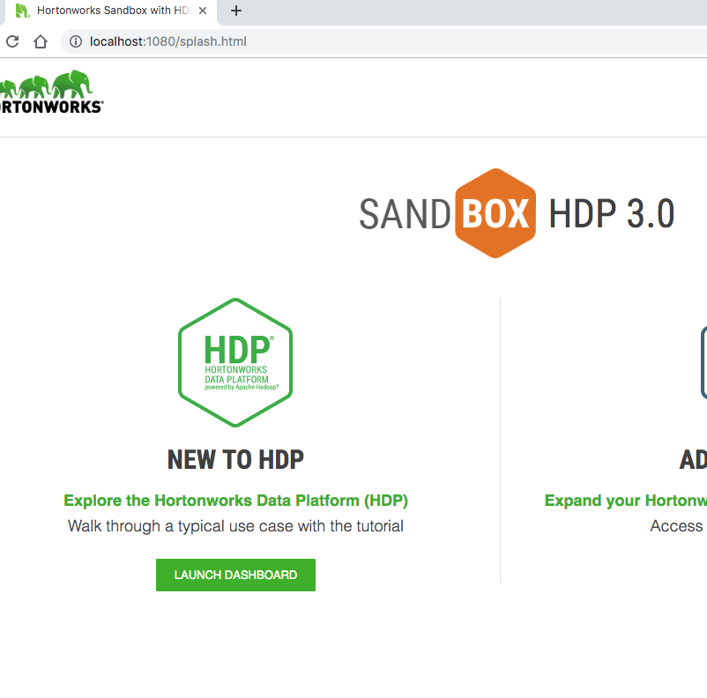

You can use many accounts. This example uses the maria_dev login/password:

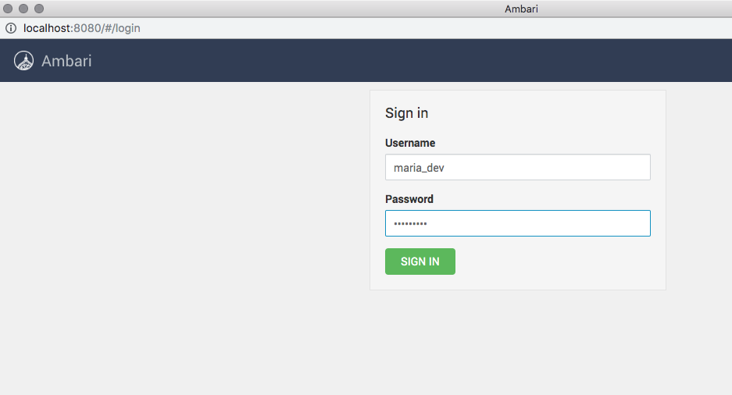

You will then see the dashboard as the user you logged in with:

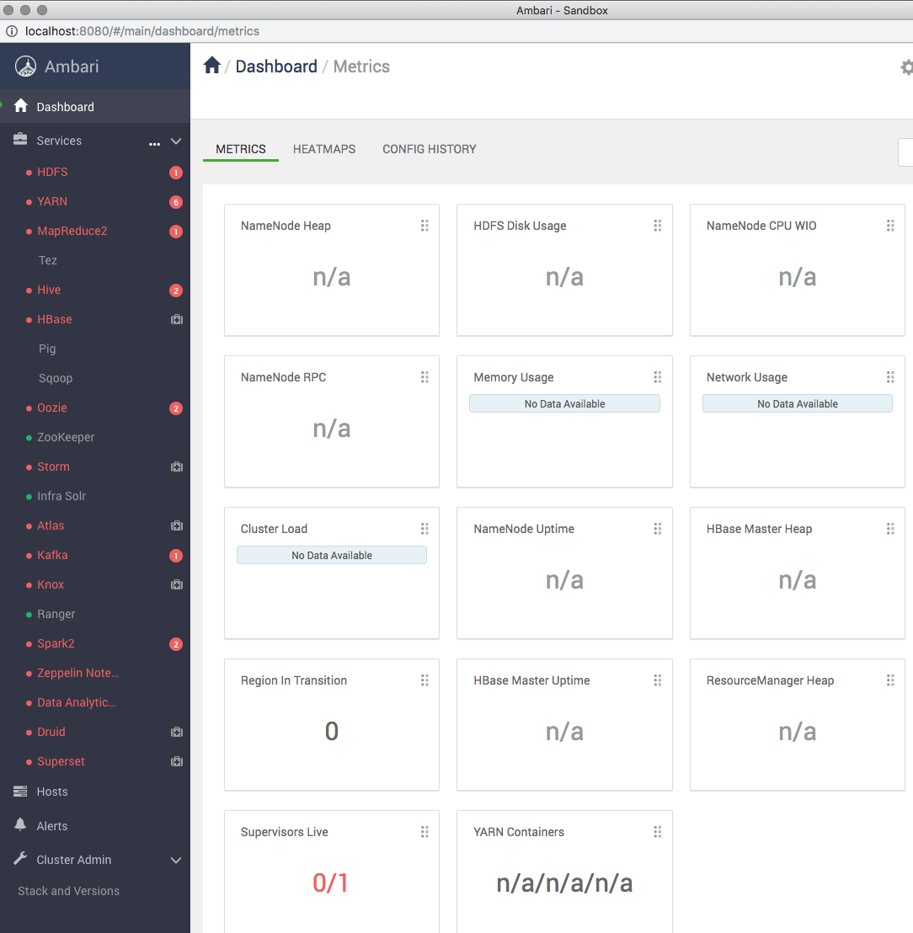

For SSH, use localhost:4200. Your first login for root has the Hadoop password. You may be prompted to change. Once you do that, login using the new credentials:

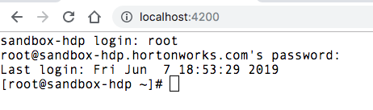

You will have assignments that use SSH and this environment allows you to complete those assignments. You can use a shell, or command prompt, or Putty™ if you desire as well. The above requires no new software though and is the recommended method.

