**SQL Server Express Setup**

Download [SQL Server Express](https://www.microsoft.com/en-us/sql-server/sql-server-editions-express)

Click the link above and then click the Download now button:

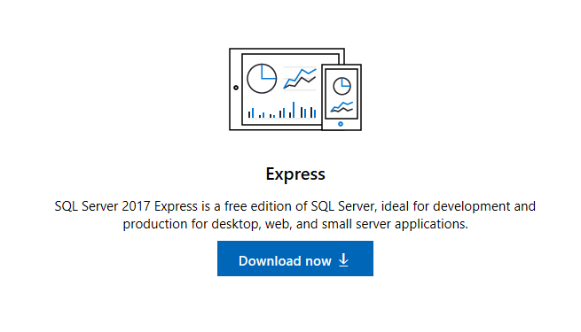

Then click Run:



Then click Basic:

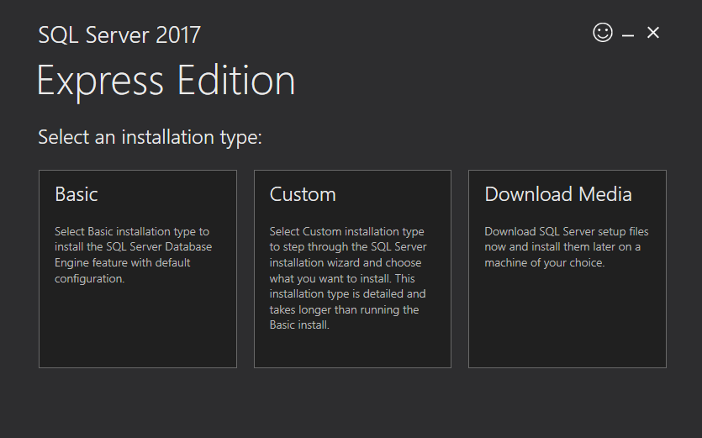

Accept the license:

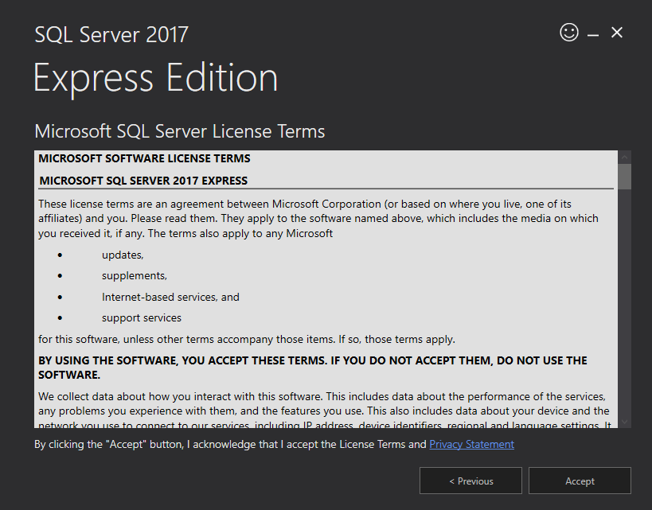

Then click Install: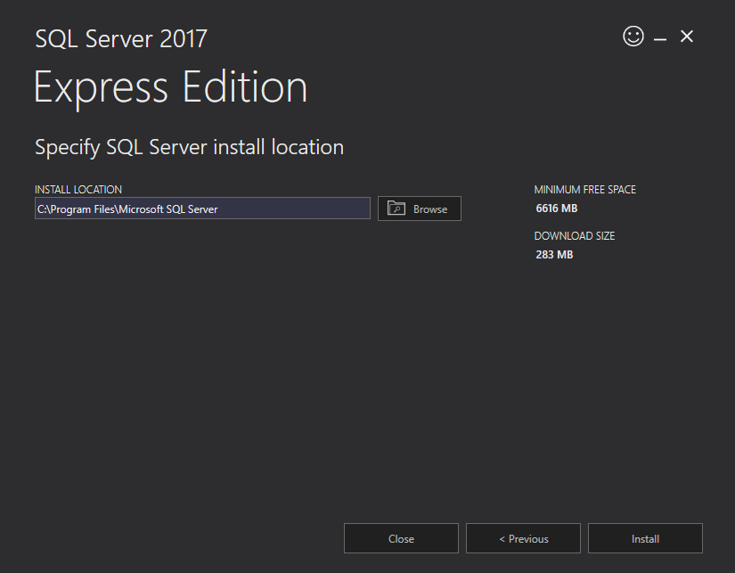

Click the Install SSMS button: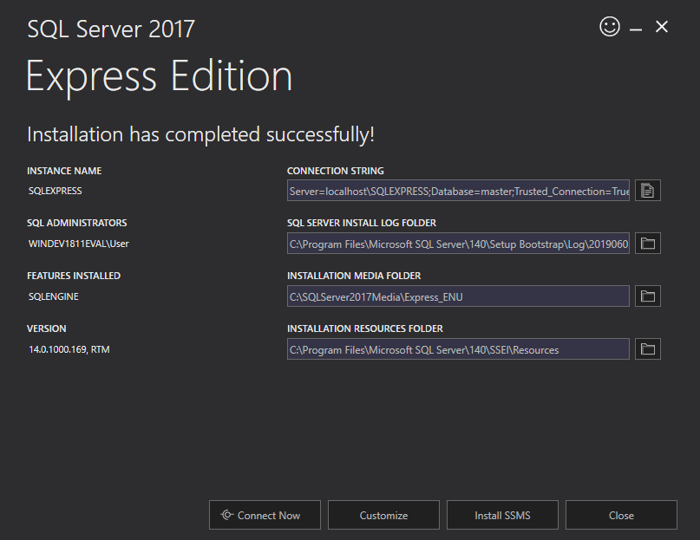

Download [SMSS](https://docs.microsoft.com/en-us/sql/ssms/download-sql-server-management-studio-ssms?view=sql-server-2017):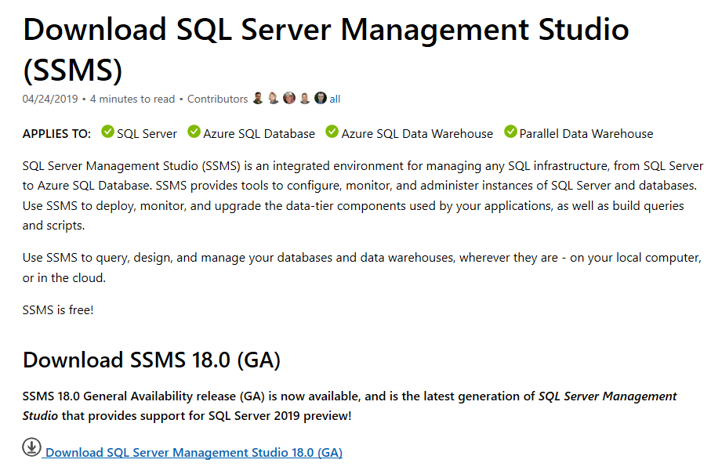

Click Run:Image showing SSMS Run option pop-up.

Once downloaded, double-click the SMSS-Setup-ENU.exe file:

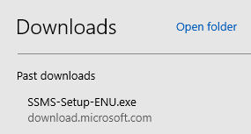

Click the Install button:

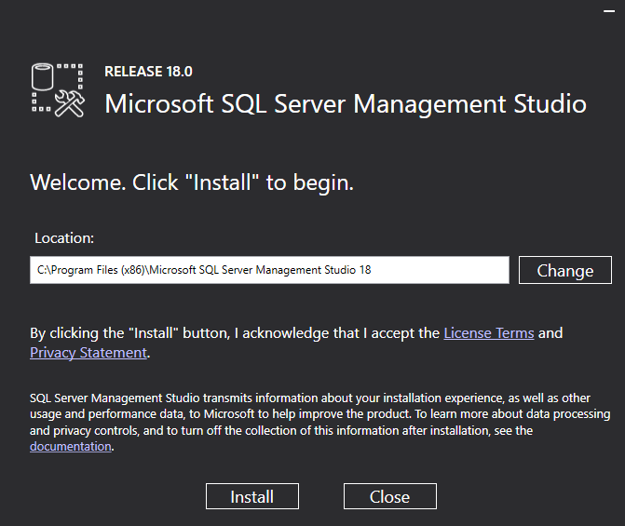

Restart your computer or virtual machine: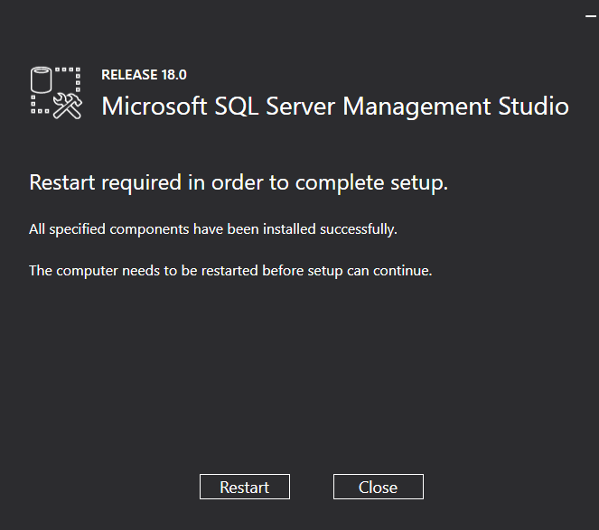

Once restarted, download the [AdventureWorks2017 backup](https://github.com/Microsoft/sql-server-samples/releases/tag/adventureworks):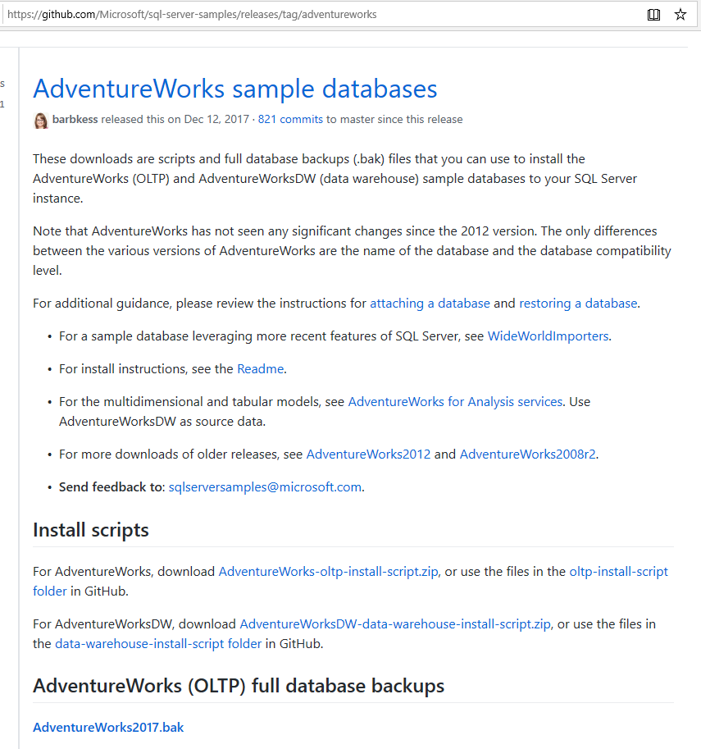

Once the AdventureWorks2017 backup is downloaded, start Microsoft SQL Server Management Studio (SSMS) and click connect using these steps: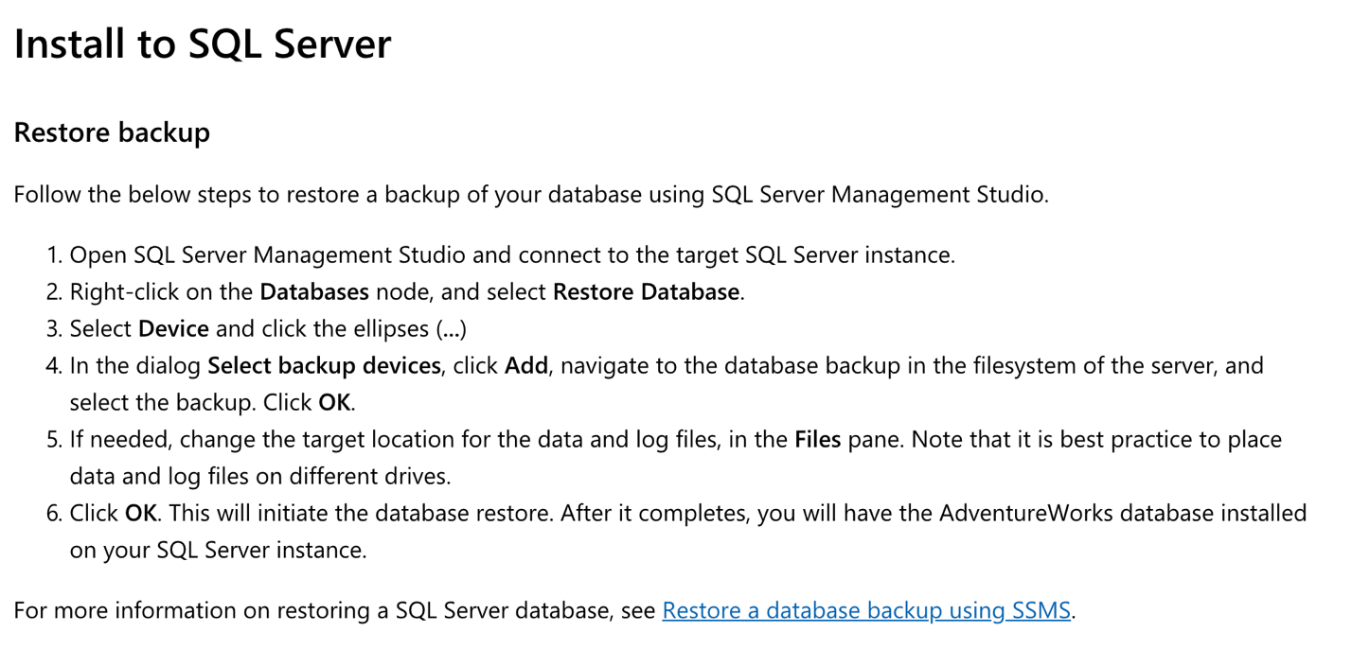

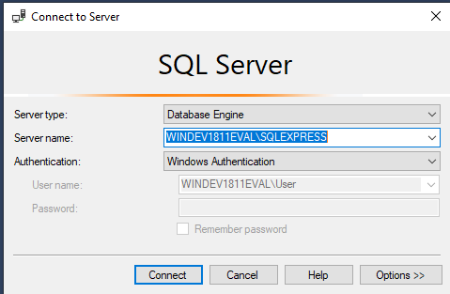

Right click database and select restore database:

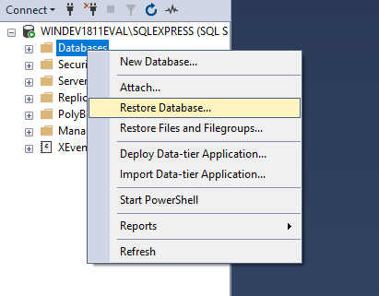

Add the backup file: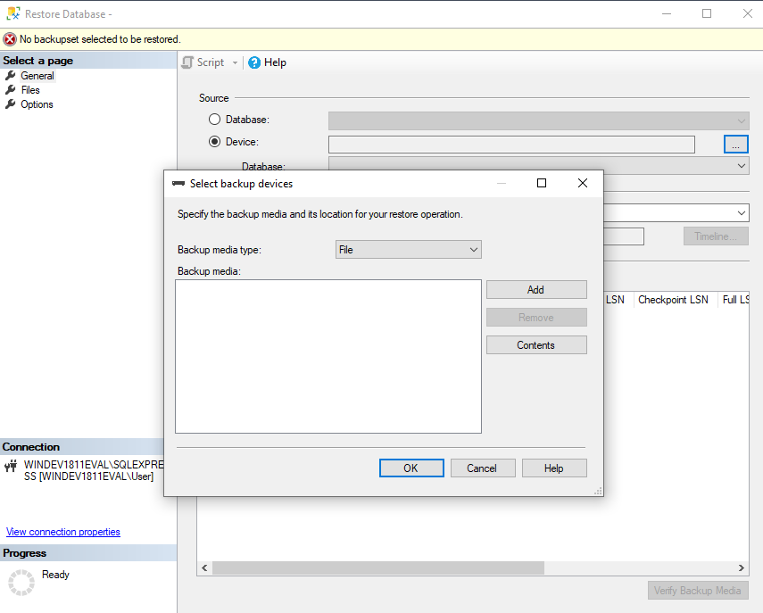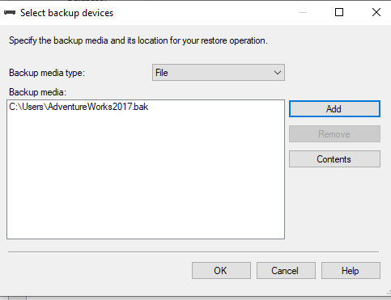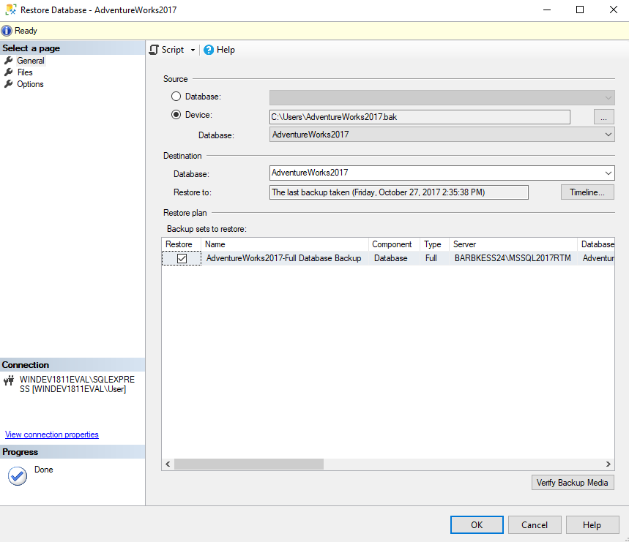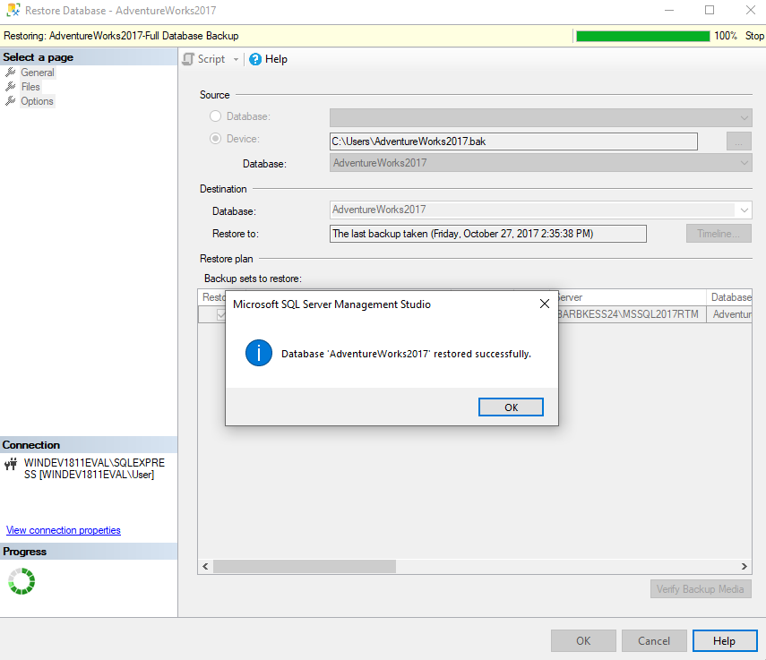

You should see the database restored as below:

Image showing database restored in the folder
