AWS-SHELL Walkthrough

Open A Cloud Guru
Open the AWS Sandbox
Log in with the provided username and password (Your password will be different)
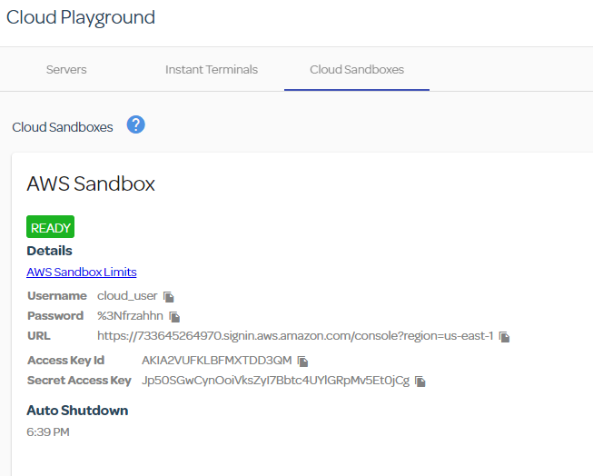
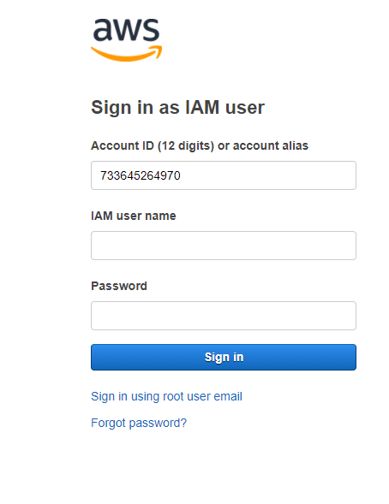
Click the arrow next to all services
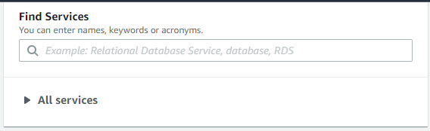
Click on Cloud9 under developer Tools
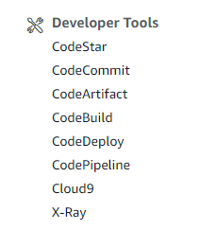
Click Create Environment
Name your environment (IT306_Lastname_Firstname)
Click Next Step
Keep the defaults and click Next Step
Click Create Environment
It will take some time for the environment to be created:
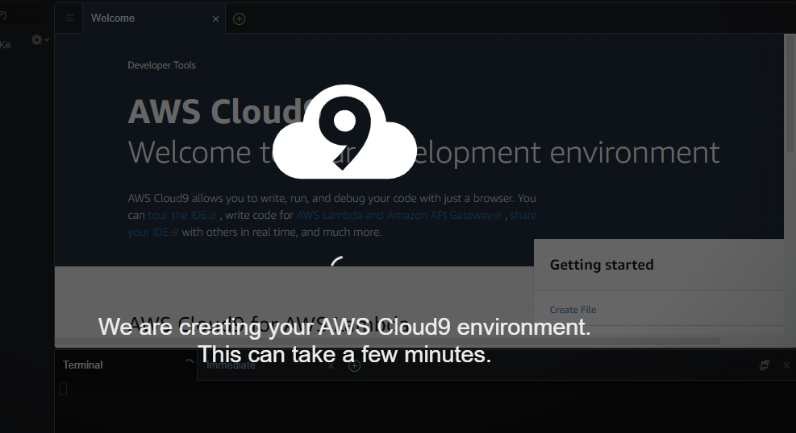
When done you will see:
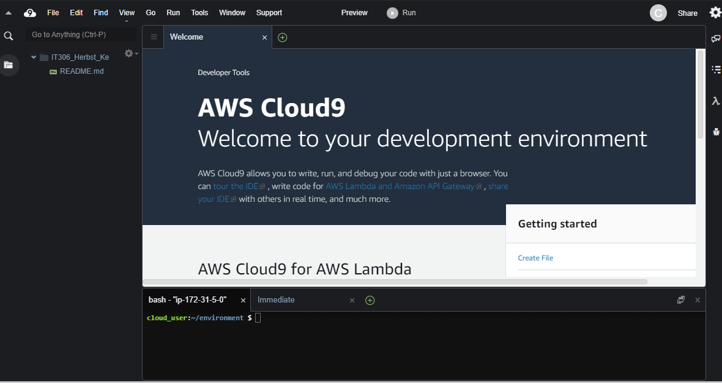
Check if Python 3.6 and pip are installed
Execute at command prompt: pip --version

Check to see if aws-shell is installed
Execute at command prompt: aws-shell
If you see “-bash: aws-shell: command not found” then you do not have aws-shell installed.

Install aws-shell
Execute at command prompt: sudo pip install aws-shell

Check aws-shell installation
Execute at command prompt: aws-shell
You should see the command prompt “aws>”

Exit out of the aws-shell
Execute at command prompt: .exit

Create a text file
Execute at command prompt: Nano testfile.txt

Enter in the text: This is a test file.
Save the file (CTRL-X)

Open the aws-shell
Execute at command prompt: aws-shell

Create a S3 Bucket
Execute at command prompt: s3 mb s3://test-cloud9-bucket

Copy the file to the S3 bucket
Execute at command prompt: s3 cp testfile.txt s3://test-cloud9-bucket/testfile2.txt

Verify the file was copied
Execute at command prompt: s3 ls s3://test-cloud9-bucket

Remove the file
Execute at command prompt: s3 rm s3://test-cloud9-bucket/Testfile2.txt

Remove the S3 bucket
Execute at command prompt: s3 rb s3:test-cloud9-bucket

