Deploying and Updating Applications with Elastic Beanstalk

This walkthrough consists of the steps in the following videos on A Cloud Guru:
- Elastic Beanstalk 101
- Deploying An Application With Elastic Beanstalk – Demo
- Updating Elastic Beanstalk
- Updating An Application In Elastic Beanstalk - Demo

The videos can be accessed by the following steps:
1. Log into A Cloud Guru.
2. Click on the search icon on the right of the banner to search
3. Search for “AWS Certified Developer - Associate 2020”
4. Select the “AWS Certified Developer - Associate 2020” course
5. Click on the appropriate video to watch

Video: Deploying Apps With Elastic Beanstalk:

Open The Cloud Sandbox:
From anywhere within A Cloud Guru click on Playground at the top navigation bar:
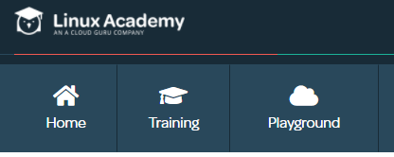
Next select Cloud Sandboxes
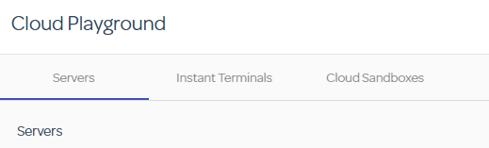
Next click on Start AWS Sandbox Access
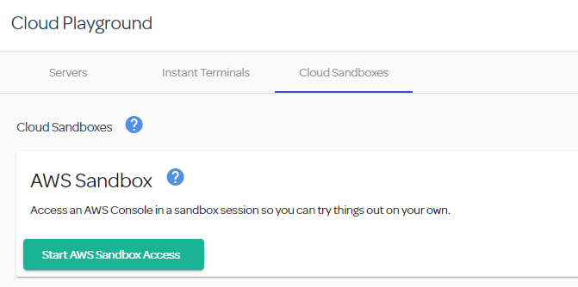
Right click on the Open Sandbox button and open in an incognito window
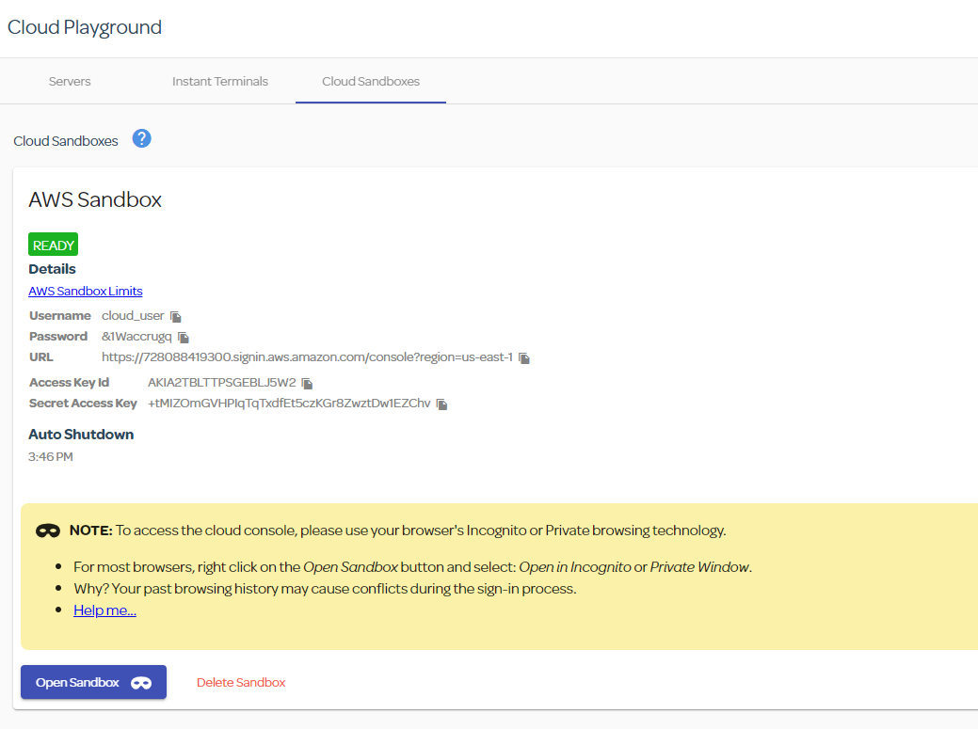
Enter the IAM UserName and Password from the previous page (you can copy the information by click on the copy icon after each item) and click sign in.

Click the arrow next to All Services and under Compute you will see Elastic Beanstalk
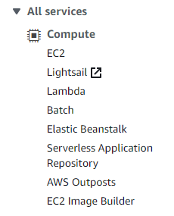
Click Elastic Beanstalk
Click the Create Application button in the Orange Box
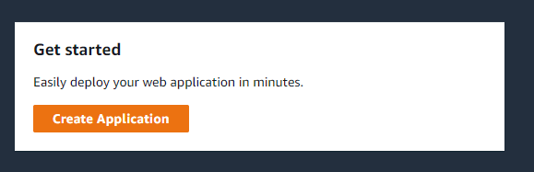
Enter in an Application Name (IT304Unit7-LastName)
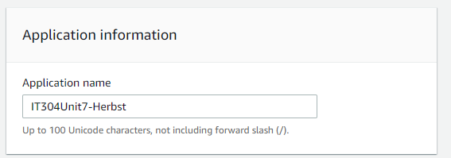
Under Platform, Select PHP
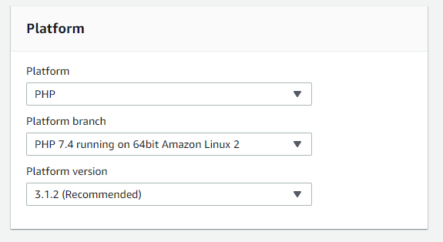
Under Application Code Select Upload your code
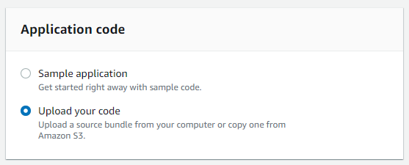
Click on Choose File
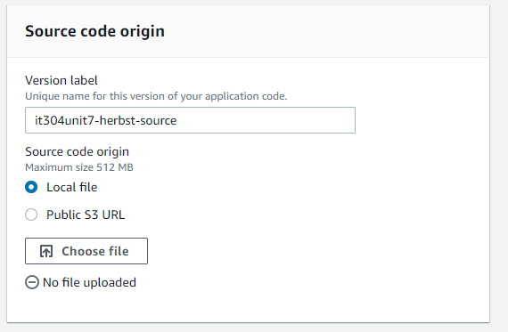
And navigate to where you have Website1.zip stored on your computer.
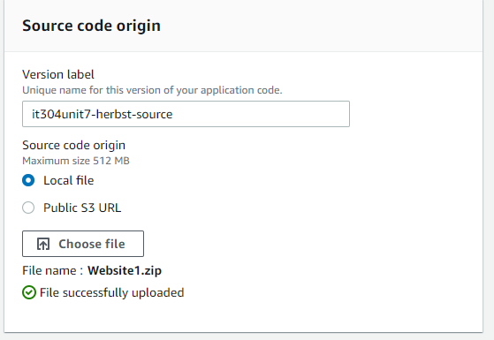
Click Create application


Your website will deploy
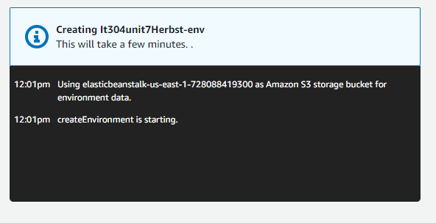
When it is done, the box will go away. Scroll down to Recent events and you will see the Successfully launched environment message.
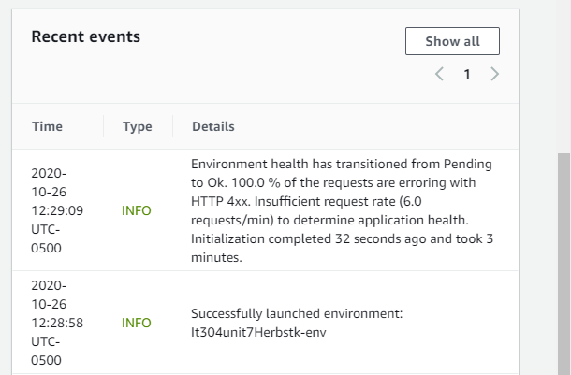
Above the recent events panel, you will see the health status and a hyperlink to open your application. Click on the hyperlink.


You are now able to see the website.

To verify what application version you are on, you can Click on Application versions from the left navigation pane.
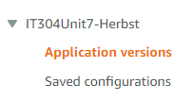
You will see all the versions that have been deployed
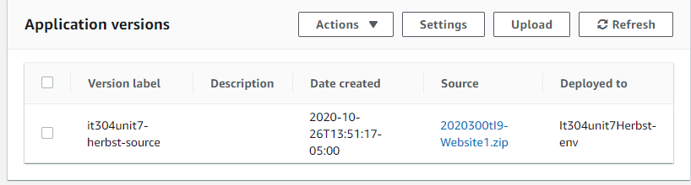

Now it is time to load a new version of our webpage. Go back to your environment, but clicking on the environment name
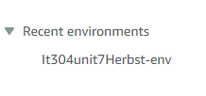
Click the Upload and deploy button
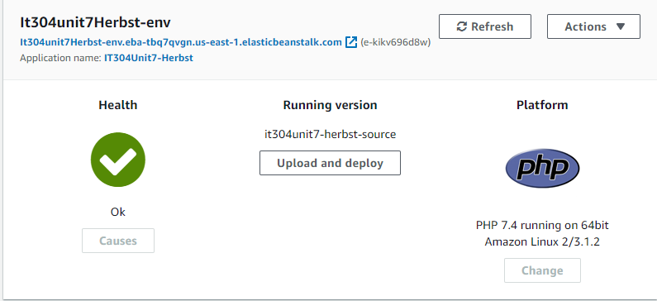
Click on Chose File
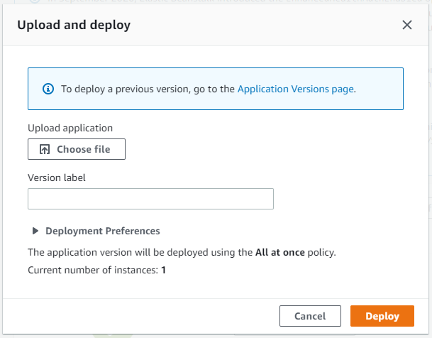
Select the new version of your website. In our case we will navigate to and select Website2.zip
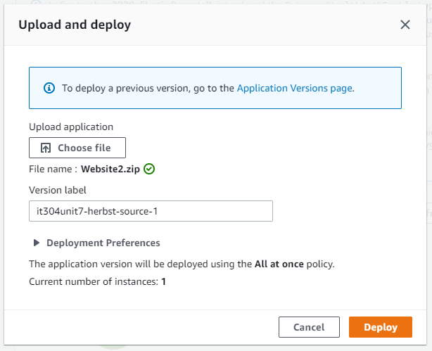
Click on Deploy
Once it is finished deploying, click on the hyperlink again.
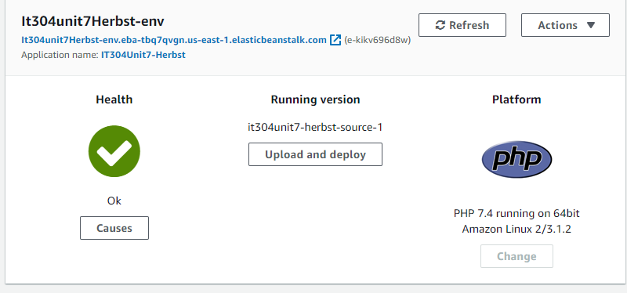

Now when you click on the hyperlink, you will get the new page. (If it shows the old page it may have cached and just click refresh).



Once you are complete, you can go back to the Sandbox and delete the sandbox to clean up.

