Guide to install Python on Windows Server

Click on Azure sandbox
Open Azure sandbox using incognito mode. (right click on the button and click open in incognito mode)
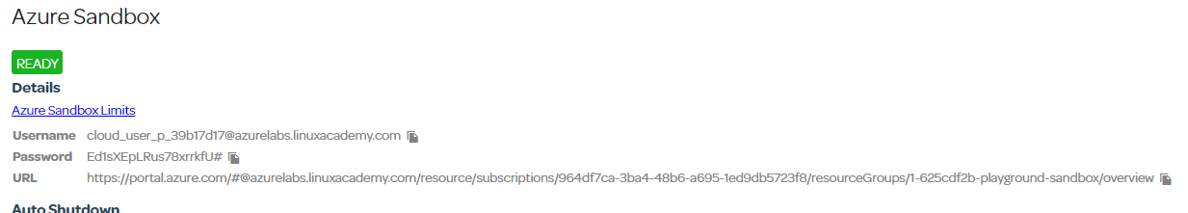

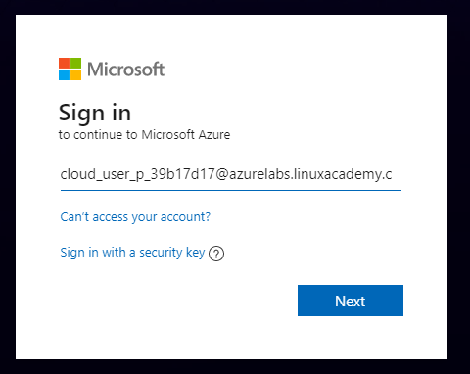
Enter in the username is shown. Click on the icon to copy to clipboard. Then click next.
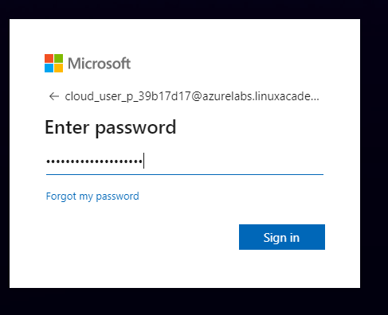
Enter the password and click Sign in.
Check the don’t show this again and click Yes
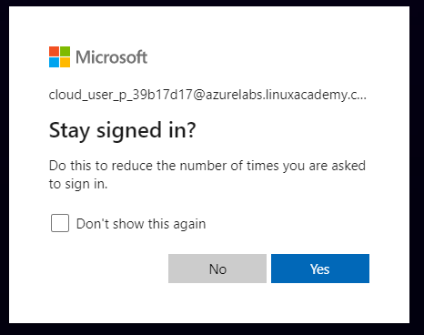
Click on Add at the top of the screen.
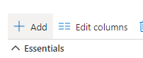
Select Windows Server 2016 Datacenter
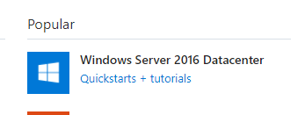 (if it is not shown click Get started)

Enter in a name for the server (IT305-LastName-FirstName)
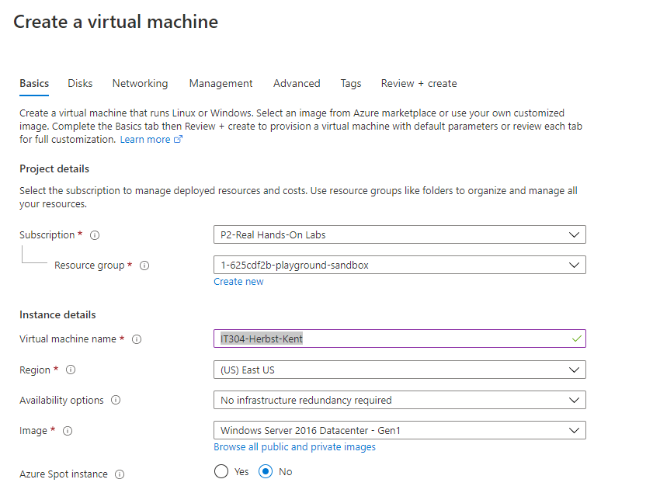
Scroll down and enter a username and password for the Administrator account
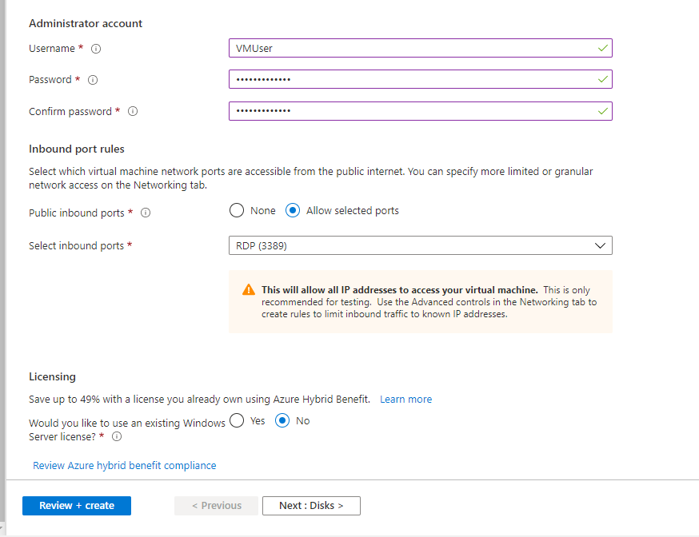
Keep everything else the same and click Review + create.
Click Create
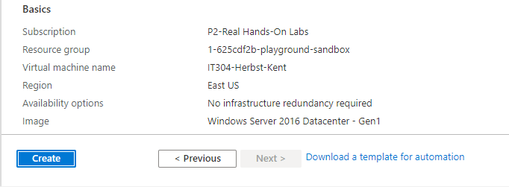
You will see deployment in progress
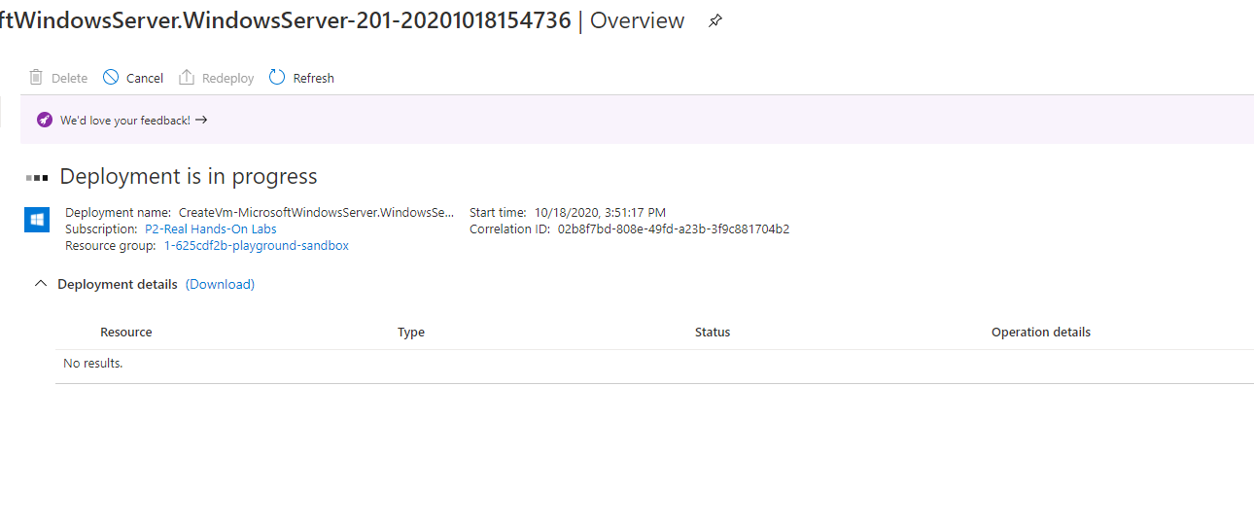
When it is done you will see Your Deployment is complete.
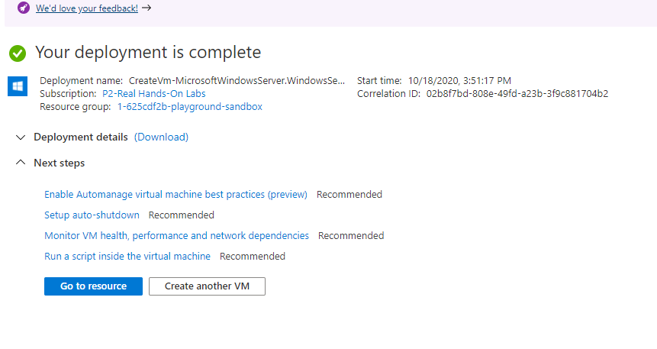
Click Go to resource
Click Connect in the upper Left and select RDP (if you are using Windows. If you are using MAC you can use SSH and use your terminal application).
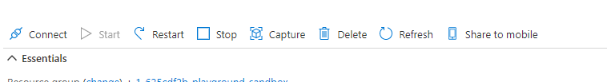
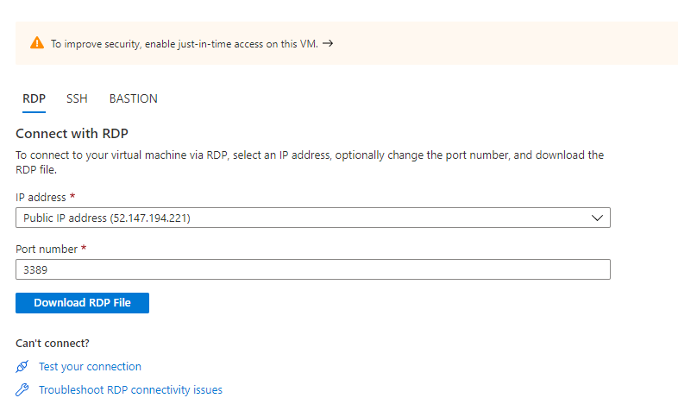
Click Download RDP File
Open the RDP file
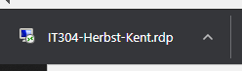
You can click Don’t ask me again for connections to this computer or not. Click connect.
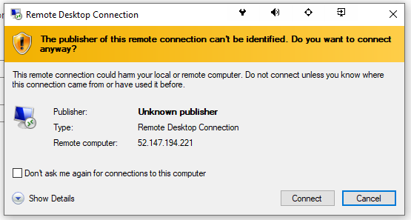
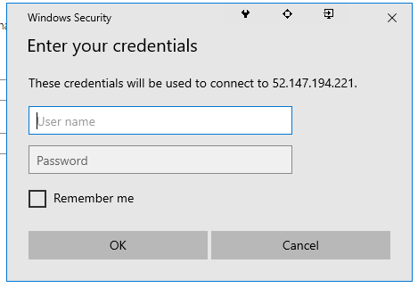
Enter the Administrator credentials you created before
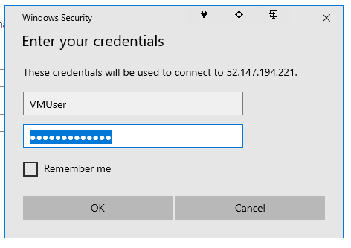
Click OK
You will be presented with another warning message
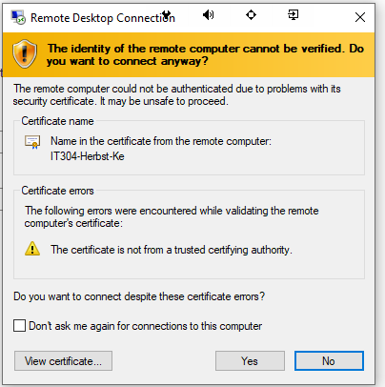
Click Yes
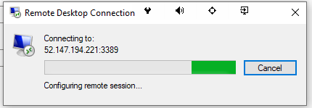
You will then be logged into your Datacenter version of Windows Server.
You can choose Yes or no to the next prompt
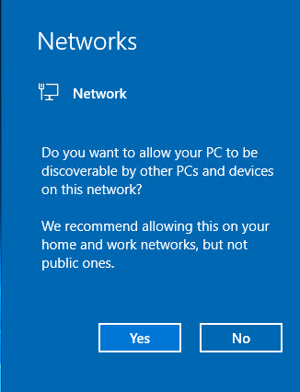
You will be presented with the Server Manager Dashboard
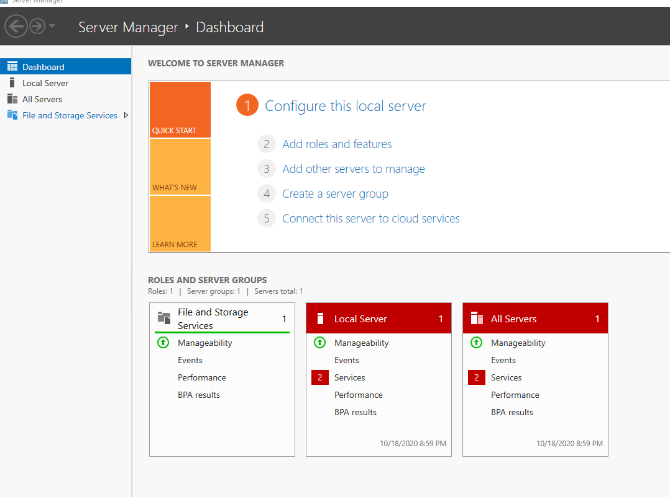
Open Internet Explorer
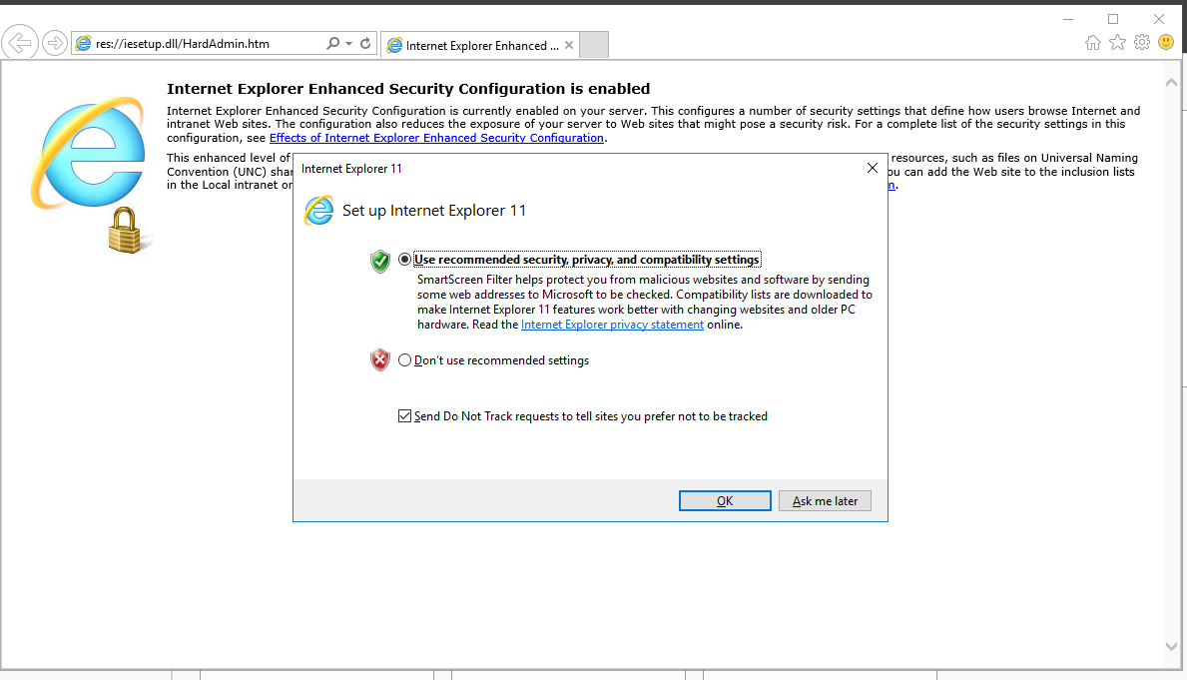
Click OK (unless you want to change the default search engine, etc.)
Enter www.python.org in the address bar
Click OK to the warning that shows
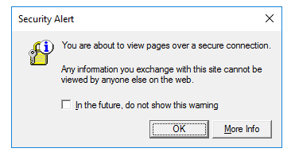
You will need to add the website
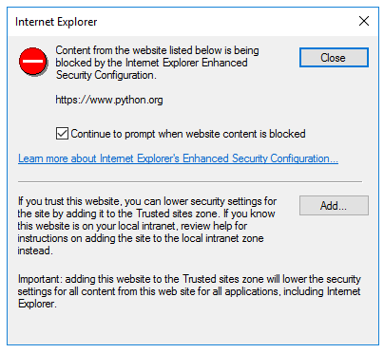
Click Add
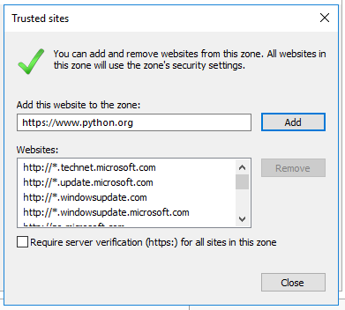
Click Add and then click Close
If prompted again, repeat the process
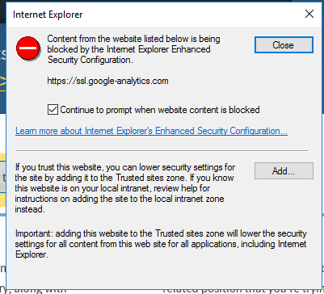
Click Downloads
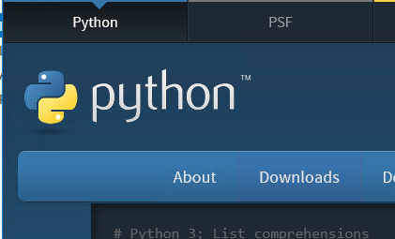
Click to download Python
Click Save
Then Run
Check the Add Python 3.9 to PATH checkbox and click Install Now
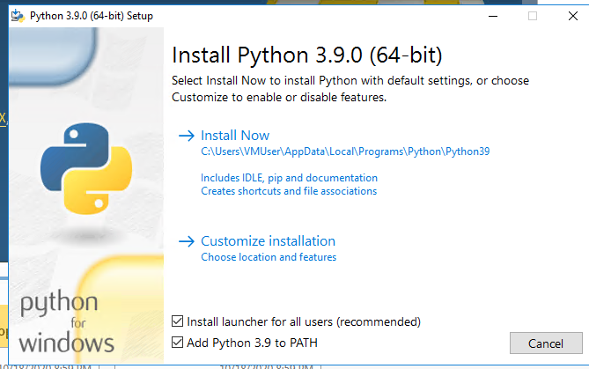
Install will start
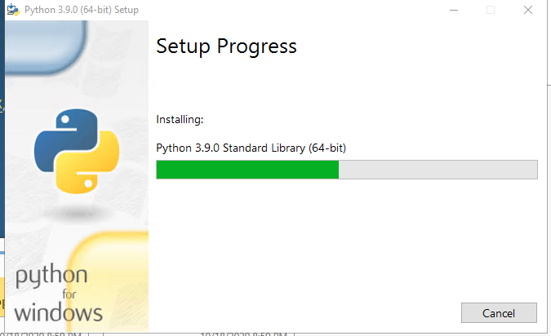
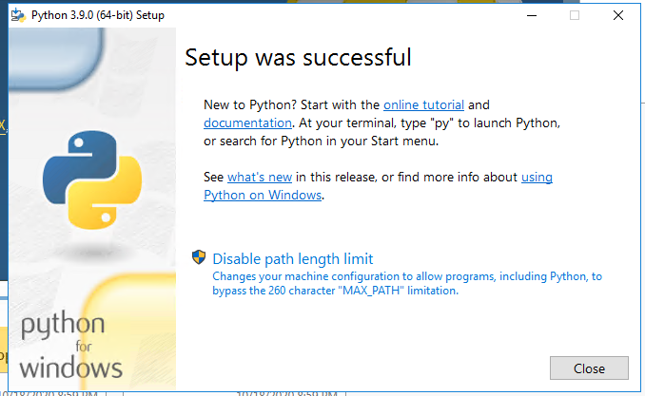
Click Close
Open File Explorer
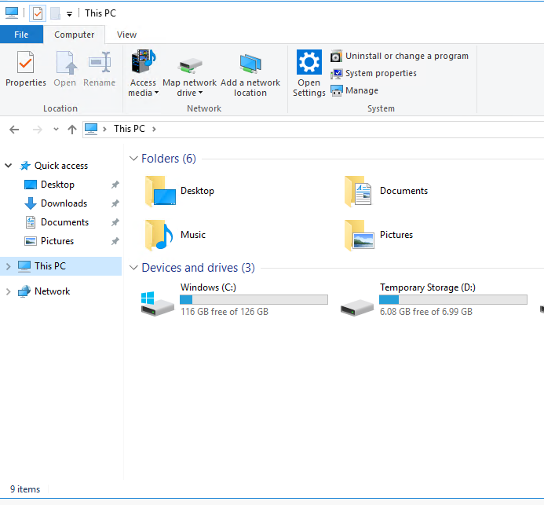
Click on This PC
Open Windows Drive C:
Create a new folder IT304 by clicking on the new Folder Icon
Open IT304
Right click in the window, select New, select Text Document
Name the file HelloWorld.py
Open the file
Copy in this code:
print("HelloWorld.")
Save the file
Click on the View Tab
Click File Name Extensions
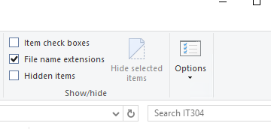
You will then see that your file is actually HelloWorld.py.txt
Rename the file to remve the .txt
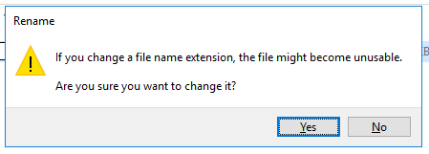
Click Yes
It will now show as a Python file.
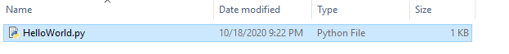
Click the magnifying glass and type cmd
Click on Command Propt
Type cd c:\IT304 and press enter
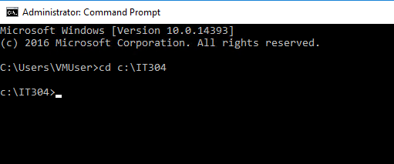
Type DIR and you will see our file
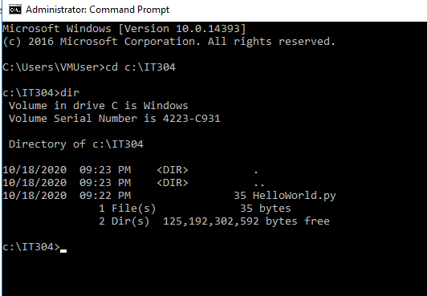
Type Python HelloWorld.py and press enter
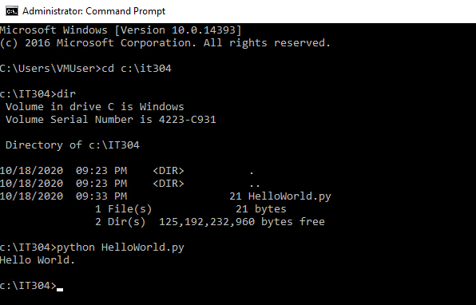
You have just run your program on a Windows Server on the Azure Cloud.
The other option is to right click on your file and choose Edit with Idle
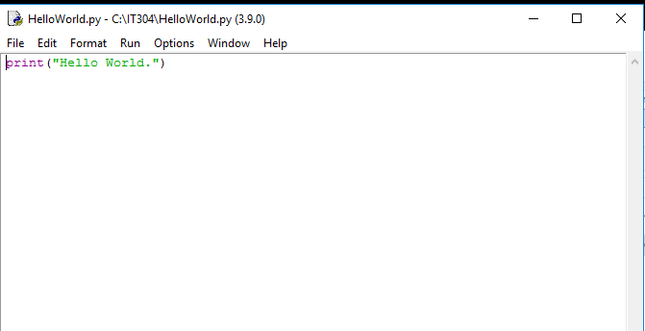
You can then select Run from the menu
And chose Module
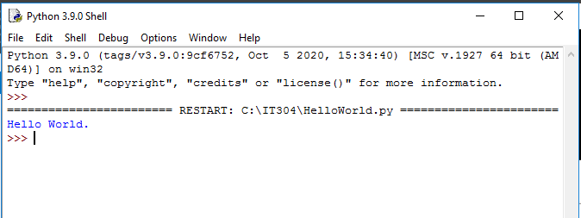
And you will see your program has run.
As an alternative to creating your file in notepad and then going through all the processes to change extensions you can also use Python Idle.
Click Start and look under Python and you will see Idle application
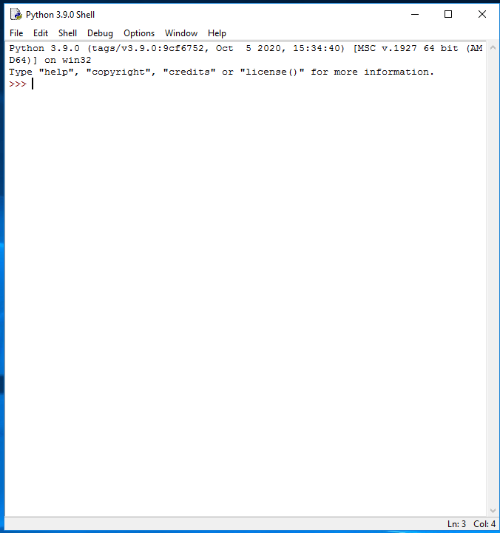
In this window you can type python commands and have it evaluate the code.
2+2 for example
Or Print(“Hello”)
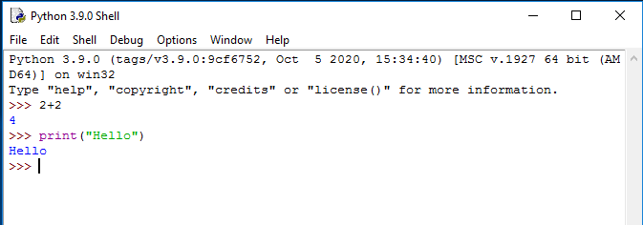
You will see that it color codes the python commands
To start a new program click File and New File
This will open a new window that you can type your python code into.
Import time
print("Hello")
time.sleep(5)
print ("Goodbye")
Go to Run and select Module
It will prompt you to save
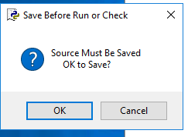
Name this HelloGoodbye.py
You will then see in the python shell window Hello followed by Goodbye 5 seconds later.

