J & B Virtual Labs
Example 1
If you’re having trouble with entering a password:
First, make sure you’re running the correct virtual machine.
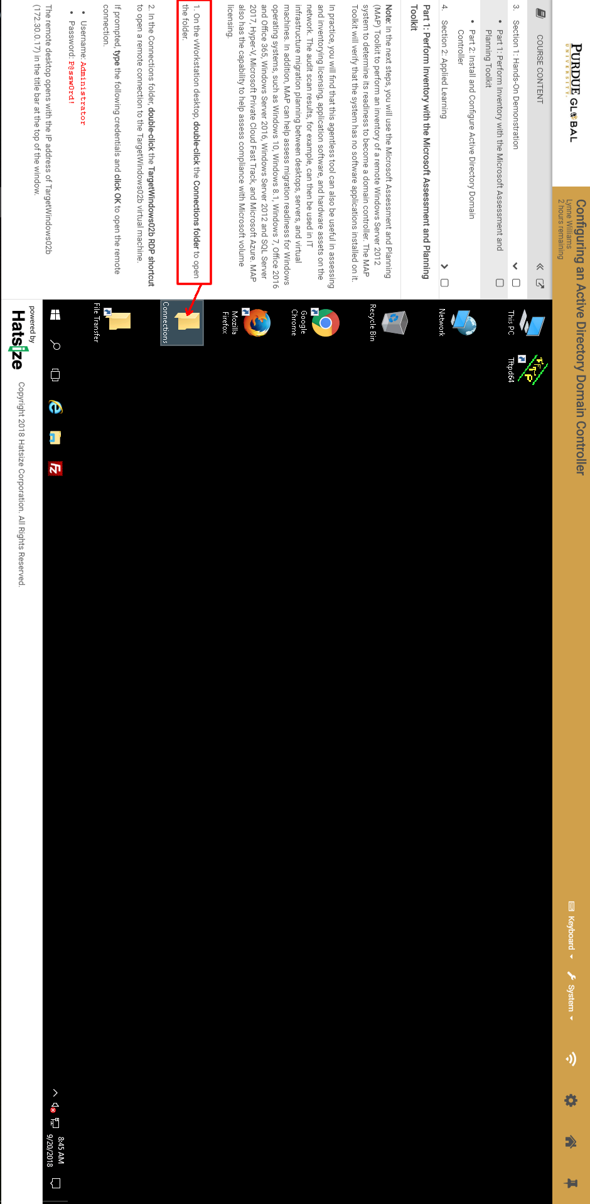
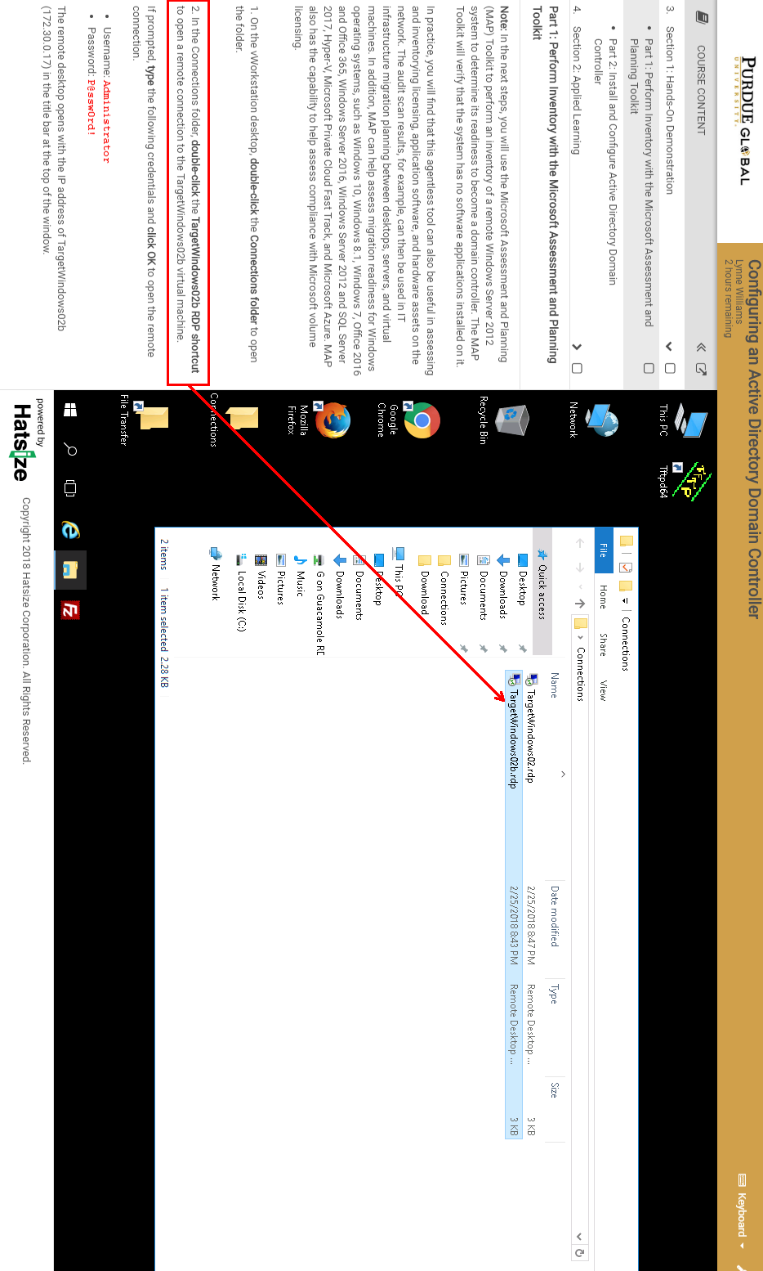

If you are prompted to enter a password, use the on-screen keyboard to type it in:
