How to Submit Your CBA Module Assignment

Step 1

Access your main page of the CBA Modules website.

From the top right toolbar, click *Reports*, then click *Exercise Log*:

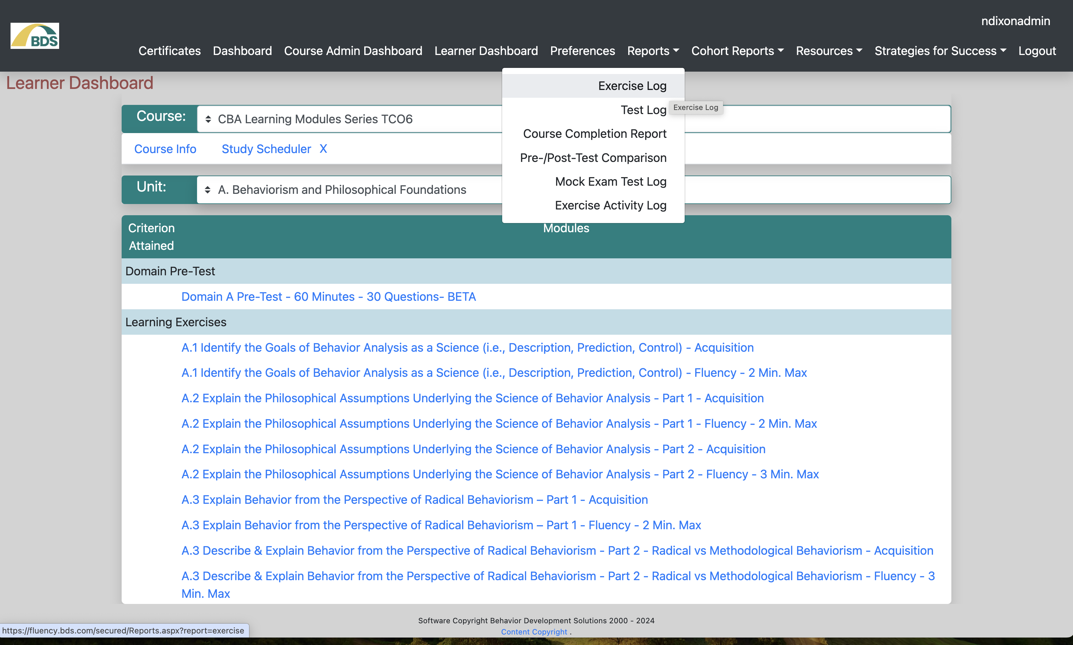

Step 2

From the top left area of the *Exercise Log* page, click the dropdown menu. Then click *CBA Learning Modules Series*.

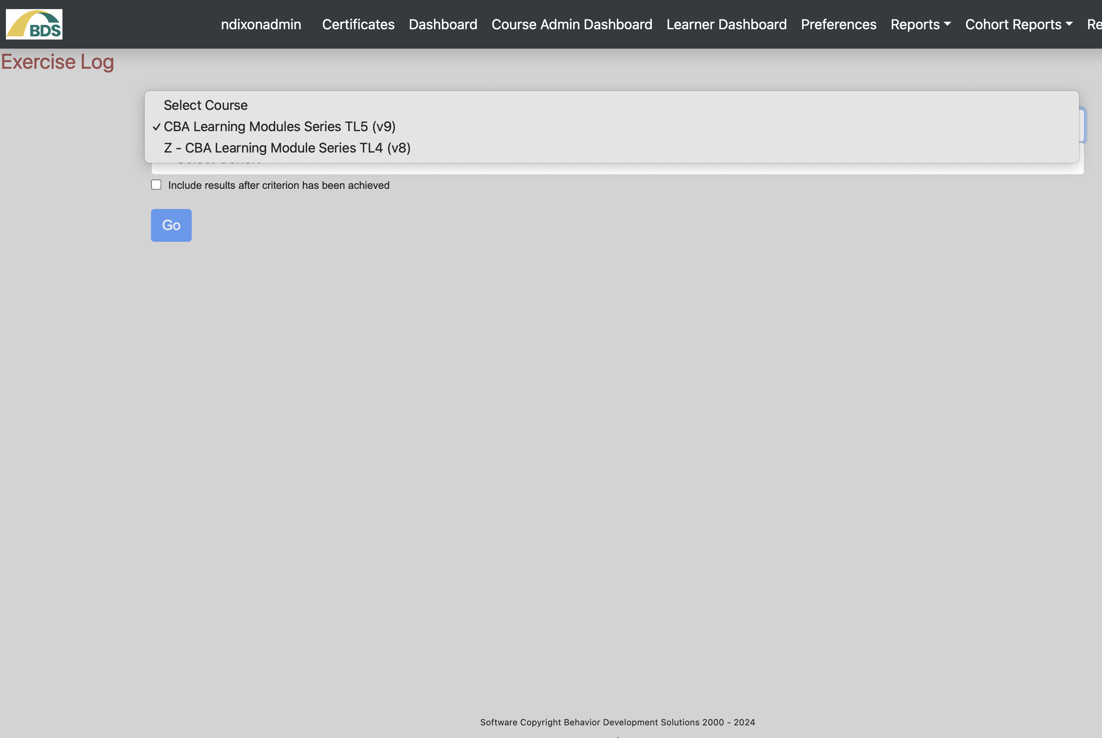

Step 3

On the next page, click the dropdown menu, S*elect Unit*, then choose your desired unit. In the example below, we want a screenshot of last week’s learning module (A-01), so we are looking for Unit A. Philosophical Underpinnings.

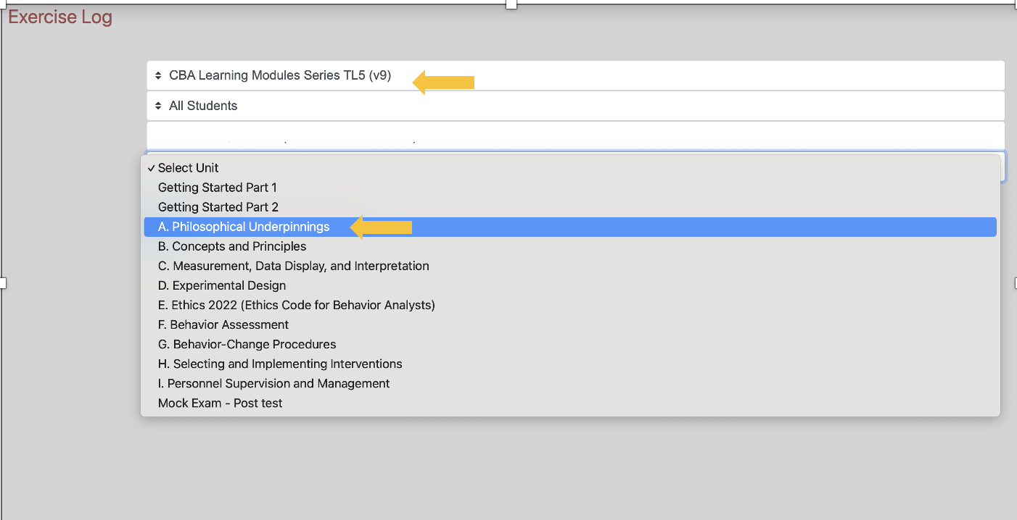

Step 4

The final dropdown menu will display, allowing you to *select your desired module:*

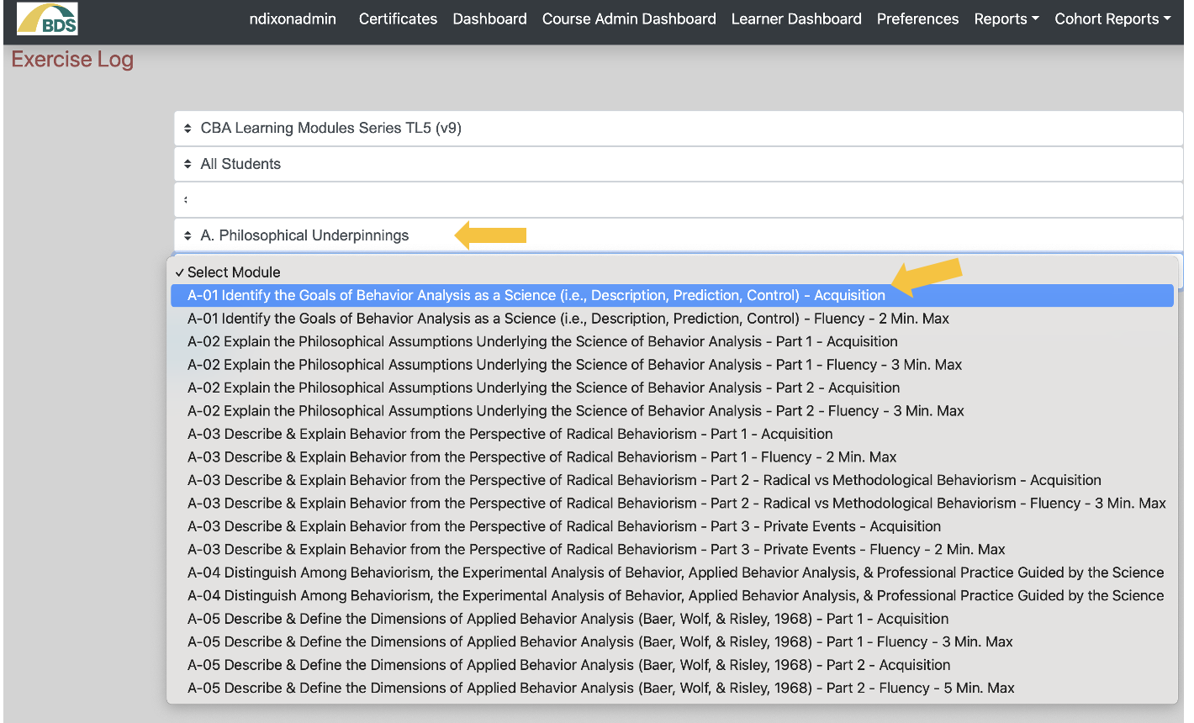

­­­­­­­­Step 5

Once you have chosen your desired module, click *Go*; the page will refresh with your exercise log:

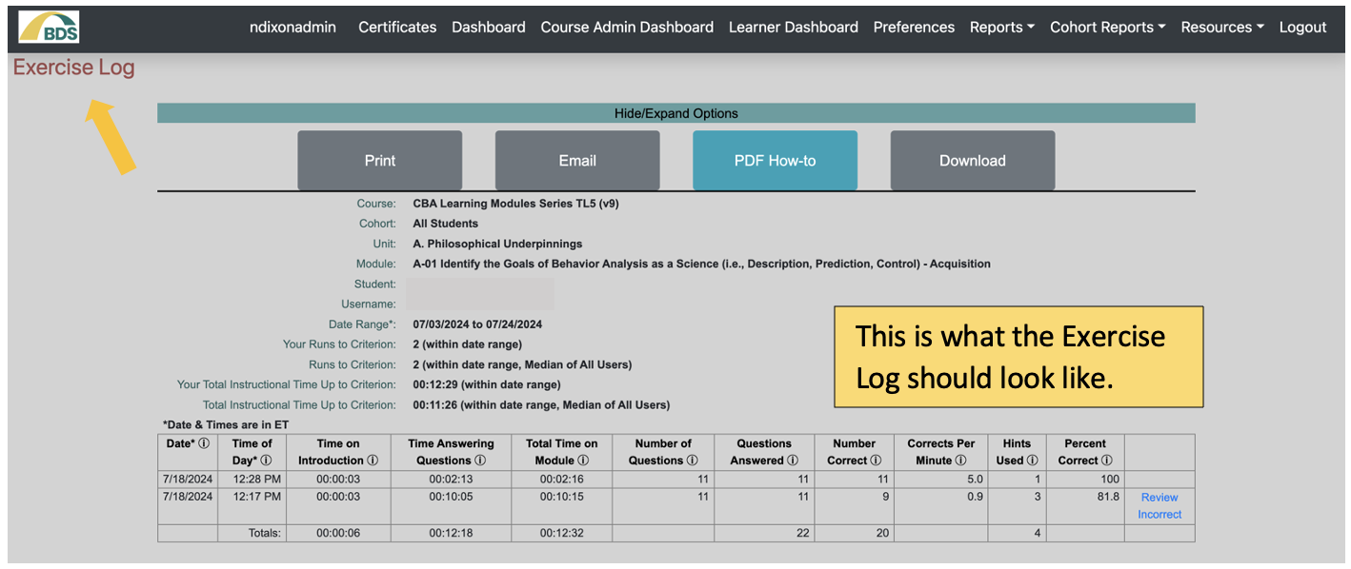

This is what the Exercise Log should look like.

Step 6

Take a screenshot of your Exercise Log screen. Taking a screenshot (aka, screen capture) is simple to do, but the steps vary, depending upon your computer operating system.

[How to Take a Screenshot](https://www.wikihow.com/Take-a-Screen-Shot-(Screen-Capture)) will walk you through the steps for capturing screenshots. Access this page and look for your operating system. Or, do your own Google search for “how to take a screenshot.” Be sure to include your operating system in your search.

Step 7

Paste or insert your screenshot into a Word document.

* If your screenshot capture method saved your screenshot image to your clipboard, simply place your cursor in the Word document and paste.
* If your screenshot capture method placed the image on your computer, in Word, click *Insert,* then click *Pictures*, and then navigate to your file and click to insert it.  
  + 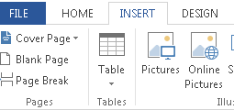

Note that you should not have to adjust the size of your image (but double-check your final document to ensure that all information on the exercise log is visible. It will be readable once in PDF format (which you will save the document as, as detailed below). Please place only one image on a page.

Step 8

Copy your summary and paste it into the bottom of your document, after the screenshots.

Step 9

Save your document.

Use this naming format: Lastname underscore first name course #, unit#, assignment title. For example if your name is Amy Smith, you would save your document as:

Smith_Amy PSXXXUXModules-CBAModule

Be sure to save it to a location you can find! (If you lose track of your file, remember, you can always search for it on your hard drive.)

Step 10

Create a PDF of your Word document. From the File menu within Word there should be an Export as PDF (or Export as Adobe PDF) option. It may look like this (shown here from Word 2013 on Windows):

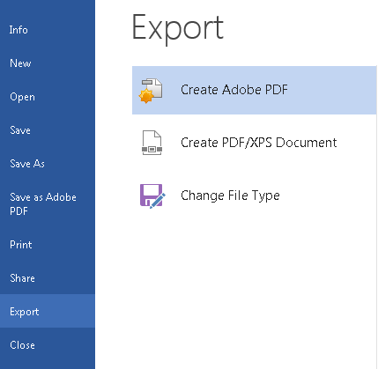

(You can also simply select *Save as Adobe PDF*, as seen here above the *Export* option.)

If your version of Word does not match what is described here, search Google for “how to save a Word file as a PDF.”

Step 11

Upload your PDF to the appropriate Dropbox. Access the Dropbox, then navigate to your PDF (it should appear in the same location as your Word document). If you have any difficulties, contact your instructor or tech support.