Please delete all red type prior to submission and fill in with your original information.

Creating Promotional Communications
First/Last Name
Purdue University Global
CE371 – Section #
Date

Organization Name

Developmentally Appropriate Practices

Provide two to three sentences about the importance of developmentally appropriate practice in early childhood.

Play-Based Learning

Infants: Include one example of play-based learning that is developmentally appropriate for infants used at your facility.
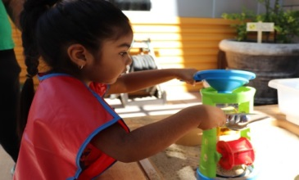
Preschoolers: Include one example of play-based learning that is developmentally appropriate for preschoolers used at your facility.

Literacy Strategy

Infants: Include one example of a literacy strategy that is developmentally appropriate for infants used at your facility.
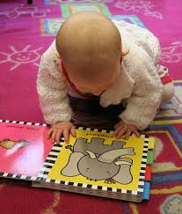
Preschoolers: Include one example of a literacy strategy that is developmentally appropriate for preschool children used at your facility.

Health and Safety

Provide two to three sentences about the importance of health and safety practices at your facility.

Share two policies for keeping children safe at your facility.
Share two policies for keeping children healthy at your facility.
Organization Website “About Us” Page
Imagine you are working on the content for your organization’s website and must develop the information for the “About Us” page on the site. Be sure to include the following information:
Organization Name: Provide the name of your organization
Mission Statement: Provide the mission statement of your organization
Vision and Goals: Using 1-2 paragraphs provide the vision and goals of your organization
Social Media Post
Create a social media post to share a sample menu of what you would serve at your facility. Please provide each of the following:
Breakfast: Give an example a breakfast menu you might serve for preschool children
Snack: Give an example of a snack menu you might serve for preschool children
Lunch: Give an example a lunch menu you might serve for preschool children
Nutritional Guidelines: Explain two guidelines you will follow to ensure your meals are nutritious.

References
Please include all references used in your responses and cite all sources using proper APA formatting and citation style. The full reference for each in-text citation (ex. (Doe, 2013)) used in the body of your paper should be included and listed alphabetically on this reference page.
Doe, J. (2013). This is a sample APA journal article. Sample APA Journal Articles Weekly, 52(1), 34–76.

