**Graphing Module**

**How to Make a Graph Using Microsoft Excel**

1. Before you begin, determine what kind of visual display you will need based on your experimental design.
2. Start the Excel graphing program; you will start with a blank spreadsheet
3. Type data in cells, using one column for the *x*-axis labels, and one column for each dependent variable you will create. It is helpful to label the columns with words that will help you to remember what each string of data represents, especially if you will be entering data from multiple participants, settings, etc. Note that data across phases for one dependent variable, one participant, etc., can be entered consecutively in one column (i.e., baseline, intervention, maintenance). You will use formatting tools to hide the lines that connect across phases.

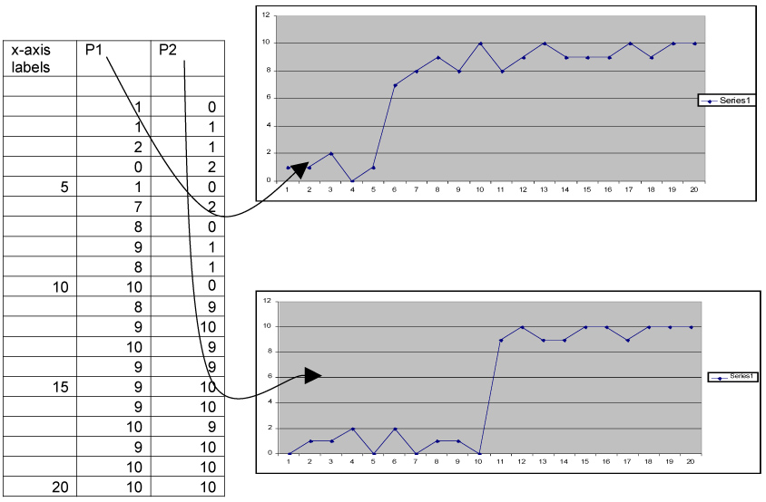

1. Click and drag to highlight the cells you want to graph. In the example shown, highlighting only the cells with data in each column (highlight one column at a time) and making one graph each for the first participant (P1) and one for the second participant (P2) columns will produce two charts that can be arranged as two tiers in a multiple baseline graph.
   * If you want to put more than one series on a graph, highlight all of the columns you want to appear on the graph.
   * To highlight non-consecutive columns, hold down the control key while highlighting each column.
   * Only highlight the cells with numerals in them if you are creating a multiple baseline graph. If you do highlight your text labels, Excel will use them to create a legend. You may prefer to use arrows and labels (not a legend) for multiple baseline graphs.
   * You can leave gaps between data points (empty cells in a column) for multielement designs, for missed sessions, or to include placeholders for data yet to be collected by leaving cells blank within a series. Highlight those blank cells when you insert your chart. For example, if you have data for 20 sessions, but your final graph will include 30 sessions, highlight 10 extra cells beyond your last available data point and Excel will leave 10 extra spaces at the end of your graph. Save this graph and insert your data into the spreadsheet when the data are available, and Excel will update the graph automatically.
   * In order to set the values of your *x*-axis (instead of letting Excel format the numbers automatically), use the first column to type in the labels you want to use and highlight them along with the participant data (see far left column in example above). Note that the first row (below the labels and before the first data point) is left blank in order to force Excel to keep your data off of the *y*-axis. Be sure to highlight this row when selecting the data to be included in your graph. See instructions below to plot points in line with tick marks (Excel’s default settings will plot points between tick marks – see sample charts above) instead of in line with them.
2. Click on the INSERT menu and then select CHART
3. On the STANDARD TYPES list, select the LINE chart if you need one axis; go to the CUSTOM TYPES tab and scroll down to select a graph with two axes if your data require more than one axis.
4. Select the fourth type of line chart; the label “line with markers displayed at each data value” will appear in the area below the various charts.
5. Click NEXT to start the “Chart Wizard” process
6. The second step lets you change or select the data you want displayed; note the DATA SERIES range reflects the cells you highlighted. Becoming familiar with the information presented in this step will help you improve your graph-making.
7. Click NEXT to go to the third step
   * Do not insert TITLES if you are making a multiple baseline graph; you will do this later during the formatting stage. Otherwise, fill in axis labels as needed.
   * Click on GRIDLINES and remove checks for all gridlines to avoid having gridlines on your chart.
   * Click on LEGEND and remove the legend if only one data path or if you will use arrows and labels inside the chart.
8. Click NEXT and select the location for your graph. Select AS OBJECT IN if you are creating a multiple baseline graph – this will enable more efficient formatting. Select AS NEW SHEET if you want the chart to be a new worksheet in your Excel file.
   * If at any point after you’ve finished this process, you want to change your “Chart Options,” simply right click on the chart and you will have the option to select “Chart Options” and make changes. You can also make changes in the source data by right clicking on the chart and selecting “Source Data.”
9. Before formatting, open up the drawing toolbar by clicking on the VIEW menu, selecting TOOLBARS and then selecting DRAWING. You’ll need this toolbar for drawing lines and text boxes.
   * In general, to format elements of a graph in Excel
     + place the cursor over the item you want to format
     + wait for a second or two, and the label for that element (e.g., data series, plot area) will be displayed near the cursor. You can click once on a series to select an entire series, or click a second time after the “data series” label is displayed to select a single point.
     + click once on an element to select it
     + double click  on an element to open up the formatting dialog box
     + the box will have the label of the selected element at the top
   * If you are formatting very small areas of the graph, it is helpful to zoom in on the chart. You can use the VIEW menu to ZOOM in and increase the size of objects to 200% and above. Note that you must select an area outside of your chart in order for this option to be available.
10. Start here if you are creating a multiple baseline graph (skip to the next step for other types of graphs)
    * Click on a new worksheet in Excel and change the VIEW on the new sheet to PAGE BREAK PREVIEW
    * You can change the name of the sheet by double clicking on the tab at the bottom of the window and typing in the desired name, e.g., “graphs.”
    * Go back to the sheet that has your graphs and select (click on the outer edge), copy (using the EDIT menu, or holding down the CTRL and C keys on your keyboard), and paste (using the EDIT menu, or holding down the CTRL and V keys on your keyboard) what will be the top-most graph into the new worksheet.
    * Drag the blue solid and dashed lines in the PAGE BREAK PREVIEW view until you’ve found the borders of “Page 1” (written in gray letters in the center of the page – dashed lines indicate the edge of the page).
    * Place your graph at the top of the page, and click and drag on the edge of the graph until it takes up the width and appropriate proportion of the height of the page (e.g., if your graph will have three tiers, it should take up a third of the page, if you have four, it should take up a fourth, etc.) A two-tier graph should take up about two thirds of a page.
    * Copy and paste your other graphs onto this new page, one below the other, until you have one copy for each tier that your final graph will have. Move and stretch each copy as needed.
    * Leave room for axis labels and a figure caption, if you will be inserting one on the page with the graph.
11. Format chart area
    * Double click on gray background area.
    * In PATTERNS box, under BORDER click NONE.
    * Under AREA click NONE.
    * Click OK.
12. Format data series; point to series/path with cursor and double click to format
    * Format data points/markers; double click on a series to change it (with multiple series on one graph, use the following data point styles in the following order)
      + closed circle (select STYLE to change shape, and change FOREGROUND and BACKGROUND to black)
      + open circle (select STYLE to change shape, and change FOREGROUND to black and BACKGROUND to white)
      + closed triangle
      + open triangle
    * Change SIZE (default = 5): increase or decrease depending on your preference; the fewer points you have, the larger they can be, up to 8 pts
    * Format data paths/line (same formatting box as data points/markers)
      + Select solid (STYLE) and black (COLOR) line with closed data points
      + Select dashed (STYLE) and black (COLOR) line with open data points
      + Click OK to close this box
    * Interpolate data points if you want data paths to connect points across empty cells, as in a multielement design (this step is not needed if you didn’t leave any cells within a series blank when entering data)
      + Click on the TOOLS menu
      + Select OPTIONS
      + Click on the CHART tab
      + In the ACTIVE CHART: PLOT EMPTY CELLS AS area, click on INTERPOLATED
      + Click OK
13. Change *y-*axis scale (remember to keep scales across multiple baseline graphs the same)
    * Double-click on *y-*axis to format; select SCALE tab
    * Determine the size increment you want to use on your *y-*axis; type this number in the MAJOR UNIT box
    * Set MAXIMUM to be slightly higher than or equal to the upper end of your dependent variables. If you are graphing percent, your *y*-axis should go to 100%.
    * To lower the *x-*axis to below 0 on the *y-*axis: set scale with MINIMUM NUMBER equal to negative value of MAJOR UNIT; set CATEGORY (X) AXIS CROSSES AT value to a number between the MINIMUM NUMBER and 0 (this will be a negative number). You may have to try a couple of different values to see what works best with your graph. For a graph with a maximum of 10, the *x*-axis should cross somewhere around –0.3.
    * Cover up the negative number on the *y-*axis by clicking on the TEXT BOX icon on the drawing toolbar (it looks like a white piece of paper with an *A* and some lines on it) and click and drag to draw a text box over the negative number. Double click on the text box to format it. Select the COLORS AND LINES tab and select white under FILL and NO LINE under LINE.
    * Draw another small text box over the area on the *y*-axis below the 0; this will produce a gap between the bottom of the *y*-axis and the left edge of the *x-*axis. Double click to format, and change the FILL to white and the line to NO LINE
    * Click OK
14. Format the *x-*axis scale – you have set the values that will be displayed on the *x*-axis by typing them in a column on your worksheet, but additional formatting is necessary, especially if you are creating a multiple baseline graph.
    * Double-click on *x-*axis to format; select SCALE tab
    * If you are creating a multiple baseline graph, remove the tick mark labels from the *x-*axes of all but the bottom-tier graph. Click on the PATTERNS tab in the FORMAT AXIS box and select NONE for TICK MARK LABELS
    * Make sure that the box labeled VALUE Y AXIS CROSSES BETWEEN CATEGORIES is not checked. If you haven’t entered a “dummy” empty cell at the top of your data series (and included that cell in your data range), your first data point will be on the *y*-axis. Insert a row into your data range before your first data point, and make sure that cell is included in the data range as the first cell.
    * Click OK
15. Draw phase change lines
    * Click on the straight diagonal line on the drawing toolbar (next to AUTOSHAPES)
    * Click and drag to draw a vertical line between phases on your graph.
    * If you hold down the shift key while you click and drag, the line will be straight
    * The line should only extend from the *x-*axis to a point equal with the top of the *y-*axis (it may be helpful to draw a horizontal line out from the *y*-axis so that you know how high the phase change line should go—you can delete this horizontal line later after you’ve put in the phase labels).
    * Lines for major changes should be solid; minor changes should be dashed.
    * To make a dashed line, draw the line, then double click on it to format it. Under LINE, in the DASHED section, click the dashed pattern you want to use
    * Click OK
16. Remove lines that cross phase changes:
    * Select entire data path by clicking once, and then select the section that needs to be removed by clicking once on the portion of the line that falls where the phase change occurs. Double click on that portion of the line to format it.
    * On the PATTERNS tab under LINE change the COLOR to white.
    * Click OK
17. If you don’t want the lines of your data paths to touch the dots
    * Double click on the series to format it
    * Change the foreground of the data points to white (this only works with closed data points)
    * Click OK.
18. Dogleg/stair step lines between tiers on a multiple baseline graph should be dashed lines regardless of major and minor changes.
    * Use the drawing toolbar to draw lines between phases; horizontal portion of dogleg/stair-step lines should be at the top of the *y-*axis.
19. Label phases
    * Draw text boxes and be sure to format text boxes (double click on them) so that they have no line. Select NO FILL to avoid obstructing other elements of the graph. Mark major changes with larger, higher labels, and smaller changes with smaller, lower labels.
    * Use a sans serif font for all words on a graph (the default font for Excel is Arial, which is a sans serif font)
    * Click OK when you’re done
20. Label the *y-*axes if you’ve created a multiple baseline graph by drawing a text box.
    * Double click on the text box to format it
    * On the ALIGNMENT tab, click VERTICAL, and select CENTERED alignment
    * In ORIENTATION, set the text so that it starts at the bottom and reads up
    * Click on the COLORS AND LINES tab and select white FILL and NO LINE
    * Click OK
    * Drag your text box to the outside of the *y-*axis and position it so that it is vertically centered across all tiers
    * If you do not have a multiple baseline graph, you can label the axes during the “Chart Wizard” process or by clicking on the CHART menu and on CHART OPTIONS, then on the TITLES tab.
21. Label the *x-*axis with a text box
    * Follow the instructions for the *y-*axis, keeping the orientation horizontal
    * Make sure the font size is the same as the major *y-*axis label.
22. Label data paths if you have more than one data path/series
    * Insert text boxes and format them (double click) with no FILL and NO LINE.
    * Use the arrow tool on the drawing toolbar to draw an arrow from the text label to the nearest respective data point
    * Try to keep labels close to their respective paths/points and don’t let arrows cross each other or data paths, if possible
23. Figure caption
    * To insert a figure legend below your graphs, use the TEXT BOX tool.
    * Click on the TEXT BOX icon and click and drag over the area in which you want the legend to appear.
    * Type the text of the legend in the text box.
    * Click outside of the text box, then double click on the border of the text box to format
    * Under LINE select NO LINE

|  |  |
| --- | --- |
| graphing02.jpg | This is what your finished multiple baseline graph will look like after you’ve completed formatting it. |

|  |
| --- |
| **Copyright © 1995 - 2016**[**Pearson Education**](http://www.pearsoned.com/)**. All rights reserved. Pearson Prentice Hall is an imprint of**[**Pearson**](http://www.pearson.com/)**.** [**Legal Notice**](http://www.pearsoned.com/legal-notice/)**|**[**Privacy Policy**](http://www.pearsoned.com/legal/privacy.htm)**|**[**Permissions**](http://www.pearsoned.com/legal/permissions.htm) |

[Return to the Top of this Page](http://wps.prenhall.com/chet_cooper_appliedbeh_2/73/18705/4788645.cw/content/index.html#topofpage)