Unit 9 Individual Assignment

Functional Behavior Assessment: Design an FBA to identify the function of one of the behavioral excesses listed in your assigned case study from the Unit 6 Assignment. The FBA must include an indirect assessment, a direct assessment, a functional analysis, a skills assessment, and a preference assessment. Select the procedures to be used for each type of assessment according to the information provided in the case study as well as relevant research literature and best practice standards.

Here is a template for your individual assignment for Unit 9. This provides an overview of what an FBA might look like when you finish your assessment.

Included in this template are the types of graphs that would be used to present the data for each of the assessment methods. The team assignment should NOT include these data; they only belong in the individual assignment.

(TEMPLATE)
FUNCTIONAL BEHAVIORAL ASSESSMENT

Identifying Information
Student | FirstName LastName | Parents/guardians | Parent1 and Parent2 LastName
Date of Birth |  | Home address & phone

FBA Activities
Data gathering activities (check all that apply)
Indirect Observation Methods | Direct Observation Methods
___ Raters/FBA checklists (specify):  ____________________________________  ___ Student interview  ___ Parent interview  ___ School staff interview | __ Observations  __ Functional Analysis  __ Reinforcer Assessment

Biopsychosocial History

Paragraphs giving relevant background information.

Behavior of Concern (operationally define):

- Behavior –

Indirect Assessment Method(s)
Describe indirect measures used. Include description of the measures used and justification for selecting those measures. You should utilize reference material to support your reasoning.

- Method 1 – description of what was done.
- Method 2 – description.

Data from Indirect Assessment:

Explanation of Data --

Direct Assessment Methods
Describe direct measures used. Include description of the procedures used and justification for selecting those procedures. You should utilize reference material to support your reasoning.

- Direct Method 1
- Direct Method 2

Direct Assessment Data:

Explanation of data –

Functional Analysis Procedures

Describe how you conducted your functional analysis. Include description of the conditions used and justification for selecting the procedures selected. You should utilize reference material to support your reasoning.

- Condition
- Condition
- Condition
- Condition

Data:

Explanation of data

Hypothesis of functions of behavior
Synthesis of all of the data and how you reached the conclusion for these hypotheses.

Behavior | Function (reinforcing consequence)
Behavior #1

Behavior #2

Skills assessment:
Describe skills assessment measures used. Include description of the measures used and justification for selecting those measures. You should utilize reference material to support your reasoning.

Description of procedures used.

Data:
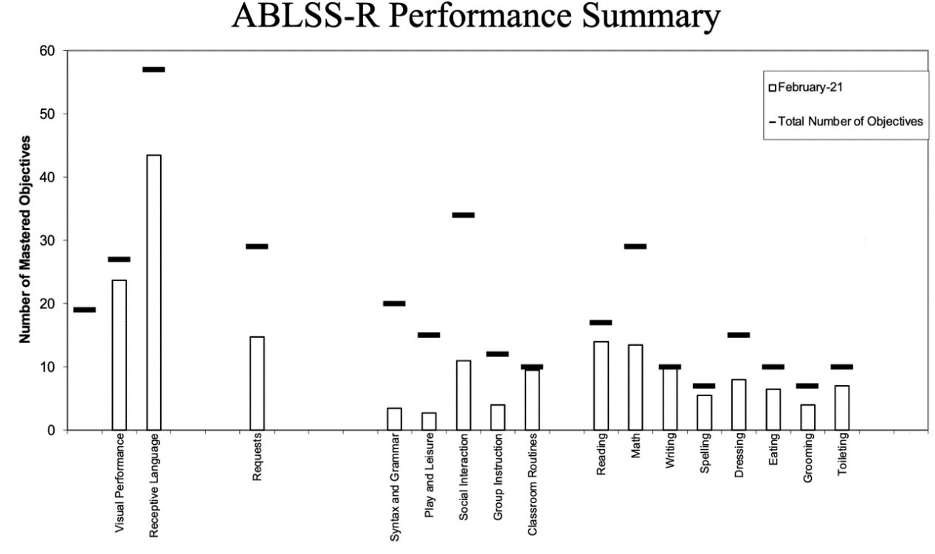

Explain your data. You can do paragraph format with a description of each area and the skills that the child has in each area. You may also give a weakness that you will develop into a goal.

Reinforcer assessment:
Describe preference/reinforcement procedures used. Include description of the procedures used and justification for selecting those procedures. You should utilize reference material to support your reasoning.

Describe the procedures used for conducting your reinforcer assessment, including how items were selected for inclusion in your assessment. You should also indicate how you know that these preference items will work as reinforcers.

Data:

References

A minimum of 3 references should be included here.

