In this Assignment, your role will be of an assistant researcher in economics. Your job is analyzing the consequences of the changes in fiscal and monetary policy instruments that may be associated with the variations in the U.S. economic conditions. With this in mind, address the following on the effects of monetary and fiscal policies on the aggregate demand (AD) and short run macroeconomic fluctuations that lead to the recessionary gap and inflationary pressure in the U.S. economy.

There are three parts to this Assignment. This Assignment requires a combination of short paragraph answers, computations, and completion of a 450–500 word essay.

One of the main roles of the government is stabilizing the economy to attain macroeconomic goals such as price-level stability, full employment, and economic growth. Macroeconomic fluctuations may occur due to shifts in the aggregate demand (AD) or shifts in the short-run aggregate supply curve (SRAS) (See Figure 1). Therefore, policymakers every so often strive to counterbalance these AD and AS curve shifts by using monetary policy and fiscal policy instruments in an attempt to reach long-run equilibrium by closing the recessionary and the inflationary gaps.

**Figure 1**

Figure 1 is a combination of three separate graphs, each with the horizontal axis labeled “real GDP” and the vertical axis labeled “Price Level”. 
 
The first graph on the left is labeled below the graph with the words, “Below full-employment equilibrium”.  The horizontal axis is labeled “real GDP” and the vertical axis is labeled “Price level”.  There is a descending to the right straight line labeled “AD” and an ascending to the right straight line labeled “SAS” the point where these AD and SAS lines cross is labeled “A” and a dashed line extends from point “A” horizontally to the left to the vertical axis and ends at a label “P”.  Similarly, another dashed line descends vertically from point “A” to the horizontal axis and ends at a label “Y1”.  To the right of point “A” is another vertical line that extends from a label with the letters “LAS” at a position well above the “SAS” line down to the horizontal axis, ending at a label “Yf”.  Between point “A” and the “LAS” line is a double arrow headed short red line with a label box above it stating “Recessionary gap”.
 
The middle graph is labeled below the graph with the words, “Long-run equilibrium”.  The horizontal axis is labeled “real GDP” and the vertical axis is labeled “Price level”.  There is the same descending to the right straight line labeled “AD” and an ascending to the right straight line labeled “SAS” the point where these AD and SAS lines cross is labeled “B” and a dashed line extends from point “B” horizontally to the left to the vertical axis and ends at a label “P”.  Another vertical line extends from a label with the letters “LAS” at a position well above the intersection of the “SAS” line and the AD line vertically down to the horizontal axis, ending at a label “Yf”.
 
The last graph on the right is labeled below the graph with the words, “Above full-employment equilibrium”.  The horizontal axis is labeled “real GDP” and the vertical axis is labeled “Price level”.  There is a descending to the right straight line labeled “AD” and an ascending to the right straight line labeled “SAS” the point where these AD and SAS lines cross is labeled “C” and a dashed line extends from point “C” horizontally to the left to the vertical axis and ends at a label “P”.  Similarly, another dashed line descends vertically from point “C” to the horizontal axis and ends at a label “Y2”.  To the left of point “C” is another vertical line that extends from a label with the letters “LAS” at a position well above the “AD” line down to the horizontal axis, ending at a label “Yf”.  Between point “C” and the “LAS” line is a double arrow headed short red line with a label box above it stating “Inflationary gap.”

**Fiscal Policy**

The government utilizes fiscal policy instruments (tools) to stabilize the economy and to achieve full employment, control inflation, and encourage economic growth. Fiscalpolicy is planned adjustments in the government spending and taxes. This part introduces you to the use of fiscal policy instruments to deal with the two major economic problems of recession (unemployment) and inflation. With this background information, answer the following questions on the uses and the effects of the fiscal policy tools to deal with the recessionary and the inflationary gaps.

**Question 1: Fiscal Policy and the Recessionary Gap**

Suppose that the U.S. economy is operating below full-employment equilibrium due to the recessionary gap with high rate of unemployment, and the equilibrium point between AD and SRAS occurs below potential real GDP (See Figure 2). Cognizant of the government plan, answer the following questions on the use of fiscal policy tools during the recessionary gap.

**Figure 2**

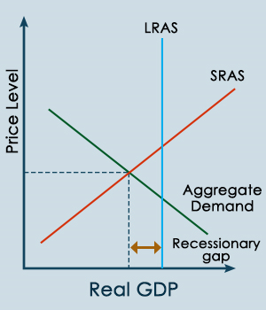

1. What is the type of fiscal policy the government uses to close the recessionary gap?
2. What are the fiscal policy instruments available to the policy makers and how would they be used? Explain.

c) What are the effects of each of the fiscal policy instruments designed to fight recessions on the Federal Budget and the national debt?

**Question 2: Fiscal Policy and the Inflationary Gap**

Suppose the U.S. economy is operating above full-employment equilibrium, which leads to significantly high demand-pull inflationary pressure (see Figure 3). The government plans to use the fiscal policy instruments to close the inflationary gap by shifting the aggregate demand curve. Mindful of this government strategy, answer the following questions on the use of fiscal policy tools during the inflationary gap.

1. What is the type of fiscal policy the government uses to close the inflationary gap?
2. What are the fiscal policy instruments available to the policy makers and how would they be used? Explain.

c) What are the effects of each of the fiscal policy instruments designed to fight inflation on the Federal Budget and the national debt?

**Figure 3**

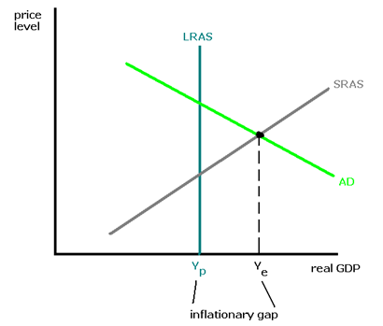

**Monetary Policy**

The Federal Reserve System uses monetary policy that involves making planned changes in the money supply to manipulate interest rates to alter the total level of spending in the economy. The policy goals are achieving price-level stability, full employment, and economic growth. Based on this information, answer the following questions on how the Federal Reserve System applies the monetary policy tools to deal with the recessionary and inflationary gaps.

**Question 3: Monetary Policy and the Inflationary Gap**

Suppose the U.S. economy is operating above the full-employment equilibrium due to an overspending in the economy with significantly high inflation rates (see Figure 4). The Federal Reserve wants to design policy plans to reduce the high rate of inflation without causing a recession. Based on this underlying assumption, answer the following questions.

**Figure 4**

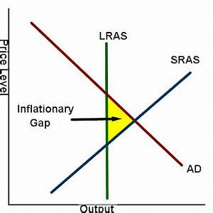

1. What is the type of monetary policy the Federal Reserve System can undertake to address the inflationary problem?
2. What are the instruments of monetary policy that the Federal Reserve System uses to close the inflationary gap? Explain.

c) How does management of its money supply enable the Federal Reserve to manage the economy in order to reduce inflationary pressure?

**Question 4: Monetary Policy and the Recessionary Gap**

Assume the U.S. economy is in a recession operating below potential output (the real GDP) and the Federal Reserve System takes appropriate monetary policy actions to close the recessionary gap (see Figure 5). Anchored in this essential statement, answer the following questions on how the monetary policy tools are used to deal with the recessionary gaps.

**Figure 5**

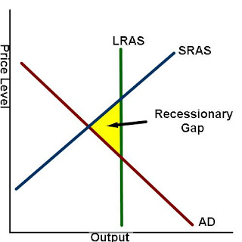

1. What is the type of monetary policy the Federal Reserve System utilizes in an attempt to close the recessionary gap?
2. What are the instruments of monetary policy that the Federal Reserve System uses to close the recessionary gap? Explain.

c) How does management of its money supply enable the Federal Reserve to manage the economy in order to reduce recessionary pressure?

**Question 5: Fiscal and Monetary Policy Applications**

Compose the following in a 450–500 word essay. Now that you have segmented the components on how fiscal and monetary policies can reduce recessionary and inflationary gaps, you must analyze how the consequences of the changes in fiscal and monetary policy instruments may be associated with the variations in the U.S. economic conditions. Provide examples based on your answers above to explain these consequences during a recession, and during inflationary times.