According to the author, economists approach economic problems with economic models, and these models will help familiarize you with how economists approach economic problems. The models also help explain how individuals and countries gain from trade. Accordingly, trade allows people to specialize in the production of goods and services for which they have comparative advantages and, then trade for goods and services that other people produce based on their comparative advantages.

The Assignment questions deal with the application of the economic models and the roles of comparative advantage in the gains from trade.

- Explain the difference between absolute advantage and comparative advantage. Which is more important in determining trade between individuals or countries? Is it absolute advantage or comparative advantage? Why?

- Assume two students must prepare a presentation for their marketing class. As part of their class presentation, they must do a series of calculations and prepare 50 PowerPoint slides. It would take Larry 10 hours to do the required calculation and 10 hours to prepare the slides. It would take Kate 12 hours to do the series of the calculations and 20 hours to prepare the PPT slides.

- How much time would it take the two students to complete the project if they divide the two tasks equally?

- How much time would it take the two students to complete the project if they use comparative advantage and specialize in calculating or preparing slides?

- If Larry and Kate have the same opportunity cost of $5 per hour, is there a better solution than for each to specialize in calculating or preparing slides?

- Assume there are only two countries in the world, and the two countries face the following production possibilities frontiers. Further assume that the two countries produce popcorn and peanuts.

(see below for questions)

Country A’s Production Possibilities Frontier Country B’s Production Possibilities Frontier

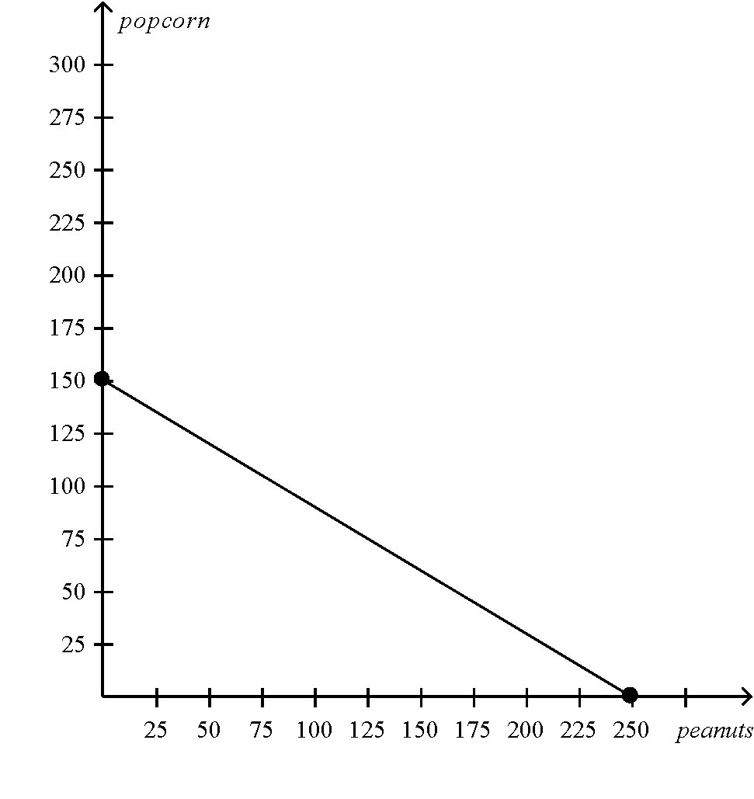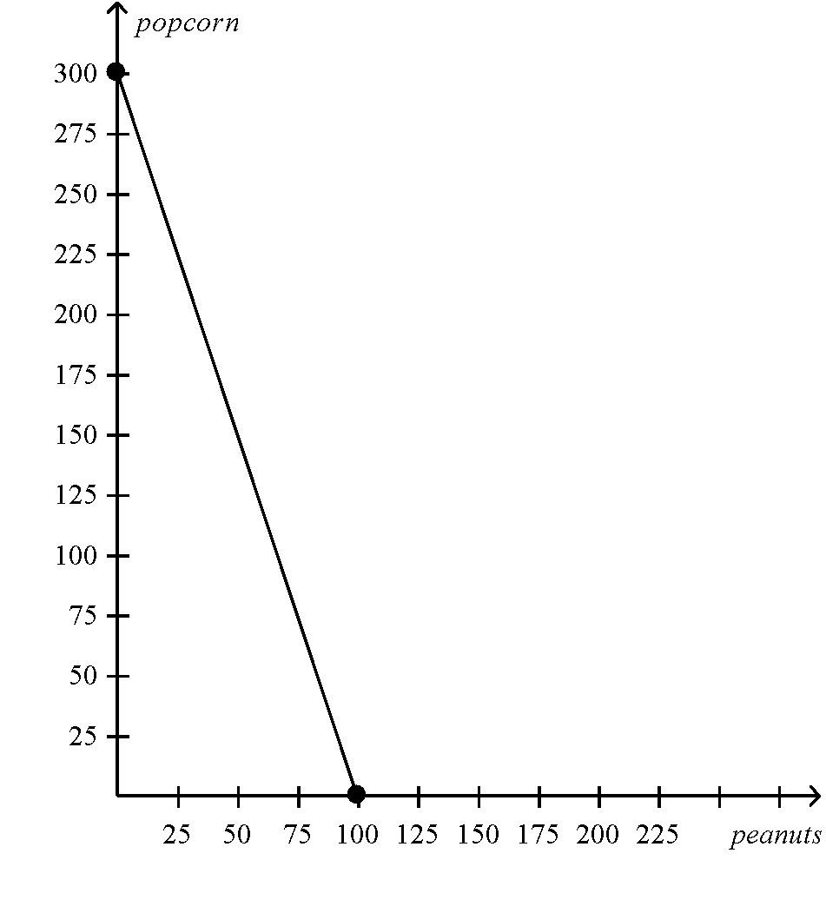

- Assume that country A and country B decide to use half of the resources in the production of each good. Indicate the points of the maximum output of each good on the graphs for each country as point A under such resource use.

- Assume the two countries choose autarky and do not trade. What would be the total world production of popcorn and peanuts under the autarky?

- Assume that each country decides to specialize in either popcorn or peanut based on its respective comparative advantage. Under the specialization, what is the total production of popcorn and peanuts?

- Assume country A and B decide to trade 100 units of popcorn for 100 units of peanuts, show on the graphs the gain each country receives from trade. Label these points on the two graphs “B.”

