As a marketing specialist working for a production company, it is your job to explain to investors how the current status of the supply will meet the changing demand for products. Based on the following Assignment questions compile answers that effectively addresses the hypothetical examples provided in the Assignment.

This Assignment deals with the Production Possibility Frontier and market forces of supply and demand models as well as the impacts of government policies on the interactions of supply and demand in the market economy.

- Given the table below, graph the demand and supply curves for flashlights. Make certain to label the equilibrium price and equilibrium quantity.

Price | Quantity Demanded Per Month | Quantity Supplied Per Month
$5 | 6,000 | 10,000
$4 | 8,000 | 8,000
$3 | 10,000 | 6,000
$2 | 12,000 | 4,000
$1 | 14,000 | 2,000

  - What are the equilibrium price and the equilibrium quantity?

  - Suppose the price is currently $5. Explain what problem would exist in the market and calculate the size of that problem. What would you expect to happen to price?

  - Suppose the price is currently $2. Explain what problem would exist in the market and calculate the size of the problem. What would you expect to happen to price?

- Consider supply and demand for Maine lobsters indicated in the following tables to answer questions from a–e below. Suppose that the supply schedule of Maine lobsters is as follows:

Price of Lobster per Pound | Maine Quantity of Lobster Supplied (pounds)
$25 | 800
$20 | 700
$15 | 600
$10 | 500
$5 | 400

First, assume that Maine lobsters can be sold only in the United States. The U.S. demand schedule for Maine lobsters is as follows:

Price of Lobster per Pound | USA Quantity of Lobster Demanded (pounds)
$25 | 200
$20 | 400
$15 | 600
$10 | 800
$5 | 1,000

  - Looking at both the schedules of supply and demand, as well as the graph of the demand and supply curve for Maine Lobsters, what is the equilibrium price of lobsters and the equilibrium quantity of lobsters demanded and supplied at that price?

  - Second, suppose that Maine lobsters can also be sold in France. The French demand schedule for Maine lobsters is as follows:

Price of Lobster per Pound | Quantity of Lobster Demanded (pounds)
$25 | 100
$20 | 300
$15 | 500
$10 | 700
$5 | 900

  - What is the demand schedule for Maine lobsters now that French consumers can also buy them?

  - Using the combined U.S. and French demand schedule, the U.S. demand schedule and the supply schedule, and the graph below, analyze the change in the market for lobsters. What will happen to the price at which fishermen can sell lobster? What will be the final output of lobsters?

  - What will happen to the price paid by U.S. consumers? What will happen to the quantity consumed by U.S. consumers?

- Atlantis is a small, isolated island in the South Atlantic. The inhabitants grow potatoes and catch fresh fish. The accompanying table shows the maximum annual output combinations of potatoes and fish that can be produced. Obviously, given their limited resources and available technology, as they use more of their resources for potato production, there are fewer resources available for catching fish.

Year | Quantity of Potatoes (Pounds) | Quantity of Fish (Pounds)
A | 1,000 | 0
B | 800 | 300
C | 600 | 500
D | 400 | 600
E | 200 | 650
F | 0 | 675

Examine the Maximum annual output options table above and the resulting Production Possibility Frontier Graph below and answer questions from a-e.

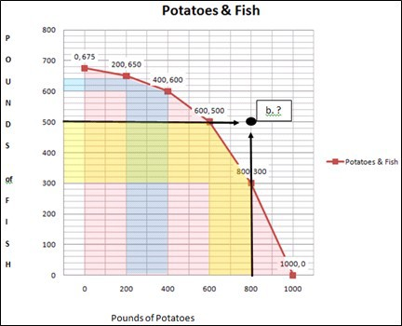

  - Can Atlantis produce 500 pounds of fish and 800 pounds of potatoes? Explain.

  - What is the opportunity cost of increasing the annual output of potatoes from 600 to 800 pounds?

  - What is the opportunity cost of increasing the annual output of potatoes from 200 to 400 pounds?

  - Can you explain why the answers to parts b and c are not the same?

  - What does this imply about the slope of the production possibility frontier?

- Now that you have segmented the components of the changes in supply and demand and the ability to meet demand, explain how the current status of the supply will meet the changing demand for the products, and the change in the production possibilities will be able to meet the market demand.

