This Assignment deals with how monetary and fiscal policy instruments are utilized to deal with macroeconomic fluctuations in order to achieve long-run macroeconomic equilibrium through changing the aggregate demand (AD) and Aggregate Supply (AS) in the economy.

- Refer to the sets of the aggregate demand, short-run aggregate supply, and long-run aggregate supply curves. Use the graphs to explain the process and steps by which each of the following economic scenarios will shift the economy from one long-run macroeconomic equilibrium to another equilibrium. Under each scenario, elaborate the short-run and long-run effects of the shifts in the aggregate demand and aggregate supply curves on the aggregate price level and aggregate output (real GDP).

  - Suppose the household wealth decreases due to a decline in the stock market asset prices (see the set of graphs below and pay attention to the 3-stage shifts in graphs).

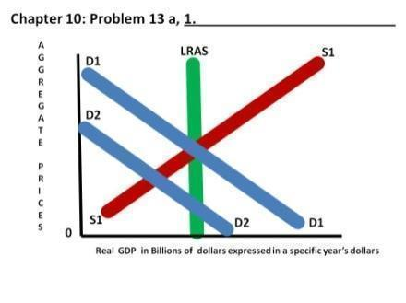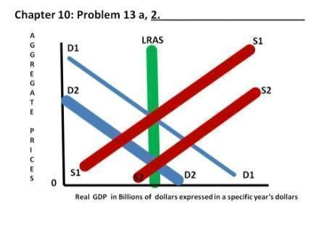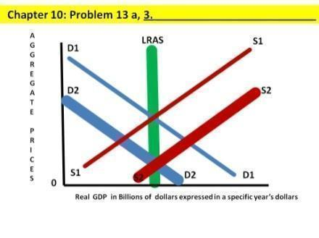

  - Assume the government lowers taxes, which increases the household’s disposable income. However, the government purchases (spending) remains the same (see the set of graphs below and shifts in graphs).

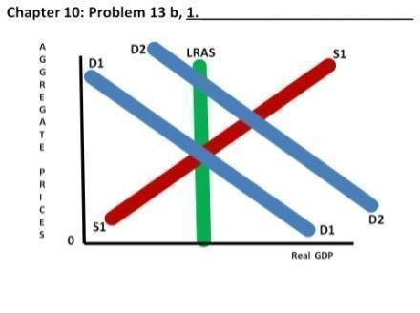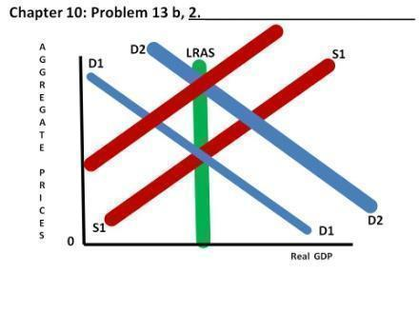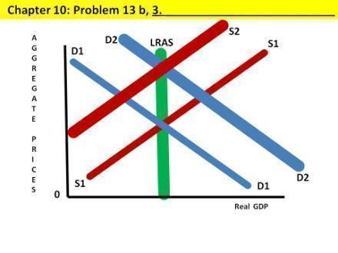

- Suppose the economy of a hypothetical country has reached its long-run macroeconomic equilibrium when each of the following aggregate demand shocks occurs. What kind of gap, inflationary or recessionary gap, will the economy face after the AD shock indicated by the shift in AD curves? What types of fiscal policy instruments will help move the economy back to the potential level of output (real GDP)? Give specific examples.

  - At the long-run macroeconomic equilibrium, the stock market boom occurs and this increases the value of stocks households hold. (See the set of graphs below and shifts in graphs in the two-steps.)
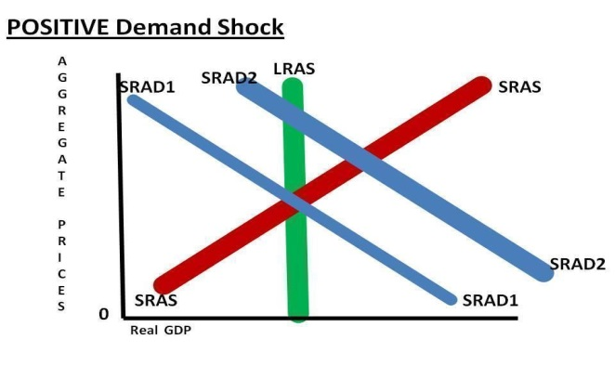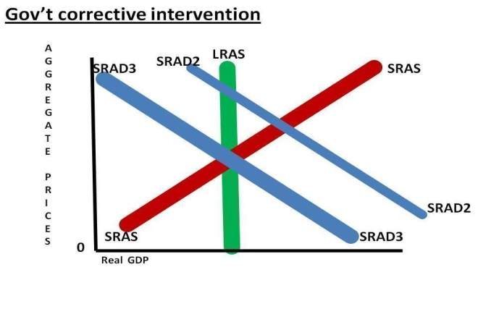

- What kind of GAP exists (inflationary or recessionary)?
- Which part of the FED’s Congressional mandate (full employment or stable prices) does this situation trigger?
- What kind of MONETARY policy might be helpful (increase or decrease money supply)?
- What kind of FISCAL policy might be helpful (expansionary or contractionary)?
- What specific FISCAL policy TOOLS can the government employ that would be helpful?

b. The government increases its purchases (spending) due to natural disasters. (See the set of graphs below and shifts in graphs.)

- What kind of GAP exists (inflationary or recessionary)?
- Which part of the FED’s Congressional mandate (full employment or stable prices) does this situation trigger?
- What kind of MONETARY policy might be helpful (increase or decrease money supply)?
- What kind of FISCAL policy might be helpful (expansionary or contractionary)?
- What specific FISCAL policy TOOLS can the government employ that would be helpful?

c. Assume the Central Bank reduces the money supply in the economy which leads to an increase in the interest rates. (See the set of graphs below and shifts in graphs.)

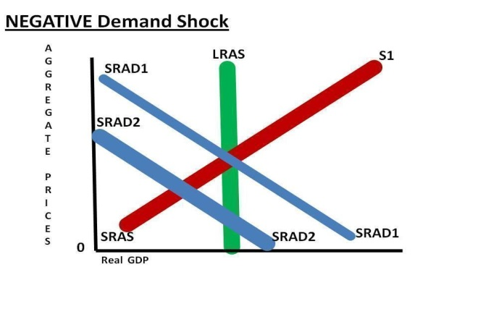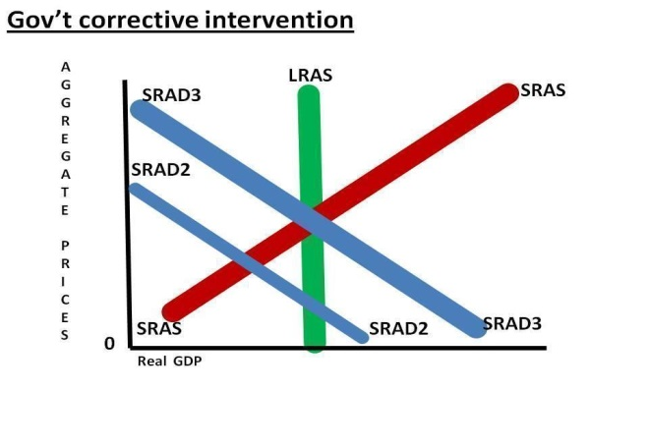
- What kind of GAP exists (inflationary or recessionary)?
- Which part of the FED’s Congressional mandate (full employment or stable prices) does this situation trigger?
- What kind of MONETARY policy might be helpful (increase or decrease money supply)?
- What kind of FISCAL policy might be helpful (expansionary or contractionary)?
- What specific FISCAL policy TOOLS can the government employ that would be helpful?

