Centralized or Decentralized?

In a centralized company, all major planning and operating decisions are made by top management, versus a decentralized company, where managers of separate divisions or units are delegated operating responsibility.

Centralized Example:

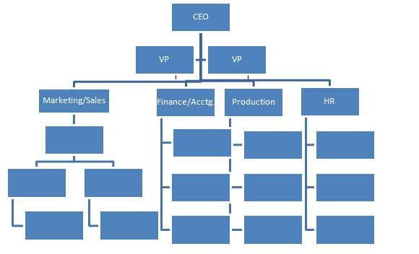

Scroll down to see the decentralized example…

Decentralized Example:

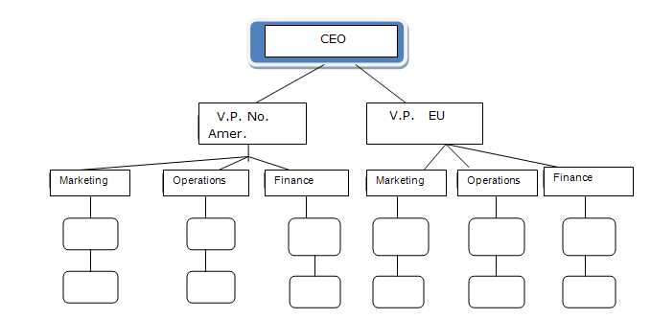

Decentralized
Taller or flatter? What would you say?

Scroll down to continue…

Taller/Vertical also known as the Bureaucratic model:

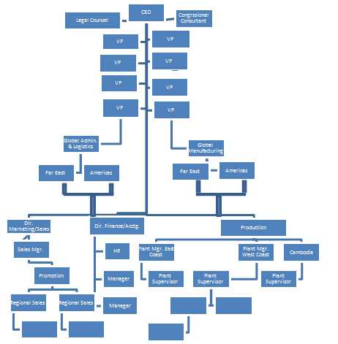

Flatter example: The Matrix Model

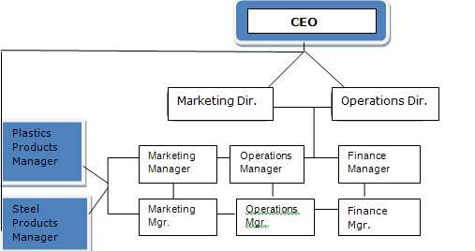

Some businesses are taller or more vertically structured than others. That is, in taller organizations, their structures have more management layers and each employee’s role is more defined and perhaps smaller (an example would be the military).

But as businesses globalized, due to the proliferation of the internet, reduced tariffs and trade barriers, and advancements in communication technologies, many companies flattened out (like the example above). In other words, they have less hierarchy in management. Decision-making has moved from a top down process to a process whereby the frontline employees make more of the day-to-day decisions since they are more directly involved with the customer.

