In a perfectly competitive market, the equilibrium price and quantity represent the most efficient operation of that market. Optimum efficiency means that sellers cannot be made better off without, at the same time, making buyers worse off, and that buyers cannot be made better off, without making the sellers worse off.

In this assessment, you will demonstrate your understanding and ability to correctly calculate the consumer surplus, producer surplus, and total surplus both before a price floor is established and after a price floor is enacted. Additionally, you will demonstrate an understanding of the impact on the entire economy, based on any changes in taxes required, if the government is to purchase any extra product that is not sold to consumers.

This assessment presents a scenario in which a government tries to improve the financial position of the sellers, in such a perfectly competitive market, by instituting a legal price floor that is significantly above the equilibrium price. A price floor is the lowest price for which a seller can legally sell the product.

Directions:

Using this Word template, answer the following questions based on the situation.

Questions

Suppose that the Gondwanaland chairman of production, who sets the governmental price floor for gosum berries, in an effort to assist the gosum berry producers to have a higher income, sets the price floor at $70 per barrel. In that particular year, the amount of gosum berries produced at the $70 price floor was 700 barrels per month. To support the price of gosum berries, the Chairman of Production’s Office had to purchase 400 barrels per month. The accompanying chart and diagram shows supply and demand curves illustrating the market for Gondwanaland gosum berries.

Price | Quantity Supplied | Quantity Demanded
$120 | 1,200
$110 | 1,100
$100 | 1,000 | 0
$90 | 900 | 100
$80 | 800 | 200
$70 | 700 | 300
$60 | 600 | 400
$50 | 500 | 500
$40 | 400 | 600
$30 | 300 | 700
$20 | 200 | 800
$10 | 100 | 900
$0 | 0 | 1,000

The accompanying diagram shows supply and demand curves illustrating the market for Gondwanaland gosum berries. Utilizing this information, answer the following questions.

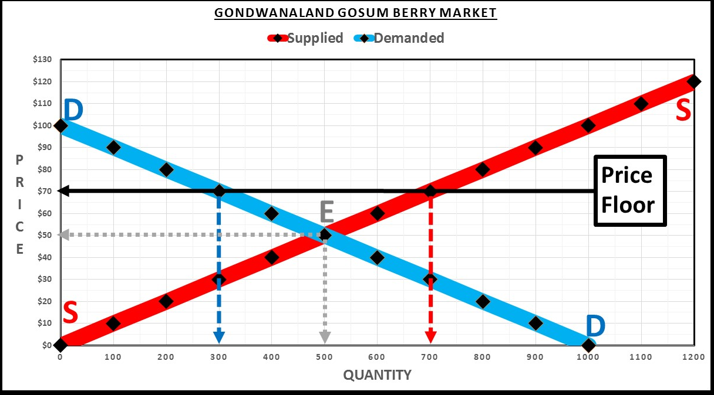

- In the absence of a price floor, the maximum price that a few of the consumers are willing to pay is up to $100 per barrel of gosum berries. The market equilibrium (E) price is $50 per barrel. How much consumer surplus is created when there is no price floor? Show your calculations.

- How much producer surplus when there is no price floor? Show your calculations.

- What is the total surplus when there is no price floor? Show your calculations.

- After the price floor is instituted, the legal minimum price that can be charged by suppliers is $70 per barrel. The maximum price that a few of the consumers are still willing to pay is $100 per barrel of gosum berries. With the price floor at $70 per barrel, consumers buy 300 barrels of gosum berries per month. How much consumer surplus is created with the price floor? Show your calculations.

- After the price floor is instituted, the Chairman of Productions Office buys up any barrels of gosum berries that the producers are not able to sell. With the price floor, the producers sell 300 barrels per month to consumers, but the producers, at this high price floor, produce 700 barrels per month. How much producer surplus is created with the price floor? Show your calculations.

- The Chairman of Production’s Office buys any barrels of gosum berries that the producers are not able to sell. With the price floor, the producers sell 300 barrels per month to consumers; but the producers, at this high price floor, produce 700 barrels per month. How much money does the chairman of production’s office spend on buying up gosum berries? Show your calculations.

- The Emperor of Gondwanaland must collect taxes from the people to pay for the purchases of surplus gosum berries by the Chairman of Production’s Office. As a result, total surplus (producer plus consumer) is reduced by the amount the Chairman of Production’s Office spent on buying surplus gosum berries. Using your answers for problems d, e, and f above, what is the total surplus when there is a price floor? Show your calculations.

- How does this compare to the total surplus without a price floor from question c above? Is it more, or less, and by how much?

--------------------------------------------
References
(List references here.)

