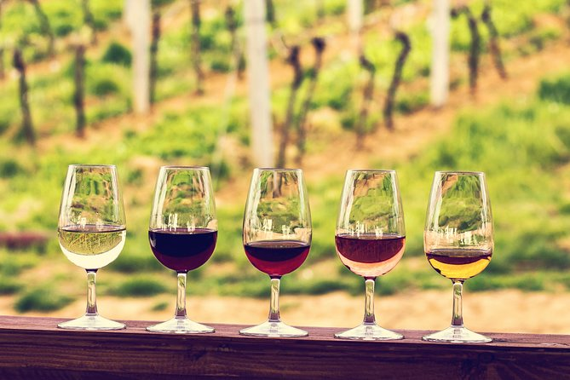

[This Photo](https://www.geoffreydromard.com/wine-tours-to-newcastle/) by Unknown Author is licensed under [CC BY](https://creativecommons.org/licenses/by/3.0/)

|  |  |
| --- | --- |
| Turul Winery*Strategic Evaluation Report* | |
|  | Turel Winery logo  *** Feel free to replace this image with one that is relevant to your organization.  *** Delete this textbox when editing this template!  *** NOTE: Change the blue font color to black throughout this document, and be sure to delete all instructions in blue. |
| Date Student Name  GB580: Strategic Management  Unit 1, 2, & 3 |  |

Table of Contents

**Strategic Development** 3

**Unique Strategy** 3

**Make sure to change the numbering in your table of contents once you have completed your Strategic Evaluation Report. *** Delete this text box.**

**Competitive Advantages** 3

**Winning Strategy Development** 4

**Mission, Vision, & Values Statement** 5

***Mission Statement*** 5

***Values Statement*** 6

**Strategic Management Hierarchy** 6

Corporate Level 6

Business Unit Level 7

Functional Level 7

**Organizational Design Theory** 7

Organizational Design & Strategic Development 7

Turul Winery Organizational Design 8

**Organizational Structure** 8

Turul Organizational Structure 8

**the McKinsey 7-S Framework** 9

Turul Winery Current Situation 10

**Organizational Culture** 11

The Competing Values Framework 11

Turul Winery Dominant Culture Quadrant 12

Turul Winery Organizational Identity 12

**Resources and Capabilities** 13

Resource-Based View Theory 13

VRIO Framework 13

**Organizational Policy** 14

New Organizational Policies 14

**Strategic Recommendations** 15

Current State of Turul Winery 15

*State of the Organizational Design* 16

Recommendations to Improve Organizational Design 16

**References** 16

**SECTION I.**

**Strategic Development**

## **Unique Strategy**

This entire document should be written in third person. There are no page or word count requirements. Be sure to use proper APA style referencing, including in-text citations and the reference page below. Use of images, diagrams, and charts to help explain the strategy concepts or to depict a component of strategy is highly recommended.

Explain the importance of developing a unique strategy to ensure long-term success for the Turul Winery. Use research to help you explain. Try using the five Ws and one H approach to help create a format for explaining the topic of unique strategy. For this section, write a strong introduction on the topics of strategy and policy. Consider using the five Ws and one H approach to describe the strategy and its principles. For instance:

* **What** is a unique strategy? Define it. What does it do? What is it good for in an organization? What does it entail? What is it used for? Etc.
* **Why** is strategy important in business (for-profit or not-for-profit)? Why does an organization use strategy? Etc.
* **Who** uses strategy? Who creates a unique strategy in an organization? Who benefits from it? Who are the stakeholders, etc.?
* **When** is it appropriate to create strategy? When is a strategy deployed? When do you evaluate, analyze, plan, or implement strategy? When does a strategy become unique in the development process? Etc.
* **Where** is strategy deployed? At what levels of the organization is strategy important and usable? Etc.
* **How** is strategy used by organizations? How is it deployed in an organization? Etc.

DO NOT present content in question-and-answer format. Write in paragraphs. These are just example questions to guide you. You do not have to answer every question. You can also create your own questions. This is just a guide. Synthesize research into your writing to present facts, and substantiate your thoughts, ideas, opinions, etc. Be sure to delete all writing in RED font, please.

## **Competitive Advantages**

Evaluates the competitive advantages of the Turul Winery. The keyword here is “evaluates.” Here is where you will evaluate the competitive advantages of your chosen organization. Dig in deep to understand the competitive advantages of your chosen organization. Break it down. Analyze it. What type of competitive advantages does your organization have? Why? Explain. Give reasoning. Are the competitive advantages sustainable? Why? Why not? Make judgments about the competitive advantages of your organization. Make recommendations and provide support for all your opinions, statements, and thoughts using research. Where do you find the informational research about the organization? Well, you will need to synthesize information from the organization's website, information from the simulation, and the Turul Winery website.

The concept of competitive advantage is an important one. In this section you will examine how organizations use strategy to build competitive advantage. Be sure to dig deep into the topic of competitive advantage. Define it. Explain why it is of importance to the success of an organization. Provide details on the types of competitive advantage that exist. Explain what each type of competitive advantage means to an organization. Use the Library resources in the spreadsheet. You are evaluating the competitive advantages of your organization in this section. You will do the evaluation in a later section.

Now, segue into the diagram below. Introduce the diagram in this paragraph, then fill out the diagram by identifying three competitive advantages of the organization.

**Figure 1:** *Turul’s Competitive Advantages*

Add a descriptor for a competitive advantage here.

Add a descriptor for a competitive advantage here.

Add a descriptor for a competitive advantage here.

Here is where you want to explain what is in the diagram. Explain each competitive advantage you identify for the organization. Dig deep to explain exactly why these are competitive advantages of the organization. Feel free to use research to back up your thoughts.

## **Winning Strategy Development**

Explain how to develop a winning strategy to ensure the Turul Winery's long-term success. Here, you may also consider the five Ws and one H approach. One direction you can take is to explain the strategic planning process and how it leads to the development of a winning strategy. What are the components of a winning strategy? What is the value proposition of the organization? Perhaps you might consider a topic called strategic fit. What is the process for developing a winning strategy? Why is it important? How is it constructed? Etc. These are just example questions to guide you. You don’t have to answer every question. You can also create your own inquiries if you wish. This is just a guide. Synthesize research into your writing to present facts, substantiate your thoughts, ideas, and opinions, etc. Be sure to delete all writing in RED font, please.

Segue into explaining why a mission, vision, and values statement is important to developing a winning strategy. What are they used for? Etc. Then, fill out the diagram

## 

## **Mission, Vision, & Values Statement**

Introduce these three components of a strategy, including your chosen organization's vision, mission, and values. This is the process. In three separate paragraphs in this introduction section, explain the meaning and purpose of each strategy component. What is a vision, why is it important, and how is it constructed? The five Ws and one H approach works well here. Do the same for the other two topics, mission and values. Next, you will segue into the actual evaluation of each component of strategy for your chosen organization.

Next, you want to introduce the diagram below. What is the diagram, what does it contain, etc. Then, fill out the diagram.

**Figure 2:** *Turul’s Mission, Vision, and Values*

Here is where you want to explain what is in the diagram. Explain each strategy component you identify for the organization in the diagram above.

## ***Mission Statement***

Here is where you will evaluate the mission of your organization. You start by analyzing the components of the mission statement. Is it well structured? Does it do and say what it should according to the research you have gathered about mission statements? If yes, great! Explain why using the research as support. If not, great! Explain why using the research as support. Then make recommendations on improving issues or maintaining the mission as-is. Be critical in your evaluation. This is where we need to see that you can demonstrate your critical thinking skills. Here would be a great place to use some of the resources provided to you. They can be very helpful. Use them and Library resources to help backup your opinions, thoughts, ideas, etc.

***Vision Statement***

Here is where you will evaluate the vision of your organization. You start by analyzing the components of the vision statement. Is it well structured? Does it do and say what it should according to the research you have gathered about vision statements? If yes, great! Explain why using the research as support. If not, great! Explain why using the research as support. Then make recommendations on improving issues or maintaining the vision as-is. Be critical in your evaluation. This is where we need to see that you can demonstrate your critical thinking skills. Here would be a great place to use some of the resources provided to you. They can be very helpful. Use them and Library resources to help backup your opinions, thoughts, ideas, etc.

## ***Values Statement***

Ditto, but now focus on the values statement of the organization. Here is where you will evaluate the values statement of your organization. You start by analyzing the components of the values statement. Is it well structured? Does it do and say what it should according to the research you have gathered about values statements? If yes, great! Explain why using the research as support. If not, great! Explain why using the research as support. Then make recommendations on improving issues or maintaining the values statement as-is. Be critical in your evaluation. This is where we need to see that you can demonstrate your critical thinking skills. Here would be a great place to use some of the resources provided to you. They can be very helpful. Use them, along with Library resources to help backup your opinions, thoughts, ideas, etc.

**Strategic Management Hierarchy**

Introduce the concept of the strategic management hierarchy. What is it? Who created it, etc.? Use the five W’s and one H approach here too! Give a good, thorough explanation of the strategic management hierarchy and the theories behind it. Use research to help you explain. Be concise, though. Inserting a diagram or image here to illustrate the strategic management hierarchy might be a good idea.

## Corporate Level

Evaluate the **corporate** **level** of the Turul Winery using strategic management principles. In this section, you literally want to evaluate the corporate level of the Turul Winery. Do the research. Find out what the corporate level of strategy is, and why it’s important. Provide the analysis using research. The next step is the make judgments on whether the Turul Winery has a corporate strategy, and whether it lives up to what a corporate level of strategy should be, could be, and is in application of the concept. Then you provide recommendations on improving or maintaining effectiveness and efficiencies. Do not forget, synthesis of research is your best friend here.

## Business Unit Level

Evaluates the **business unit level** of the Turul Winery using strategic management principles. In this section, you literally want to evaluate the business unit level of the Turul Winery. Do the research. Find out the business unit level of strategy and why it’s important. Provide the analysis using research. The next step is the make judgments on whether the Turul Winery has a business unit strategy, and whether it lives up to what a business unit level of strategy should be, could be, and is in application of the concept. Then you provide recommendations on how to make improvements or how to maintain effectiveness and efficiencies. Do not forget, synthesis of research is your best friend here.

## Functional Level

Evaluates the **functional level** of the Turul Winery using strategic management principles. In this section, you literally want to evaluate the functional level of the Turul Winery. Do the research. Find out the functional of strategy and why it’s important. Provide the analysis using research. The next step is the make judgments on whether the Turul Winery has a functional level of strategy, and whether it lives up to what a functional level of strategy should be, could be, and is in application of the concept. Then you provide recommendations on how to make improvements or how to maintain effectiveness and efficiencies. Do not forget, synthesis of research is your best friend here.

**Organizational Design Theory**

## Organizational design is a very deep and extensive topic to cover. However, it’s pertinent that you introduce the concept and explain its importance to your reader, Bob Turul, the owner of the Turul Winery. You want to educate in a professional and respectful way and demonstrate your knowledge and expertise in organizational design. Synthesize your research, and let it help you explain the concept in this introductory paragraph.

Here is where you also want to **explain the value of organizational design using theories, principles, and concepts from peer-reviewed research.**

## Organizational Design & Strategic Development

This is where you **explain the relationship between organizational design and strategic development using peer-reviewed research.** You have already given a lot of detail about organizational design, but now you need to fit the puzzle pieces together. Explain the relationship between organizational design and strategic development by synthesizing research. Show your knowledge and expertise. This evaluation report is not only for informational purposes. You are showing and selling your expertise to the owner of the Turul Winery. Be the strategy expert and show Bob Turul that he made a good decision in hiring you as a general manager.

## Turul Winery Organizational Design

Make a bold statement here. **Develop a statement to explain the ideal organizational design approach for the Turul Winery**. You are the general manager, and this is your chance to show Bob Turul, the owner of the Turul Winery, that you are the consummate business professional that knows and understands the Turul Winery from an organizational design perspective. You can insert the statement into the box below or delete the box and make it a paragraph. It’s up to you.

Insert your BOLD statement on the organizational design of the Turul Winery here. This should be no fewer or more than 3–5 sentences. Make this statement convincing, powerful, and direct.

**Organizational Structure**

Organizational structure is an important aspect of organizational design. It is covered in addition to organizational design because it is of great importance to understand the people, roles, responsibilities, checks and balances, controls, accountability structure, authority structure, communication structure, etc., within the organization. Here is where you introduce the topic of organizational structure and how it interacts with the other components of strategy at the Turul Winery. Synthesize research here. This is where you want to analyze the topic of organizational structure to show what you know!

## Turul Organizational Structure

Introduce the diagram that you will create below. How is it structured? What theories, principles, or concepts helped you to make the decision on the type of structure the Turul Winery has. Synthesize research here. Use it to support your decision-making.

**Figure 3:** *The Turul Organizational Structure*

*Add your organizational structure illustration here.*

*Delete this box.*

**Evaluate the Turul Winery organizational structure configuration.** After illustrating the current organizational structure of Turul Winery, explain it. Make judgments about the functionality of the structure. Is it efficient? Is it effective? Why? Why not? Are there problems with the structure from any perspective (controls, accountability, authority, communications, etc.)? Use research to support your thoughts, ideas, and opinions. Then, segue into the next section by introducing the structure's advantages and disadvantages.

## *Advantages*

Based on your evaluation, determine **three** advantages of the Turul Winery organizational structure configuration. List them and explain them. It’s always a good idea to use research to back up your thoughts, ideas, and opinions, especially to validate observations and experiences.

## *Disadvantages*

Here you will determine **three** disadvantages of the Turul Winery organizational structure configuration. List the three disadvantages and do the same thing. Use research to support your thoughts, ideas, and opinions, especially to validate observations and experiences.

**SECTION II.**

**the McKinsey 7-S Framework**

Introduce the McKinsey 7-S framework here in this paragraph. In Figure 4 below, you are provided a diagram that illustrates the framework of the McKinsey 7-S model. Explain it. What is it? Why is it important. How does it work? Who uses it? Etc. Five Ws and one H approach is very useful when explaining such a topic.

**Figure 4:** *The McKinsey 7-S Model*

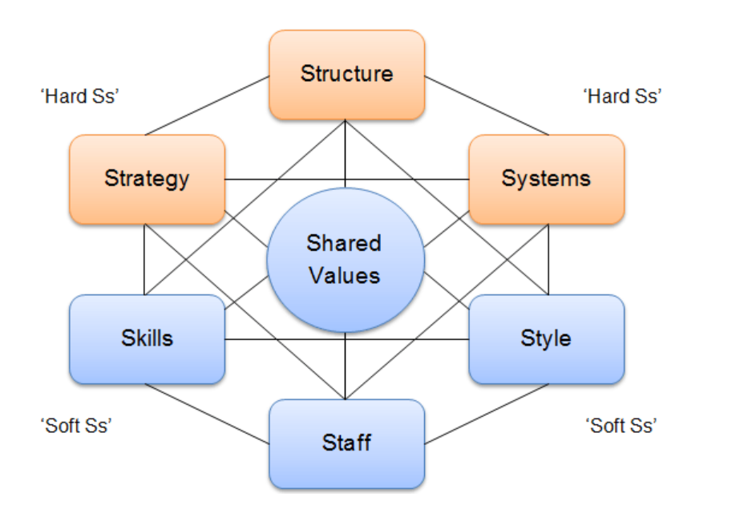

## Turul Winery Current Situation

Here you will **evaluate the current situation of the Turul Winery organization using the McKinsey 7-S framework.**

Introduce and explain what a situational analysis is using the McKinsey 7-S framework. Then you will explain what it means to analyze the strengths and weaknesses of the organization based on the variables of the McKinsey 7-S model.

Next, fill out the table below. Use your research on the McKinsey 7-S model to understand how to apply the framework as an analysis tool.

|  |  |  |
| --- | --- | --- |
| **Table 1.** *Current Situation Analysis* | | |
| **McKinsey 7-S Model** | | |
| **7S** | **Comment** | **Aligned?** |
| Strategy | *You can use bullets or sentences. It’s up to you.* |  |
| Structure |  |  |
| Systems |  |  |
| Skills |  |  |
| Staff |  |  |
| Style |  |  |
| Shared Values |  |  |

Here is where you make an impactful statement that informs Bob Turul on the overall status of the Turul Winery based on the results of the situation analysis above. Keep it brief, but let him know that you have a strong grasp of what the Turul Winery is all about based on your findings from this analysis.

Segue into the next table by explaining what it means to identify strengths and weaknesses and why it is important to identify the strengths and weaknesses in the table below.

|  |  |  |
| --- | --- | --- |
| **Table 2.** *Strengths and Weaknesses Analysis* | | |
| **McKinsey 7-S Model** | | |
| **7S Element** | **Organizations Strength** | **Organizational Weakness** |
| Strategy |  |  |
| Structure |  |  |
| Systems |  |  |
| Skills |  |  |
| Staff |  |  |
| Style |  |  |
| Shared Values |  |  |

Provide a brief statement that informs Bob Turul on how this information will be used. Look to the future. You will be developing a strategic plan in Units 3 and 4 (M2) and an implementation plan in Unit 5 (M3). Think about and explain how this information might help you in those deliverables.

**Organizational Culture**

Introduce the concept of organizational culture here. The five Ws and one H approach is useful here. Also, have you ever heard of the five WHYs approach? It may also come in handy in helping you explain a complex topic like organizational culture. Always use research to help inform your reader and to substantiate your thoughts, opinions, and ideas with facts. Segue into discussing the competing values framework that you will cover in the next section.

## The Competing Values Framework

In this section you will **explain how the competing values framework is used to evaluate the organizational culture of a business**. Use research to help you explain this concept thoroughly. Remember your audience is Bob Turul, so keep it high level, but do provide enough detail to demonstrate your knowledge and expertise on the topic. Then segue into presenting the Figure 5 diagram.

**Figure 5:** *The Competing Values Framework* (Cameron, 2017)

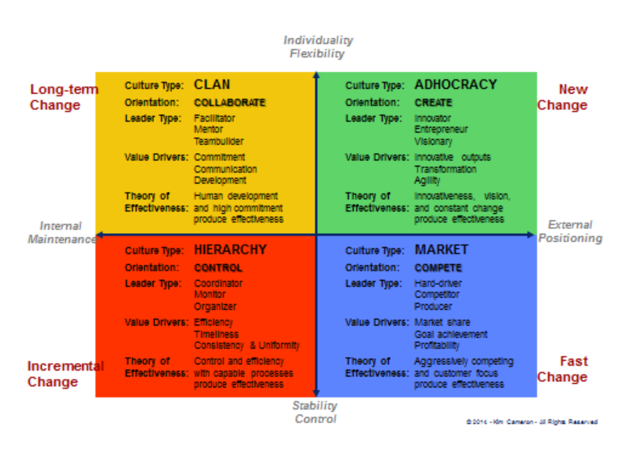

Continue explanation on the background and use cases for the competing values framework. Why is it valuable to the Turul Winery to consider this theory? How is it used? Etc.The five Ws and one H approach can help here as well.

## Turul Winery Dominant Culture Quadrant

Now it’s time to **use the competing values framework to evaluate the Turul Winery to identify the dominant culture quadrant of the organization**. Be sure to give reasoning and thoroughly explain why you chose the dominant culture quadrant you identify for the Turul Winery. Use research to help you explain.

## *Organizational Factors*

Explain the distinctive **organizational** factors of the chosen dominant culture quadrant.

## *Individual Factors*

Explain the distinctive **individual** factors of the chosen dominant culture quadrant.

## Turul Winery Organizational Identity

Here is where you develop a concise description of the organizational identity of the Turul Winery organization. You can use the textbox below to make a bold statement about the organizational identity of the Turul Winery. This should be a powerful statement describing the organizational identity.

Insert your BOLD statement on the organizational identity of the Turul Winery here. This should be no fewer or more than 3–5 sentences. Make this statement convincing, powerful, and direct.

**Resources and Capabilities**

Why is understanding the resources and capabilities of the organization important? What’s the difference between resources and capabilities? Give a concise but thorough introduction to this section of your strategic evaluation report. Synthesis of research is helpful to you in explaining this topic.

## Resource-Based View Theory

Here is where you **explain how the principles of the resource-based view theory and framework are useful in evaluating the organizational design and strategy of the Turul Winery**. Introduce the theory of the resource-based view by synthesizing research. What is it, how is it done, and why is it useful? Etc. The five Ws and one H approach can be helpful to you here. Segue into introducing the VRIO framework below.

## VRIO Framework

This section explains the VRIO framework, what it is, and how it is used. Why is it beneficial to the organization to use this framework to evaluate its resources and capabilities?

Next, **use the VRIO framework to analyze the Turul Winery organization, determine three tangible and intangible resources of the business** in the matrix below. Next, **use the VRIO framework to analyze the Turul Winery organization, determine three capabilities and dynamic capabilities of the business**.

**Table 3:** *VRIO Framework*

|  |  |  |  |  |
| --- | --- | --- | --- | --- |
| Tangible Resources | Valuable? | Rare? | Costly to imitate? | Company organized to exploit it? |
|  |  |  |  |  |
|  |  |  |  |  |
|  |  |  |  |  |
|  |  |  |  |  |
| Intangible Resources | Valuable? | Rare? | Costly to imitate? | Company organized to exploit it? |
|  |  |  |  |  |
| Brand recognition |  |  |  |  |
|  |  |  |  |  |
| Capabilities | Valuable? | Rare? | Costly to imitate? | Company organized to exploit it? |
|  |  |  |  |  |
|  |  |  |  |  |
|  |  |  |  |  |

Provide a brief explanation of the results of this analysis. What are the key takeaways, and how will they be used? You should consider synthesizing research to help you explain the value of this information.

**Organizational Policy**

What are organizational policies? What are they used for, and how do they relate to strategy? Using an approach like the five W’s and one H analysis, provide some background information on policy, the different types of policies, and specifically address the types of policies you will be creating here. Synthesize research. Then, segues into your policy creation sections.

## New Organizational Policies

**Formulate one new organizational policy that will drive performance at the Turul Winery.** Do this below. However, introduce the policy in a concise manner before presenting it below. What is a performance supportive policy? What is it used for? How is it implemented? Etc. Then, fill out the specifics related to the policy. Use Library research on policy creation to help you understand the components of a policy as outlined below.

|  |
| --- |
| Policy to Support Performance |
| **Title:**  **Purpose:**  **Scope:**  **Policy Statement:** |

**Formulate one new organizational policy that will drive innovation at the Turul Winery.** Do the same here. Explain what an innovation supportive policy? What is it used for? How is it implemented? Etc. Then, fill out the specifics related to the policy. Use Library research on policy creation to help you understand the components of a policy as outlined below.

|  |
| --- |
| Policy to Support Innovation |
| **Title:**  **Purpose:**  **Scope:**  **Policy Statement:** |

**Formulate one new organizational policy that will ensure the Turul Winery is an organization devoted to social responsibility**. Do the same here. Explain what an social responsibility supportive policy? What is it used for? How is it implemented? Etc. Then, fill out the specifics related to the policy. Use Library research on policy creation to help you understand the components of a policy as outlined below.

|  |
| --- |
| Policy to Support Social Responsibility |
| **Title:**  **Purpose:**  **Scope:**  **Policy Statement:** |

**Strategic Recommendations**

This is the conclusion to your strategy evaluation report. As the general manager, this is where it counts. You are presenting high level information to Bob Turul, the owner of the Turul Winery. You were hired for this. It’s time to impress. Synthesizing research, explain your process for strategy recommendations. How should Bob Turul view this section of the report? Why is it important? Etc. Now segue into the next section to explain the current state of Turul Winery.

## **Current State of Turul Winery**

In this section, you will **develop conclusive remarks on the current state of the Turul Winery organization from the perspective of strategic management theories, principles, and concepts**. Be concise. Make this powerful! This is a summary. Research the composition of a “State of the…” type of deliverable. Make this a positive statement, but show your worth, and explain how you will use this information to create a future strategy. Be sure to use plenty of research.

## *State of the Organizational Design*

Here you want to **develop conclusive remarks on the current state of the organizational design of the Turul Winery organization from the perspective of organizational design theories, principles, and concepts**. This is a summary. Explain what the organizational design looks like today and how you would like it to look into the future. Be sure to use plenty of research.

## Recommendations to Improve Organizational Design

Here is where you **develop a minimum of five recommendations to improve or grow the Turul Winery organization from the perspective of strategic management and organizational design over the next 3 years**. The key here is to address the 3-year timeframe. Explain that you will be providing recommendations for consideration. Remember your audience. Be professional, courteous, direct, and demonstrate your expertise. Next, below is your list of top five recommendations to improve the organization over the next 3 years.



## 

## **References**