MT104 Financial Plan Workbook Tutorial:

Step 1: Save this document to your AB104 files.

Then view the [Final Workbook Project Timeline](https://kapextmediassl-a.akamaihd.net/business/MT104/2005C/final_timeline-V1.docx).

Step 2: Then choose “save file.” Then go to your downloads file

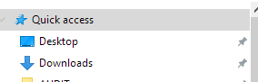

Step 3: When you find the file you downloaded, select it to open it up. Then select, “enable editing”, and save it to your MTB104 Course files as an Excel workbook file.

Step 4: When you have finished working in the assigned tab (seen at the bottom of the workbook) for that unit, submit the whole workbook following this format:

Username-MT104 Financial Plan Workbook Unit #.xlsx

Step 5: Submit the completed unit workbook to the Dropbox.