Sales Plan:
Organizational Structure
Name: ______________________ Date: _______________

Sales Plan

Provide an introduction to the project. Give the reader an overview of what this phase of the project is about. Be sure to double space your work and give credit where credit is due by citing your sources according to APA guidelines.
Organizational Structure
Provide an analysis of how the organization you have selected is structured. Create an organizational chart beginning at the top (See the basic example below, be aware that not all levels are represented, this is for illustrative purposes only). Describe whether there are vice presidents and who reports to them (such as general or regional managers) and then who reports to them and so forth.
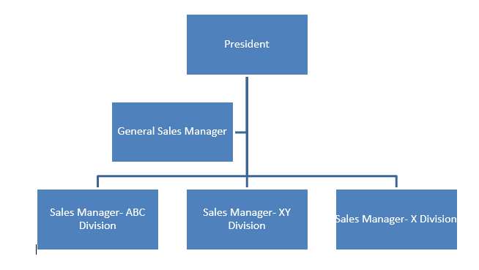
Organization of Sales Force
Determine whether the organization is structured by product, geography, customer type, selling function, or by type of customer. Refer to Chapter 6 of Cron and DeCarlo (2009) for guidance.
Sales Force
Discuss the sales channels used to sell the products or services. Are both inside and outside representatives employed. Discuss whether the company uses their own sales force or if they have outsourced the sales force through the use of agents, do they sell over the internet, or via catalog? What role does telemarketing play in the company’s sales force? How are national or key accounts handled? Is team selling used?

Reference
Cron, W. L. & DeCarlo, T. E. (2009). Dalrymple's sales management: Concepts and cases (10th ed.). New York, NY: The McGraw-Hill Companies, Inc.

Note: Include a reference list on a separate page. Be sure you cite your sources in the body of your work and use your reference list to include all sources you used. Refer to the APA manual for guidance.

