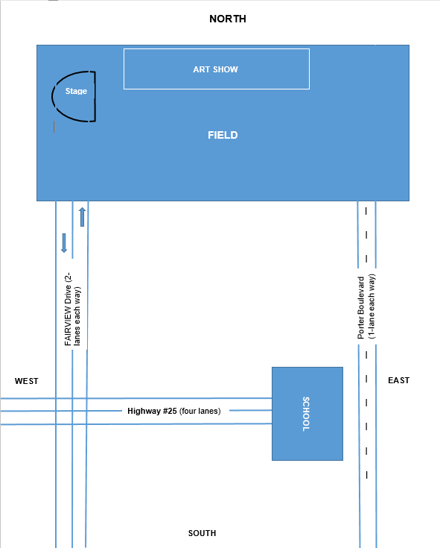

This is a 5-acre grassy field where cars can be parked for the event.