Developing a Problem Statement That Meets the SMART Criteria

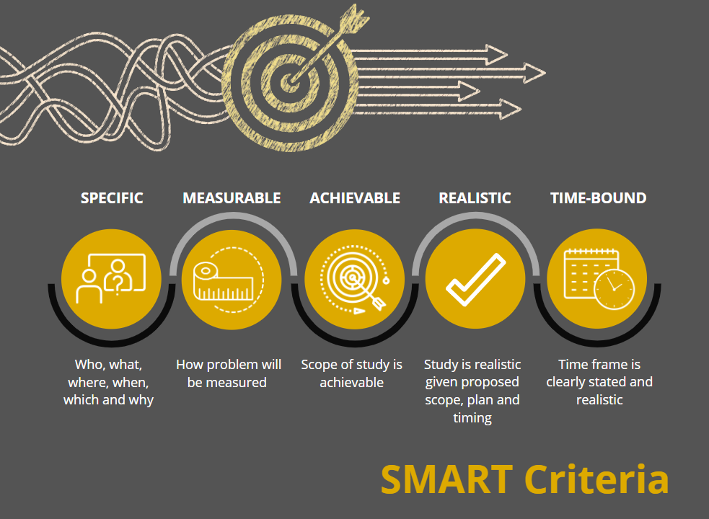

During the first 2 weeks of the course you have considered issues that might form the basis of your applied research proposal. The most important criterion for selecting your issue is that it is focused on applied research as opposed to traditional research. This means that the study should be intended to examine a real-world problem currently occurring in a specific criminal justice, homeland security, or emergency management location, such as an agency, organization, group, or community.
As you learned from the Ayiro (2012) reading in Unit 2, there are five questions you can consider when determining whether to research a problem:
- Will your study inform policy and practice? (most important)
- Will the proposed study fill a gap in the existing research literature?
- Will the proposed study replicate a past study but examine the problem from a different perspective or in a different study site?
- Will the proposed study expand past research into a new area or examine the issue in greater depth?
- Will the proposed study give more voice to silenced or marginalized people or groups? (Ayiro, 2012, pp. 85–86)
This week, you will define the scope of your applied research by narrowing the issue and developing a problem statement. In other words, you will identify and clearly describe an issue in your field that has risen to the level of a problem in a specific agency, organization, group, or community, citing sources that document the problem in the selected study site.
In addition to the unit resources, it is useful to rely on a well-known goal-setting tool, the SMART criteria. The SMART acronym stands for Specific, Measurable, Achievable, Realistic, and Time-Bound. These criteria can help you establish a sound problem statement that clearly defines the problem and sets forth a plan of action for the proposed study. The SMART criteria are defined and explained below.
SPECIFIC
Perhaps the most important element of the five criteria for applied research, a problem statement should be specific and identify 1) what the problem is, 2) where it is currently occurring, 3) who or what will be the study subjects, and 4) how you will research the problem. Think of the problem statement as the initial roadmap for developing the remaining elements of the research proposal. If you have not specifically identified the agency, organization, group, or community in which the problem is occurring, how will you be able to describe a plan for collecting data for the study? You need to know where you would physically have to go to collect data in order to propose an effective data collection plan. You also need to know who/what will or will not be included in your study (i.e., the scope of the study needs to be specifically stated). Narrowing the focus of your study in the problem statement provides the road map for preparing consistent plans for data collection and analysis.
MEASURABLE
A successful problem statement outlines the primary goal of the study and sets forth a specific metric or outcome for measuring whether the goal has been achieved. In this way, the researcher is showing that the problem is in fact measurable. As discussed in this week’s Denscombe (2012) reading, it is the researcher’s responsibility to clearly describe the objectives of the research and how the proposed study will meet those objectives (p. 20). The problem statement becomes the first point at which these objectives are discussed in the research proposal, and if they are not measurable, then the study is not feasible. For instance, consider a study whose goal is to evaluate whether illegal immigrants commit more crimes than citizens by collecting official crime rates before and after the study site became a sanctuary city. Official crime rates for the city would not be sufficient to measure whether illegal immigrants commit more crimes than citizens because rates do not tell us whether those committing the crimes were citizens or illegal immigrants. In fact, it is impossible to know the total number of illegal immigrants in a specific community, making it impossible to measure the extent to which they are or are not involved in criminal activity. The following are four criteria to consider in determining whether your proposed study is measurable:
- The scope and scale of the study should be achievable.
- Proposed data sources should be accessible.
- Necessary resources are available.
- The study will not harm or jeopardize the safety of others (Denscombe, 2012, p. 20).
ACHIEVABLE
The third element of the SMART criteria, whether the study is achievable, is closely aligned with whether the study is measurable. A problem statement must set forth a study that is achievable or attainable. Say, for example, you propose to document the number of human trafficking cases by collecting data from all 50 states. Aside from the fact that the study would be more of a traditional than applied study, the scope of the research simply would not be achievable for a researcher to accomplish in a reasonable time period. National studies of this kind typically require extensive grant funding and teams of researchers to accomplish. You might narrow the focus to a specific community or organization with recent substantiated increases in human trafficking. You might further narrow the scope of the study to evaluate the effectiveness of newly implemented local law enforcement strategies for detecting human trafficking cases in the community. With access to the right data, this study could be achievable under the right circumstances.
REALISTIC
As you draft your problem statement, you may wish to aim high and cover all your bases by proposing to conduct surveys, interviews, focus groups, and observe subjects. While it is noble to propose various measures, you run the risk of being overly ambitious and proposing a study that is not realistic. It is therefore important to narrow the focus of the study to a manageable research design that can realistically be achieved. Suppose, for example, you are interested in researching whether social networking increases disaster preparedness. A realistic approach to a study of this kind might involve focusing on a single community and one method of data collection to measure preparedness levels. A study with sound sampling and data collection strategies could realistically examine this issue and achieve results generalizable to communities of similar size and geography. When deciding on data sources, ask yourself whether more than one source is necessary to adequately answer the study research question. How would additional sources provide different data on the issue? If they would not, then they are likely not necessary. You may be surprised to find that the more narrow the scope of a study, the more realistic it is and the less need there is for multiple data sources to achieve the study objectives.
TIME-BOUND
For a study to be achievable and realistic, it must also be time-bound. The problem statement should clearly identify when the project will start and when it will be completed; otherwise, research funding agencies or involved stakeholders may not support the study. The time frame for studies varies based on the scope and nature of the proposed research. Keep in mind that you want to propose a study that you could realistically achieve by yourself. So consider how long it would take to complete the study you are proposing. If you find that it would take years and years, reconsider whether this would be feasible and financially possible. Most people would be hard pressed to set aside more than 12 months for a project. Can your proposed study be achieved in this time? Consider the steps that would have to be performed to complete a study, such as:
- Reviewing recent research to further inform your approach
- Preparing study consent forms and data sharing agreements
- Finalizing all data collection instruments and instructions
- Preparing methods for administering data collection, such as online or mail surveys
- Preparing and submitting an application to the Institutional Review Board, and receiving approval
- Preparing and coordinating data collection schedules
- Collecting all study data, having to repeatedly reschedule and recollect based on availability of study subjects
- Checking collected data for accuracy and logical inconsistencies or missing data
- Transferring collected data into an analyzable format (e.g., entering data into a database, transcribing recorded interviews)
- Analyzing data through thematic analysis and/or calculated measures
- Interpreting the meaning and significance of the research findings
- Writing a summary of the study methods, analyses, findings, and conclusions
- Disseminating study results through presentations, reports, peer-reviewed publications, etc.
Typically, the first few steps alone require a few months to accomplish. With this in mind, set forth a realistic time frame in your problem statement for completing your study. If you are unsure, bounce your ideas off of one another in this week’s Discussion Board to obtain outside perspectives and experiences. Do not fret if you find the need to revise your problem statement over the course of this class. That is a normal progression that occurs as you develop your literature review and learn more from others who have previously studied your problem. If you start with meeting the basic components of the SMART criteria in developing your problem statement in this unit, you should be well on your way to preparing an effective research proposal.

Written by Dr. Kristin Early, Professor, Purdue University Global, August 2020.

References

Ayiro, L. P. (2012). A functional approach to educational research methods and statistics: Qualitative, quantitative, and mixed methods approaches. Edwin Mellen Press.

Denscombe, M. (2012). Research proposals: A practical guide. McGraw-Hill Education.

Maxfield, M. G., & Babbie, E. R. (2014). Research methods for criminal justice and criminology (6th ed.). Cengage Learning.

Southern Poverty Law Center. (2018, March 8). Sanctuary cities: The current state of sanctuary law. https://www.splcenter.org/20180308/current-state-sanctuary-law

Recall from earlier course readings that traditional research is often conducted in an experimental, laboratory setting. The primary goal of traditional research is to advance knowledge about the phenomenon under study, not to have an immediate application to policy or practice. Examples of traditional research would be a study designed to test the validity of a theory in the field, or to explore the nature of female delinquency or poverty and crime.
Sanctuary cities refer to municipal governments that adopt policies to protect immigrants in the jurisdiction (Southern Poverty Law Center, 2018).
Concluding that increased crimes rates were caused by illegal immigrants in a sanctuary city is an example of violation of the ecological fallacy, as group-level data are erroneously used to infer individual-level characteristics. Review Chapter 2 of the Maxfield and Babbie (2018) book for more detail about this fallacy and how to avoid it.

