Introduction to Research

This course is the first in a two-part series in applied research that includes CJ525 and the capstone course of either CJ598 or HM598 (MSCJ students complete CJ598, while MSHSEM students complete HM598). These courses are positioned at the end of the Course Sequence for the master’s programs because they are more intensive than earlier courses and build upon the knowledge acquired in the previously completed classes.

You may be wondering why the master’s degrees include courses dedicated to research. In the process of becoming a “master” in a subject area, it is not only important to master an understanding of the knowledge base that has been developed in the field through scientific research, but it is equally important to be able to distinguish which studies are credible based on the rigor of the scientific approach used by the researchers. In so doing, you are equipped to reach conclusions about the contribution of a study to the body of knowledge on a subject. Rather than rely on anecdotes, personal experiences, or guesses to understand issues in criminal justice, homeland security, and emergency management, scientific research is used to “produce, substantiate, or refute so-called facts and to ultimately attain a more accurate understanding of reality” (Pope at al., 2001, p. 2).

Types of Research

There are two major types of research, traditional and applied. The focus in this course and the next is on applied research as opposed to basic or traditional research. Traditional research, also known as pure or basic research, is intended to expand knowledge about a subject. It is intended to investigate basic laws and principles, or theories of crime, homeland security, and emergency management. This theoretical approach is focused on expanding knowledge about existing phenomena, but it does not have an immediate practical application. Examples would include studies exploring why people commit crimes or why factors in society contribute to communication barriers. While the results of traditional research help us to understand the “big picture” and can inform applied research, it is not intended to investigate a specific problem currently occurring in a real-world situation.

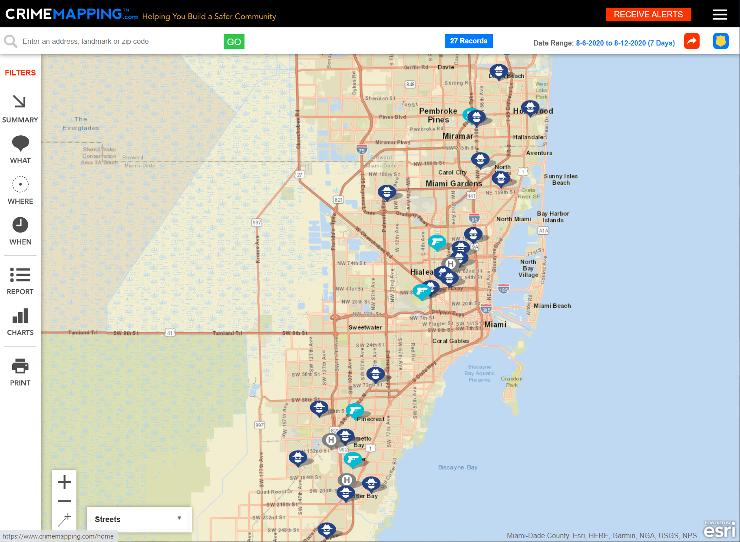
Applied research is designed to investigate specific real-world problems with findings having immediate policy applications. This type of research is particularly relevant to criminal justice, homeland security, and emergency management, because the focus in these disciplines is on examination of current practices, policies, and programs. In fact, university master’s programs are separated between those that emphasize criminology, which focuses on theory and traditional research, and those that focus on criminal justice and the organization and application of practices in the field. Homeland security and emergency management require current real-world knowledge and application to further the safety and security of Americans. For these reasons, it is important for master’s students in these fields to obtain an understanding of the basic elements of scientific inquiry and to acquire skills in both critiquing and conducting applied research.

Purposes of Research

As outlined in the Maxfield and Babbie (2018) textbook on research methods in criminal justice and criminology, research serves different purposes, including exploration, description, explanation, and application. These purposes are not mutually exclusive and can overlap in a study (Maxfield & Babbie, 2018).

Consider your current occupational context. You may be currently working or plan on working within the court system, correctional system, law enforcement, fire and protective services, social services, homeland security, or in another setting. Think about some of the problems and questions that research may help to address in these fields. When not much is known yet about a particular issue, exploratory research and descriptive research are used to develop an initial understanding of the phenomenon. An example of an exploratory study would be Scott Decker’s traditional research on gangs conducted in 1996, in which he explored the collective nature of gangs and their use of violence.

Similar to exploratory studies, the primary goal of descriptive research is to fully describe the scope of a problem, through counting (quantitative) or documenting observations (qualitative) (Maxfield & Babbie, 2018, p. 21). Recent applied research has described characteristics of cases involving lethal force by law enforcement officers. For example, the nonprofit organization Fatal Encounters.org developed a comprehensive database of all deaths involving police interaction since 2000. The database includes more than 28,000 records and describes characteristics of the individuals involved and circumstances surrounding each incident (access the Fatal Encounters Spreadsheet).

Researchers seeking to explain a particular phenomenon by determining what caused the phenomenon to occur are engaging in explanatory research. Understanding the causes of events allows us to learn from them and plan for the future. Setting forth a causal relationship between a variable and an event through research requires three conditions: 1) the cause must come before the event, 2) the causal or independent variable must be correlated to the occurrence of the event (dependent variable) in some way, and 3) and the relationship between the variables cannot be due to another intervening variable (Pope et al., 2001). A study aimed at explaining why Washington, D.C., has the highest rate of human trafficking would be an explanatory study.

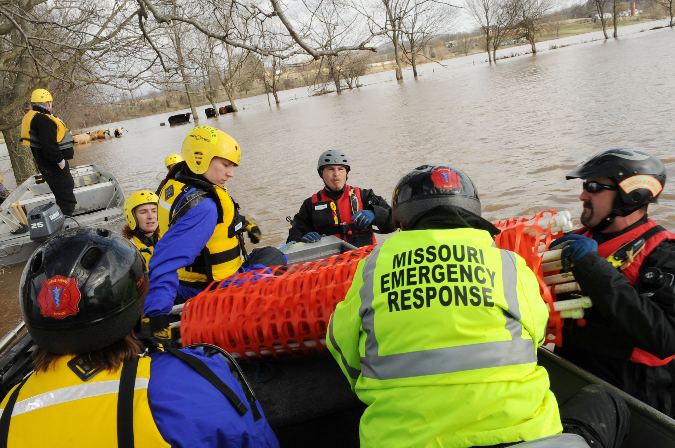
Finally, studies designed to examine real-world problems in criminal justice, homeland security, or emergency management with immediate policy applications fall into the realm of applied research. Applied studies can be descriptive, exploratory, or explanatory but must be focused on addressing a specific problem that is currently in need of investigation in a real-world setting.

Members of the Missouri Emergency Response Service team. Source: Federal Emergency Management Agency (FEMA) Photo Library (2008).

Research can also serve the purpose of application in terms of informing policies and procedures in the field. Applied research typically is used to evaluate the effectiveness of a given program or intervention or is aimed at problem analysis (Maxfield & Babbie, 2018). Very often applied research is collaborative in nature. The applied researcher works with those involved in the situation, gaining valuable insights from their knowledge and experiences, which is in turn used to describe the scope of the problem, analyze the problem, and evaluate potential solutions.
Consider the example of a recent national security breach. In 2019, the Inspector General of the United States Department of Homeland Security issued a memo indicating that the personal data of 2.3 million disaster victims had been unnecessarily shared by the Federal Emergency Management Agency (FEMA) (Mele, 2019). The discovery of the breach occurred during an audit of FEMA’s Sheltering Program. Initial applied research in this case might involve working with FEMA representatives to explore and describe the breach in more detail. More in-depth explanatory research would be needed to examine causal factors related to the breach, such as unnecessary dissemination of data to government contractors or a lack of policies and procedures governing the use and release of disaster victims’ personal data. Building upon the knowledge obtained through exploratory and descriptive research, applied research might then evaluate FEMA’s process for providing shelter and financial assistance to victims of disasters, with the goal of applying what is learned to policy reforms.

Over the coming weeks in CJ525, you will learn about research terminology, design, and implementation. You will select a pressing problem in the field that is currently occurring in a specific setting and will begin to develop a research proposal to study the problem. Along the way, be sure to check out the useful learning activities provided in each unit that further help you to master the course materials.

Written by Dr. Kristin Early, Professor, Purdue University Global, August 2020.

References

Decker, S. (1996). Collective and normative features of gang violence. Justice Quarterly, 13(2): 243–264. https://doi.org/10.1080/07418829600092931

Maxfield, M. G., & Babbie, E. R. (2014). Research methods for criminal justice and criminology (6th ed.). Cengage Learning.

Mele, C. (2019, March 22). Personal data of 2.3 million disaster victims was released by FEMA, report says. The New York Times. https://www.nytimes.com/2019/03/22/us/fema-data-breach.html

Pope, C. E., Lovell, R. D., & Brandl, S. G. (2001). Voices from the field: Readings in criminal justice research. Wadsworth.

