Research Design: Steps in the Process

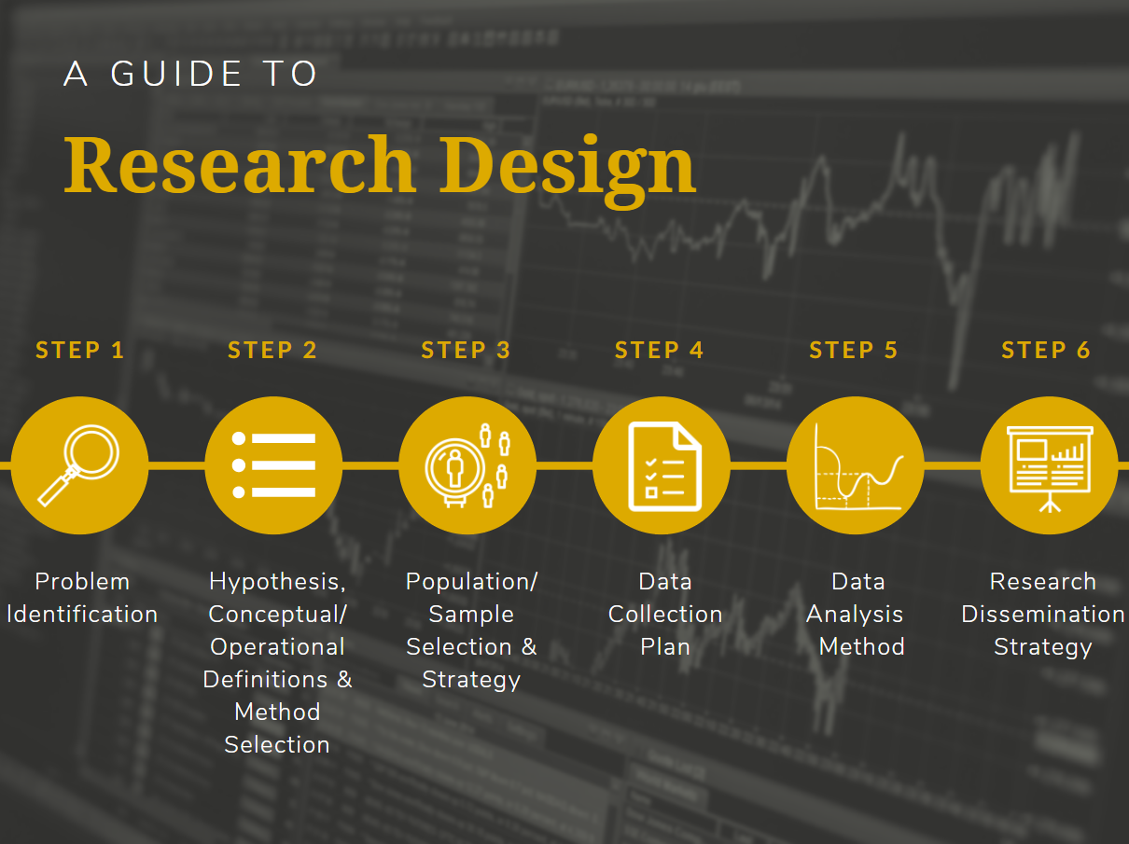

Research design in applied research generally follows a process in which the investigator identifies a pressing problem occurring in a criminal justice, homeland security, or emergency management location or setting, and then develops a detailed plan of action for studying the problem. Although there are a variety of sub-steps in this process, this course and the one that follows it will focus on the six primary research design steps depicted above.

Step 1 > Problem Identification
The first step in the process is to identify the problem that will become the focus of your research. As outlined in the Introduction to Research reading, applied research can serve the purpose of exploring, describing, or explaining. Consider issues that you have potentially dealt with yourself in the field or those that have made national news. An agency or organization may be experiencing a new problem and may need applied research conducted to identify the causes of the problem and evaluate potential solutions. If you are stuck coming up with an idea, review the MSCJ and MSHSEM topics listed in the Course Announcements. Once you select a topic, you need to determine specifically where the issue has risen to a level of a major problem in need of study. For example, if you were interested in examining mitigation strategies implemented to reduce damage caused by hurricanes, you might choose a study site or agency in Louisiana or Florida, given the high volume of hurricanes both states experience.
Step 2 > Hypothesis, Conceptualization/Operationalization, and Method Selection
After narrowing your focus to a specific problem in a given location, you will transition to beginning the process of creating a plan to conduct the study. Initial stages of research design involve developing a hypothesis, identifying and defining key study variables, and selecting the research method that will most effectively and efficiently permit you to research the problem. How do you make these decisions, though? Well, you do not have to make them alone. Instead, you start by reviewing a few prior studies on your topic published in peer-reviewed journals. This will help you learn what others have found and help you generate ideas about the variables related to the problem, which can in turn help you to develop your hypothesis. You will notice that researchers provide detailed explanations of their research design, sampling strategy, conceptualization, and operationalization. You can find these details in the “Methods” or “Methodology” section of most study publications. The following research designs are the most commonly used: experimental or quasi-experimental design, survey/interview research, field research, existing data research, comparative research, or evaluation research.
Step 3 > Population or Sample Selection and Strategy
Once you have developed your hypothesis, identified your key variables, and set forth the conceptual and operational definitions for these variables, you then must decide who or what will serve as your study subjects and where they are specifically located (i.e., where would you physically have to go to collect data from these subjects?). Consider the size of your study population: are there a few cases, hundreds of cases, perhaps thousands or more? The size of the population impacts decisions about the selection of study subjects. For a study to be realistic and achievable, two components of the SMART criteria (Rubin, 2002), a study should be one that an individual researcher could realistically conduct on their own in the period of approximately 6 to 12 months. Collecting observations from a population containing thousands of study subjects or even hundreds would be unrealistic in a relatively short period of time. For this reason and to reduce costs, researchers will turn to sampling techniques to select a sample from the larger population from which to collect data. In this phase of research design, you will decide between using probability sampling or non-probability sampling, and then choose from a variety of types within each of these broad categories as the method for selecting your study sample.
Step 4 > Data Collection Plan
The plan for collecting data serves as the road map for the entire study. It involves outlining how tabulations (quantitative data) and/or observations (qualitative data) will be made, instruments that will be used to collect data, methods for recording observations, protocols for measuring the variables under study, requests for accessing subjects and/or data, and schedules for collecting data, as well as ethical guidelines for ensuring the safety of subjects and confidentiality of collected information. The goal of this step in research design is to set forth a specific enough plan that another researcher could follow behind you and replicate your study, producing similar results. You will be introduced to this step in this course and will apply what you learn in the next course (CJ598 or HM598) when you develop a data collection plan of your own.
Step 5 > Data Analysis Method
A critical element of developing a sound research design is to outline the plan for analyzing the collected data. This plan will depend upon whether your study involved collecting qualitative or quantitative data, and whether you use probability or non-probability sampling techniques. Qualitative data are observations about characteristics or qualities that are expressed in words or through media (e.g., photographs, videos, audio recordings). Such observations must be carefully reviewed and “themed,” a process involving the classification and tabulation of participant responses or case observations. Alternatively, quantitative data are expressed in numbers and can be counted or tabulated. Researchers can further analyze data using descriptive statistics to describe the sample results (e.g., percentages, ratios, rates), or inferential statistics to make predictions or generalizations about the larger study population. Inferential statistics rely on being able to calculate the probability that study findings are not due to chance, which means they can only be calculated when the researcher has used a form of probability sampling to select their study subjects (Maxfield & Babbie, 2018). You will learn more about specifying a data analysis strategy and conducting qualitative and quantitative data analysis in CJ598 or HM598.
Step 6 > Results Dissemination Strategy
The final step in the research design process is to consider how results will be interpreted and reported back to the study site to inform immediate policy and program development aimed at addressing the problem studied. This is not as straightforward as simply creating graphs, tables, or summaries of results and presenting them to stakeholders. Rather, during this step, the applied researcher works collaboratively with the agencies, organizations, and persons involved in the study to examine the results and effectively interpret their meaning. This often involves showing the results to those who work in the midst of the problem and listening to their insights on what the findings suggest about the way things work in the study setting. Unless the researcher is a member of the agency, organization, or group on which the study was based, they likely do not have the intimate knowledge or understanding of the environment that study subjects have. It is therefore vitally important to coordinate with study participants not only to interpret results but also to develop a plan to effectively disseminate the findings to key stakeholders and policymakers.

For additional insights on research design, review Chapter 4 in the Maxfield and Babbie (2018) textbook.

Written by Dr. Kristin Early, Professor, Purdue University Global, August 2020.
References

Maxfield, M. G., & Babbie, E. R. (2014). Research methods for criminal justice and criminology (6th ed.). Cengage Learning.
Rubin, R. S. (2002). Will the real SMART goals please stand up? Saint Louis University. citeseerx.ist.psu.edu/viewdoc/download?doi=10.1.1.523.6999&rep=rep1&type=pdf

